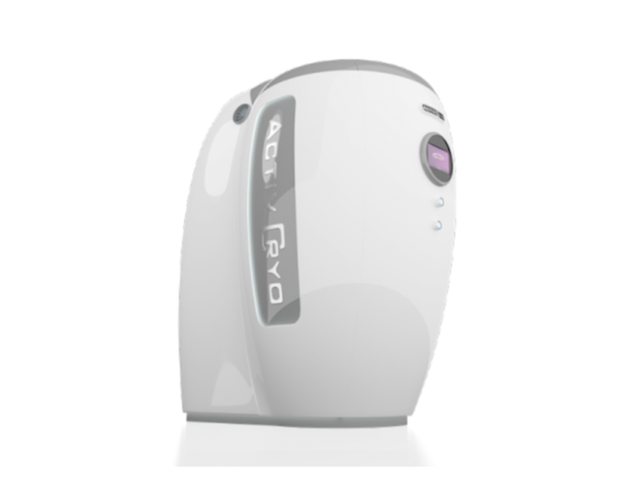

The Activ Cryo is the most technologically advanced Cryo Sauna on the market

USING ADVANCED TECHNOLOGY AND MODERN EQUIPMENT, CRYOTHERAPY’S INNOVATION INVOLVES EXPOSING THE BODY TO EXTREMELY COLD TEMPERATURES FOR 2-3 MINUTES.
The Activ Cryo chamber uses bursts of extremely cold nitrogen at temperatures as low as -170 degrees Celsius to trigger the body’s natural responses. The blasts of freezing air evoke physiological reactions that prompt recovery and healing in only 2-3 minutes.
Activ Cryo is the only chamber on the market that evenly distributes nitrogen to the entire body through the use of multiple jets.
This revolutionary procedure not only increases body performance efficiency by 30% but also increases recovery 8 times quicker than normal. The list of benefits include
- Improved muscle and joint function
- Elimination of pain
- Increased blood circulation
- Chronic pain and injury recovery
- Increased metabolism –Burn up to 800 calories in one session
- Endorphins release (the ‘Feel Good’ hormone)
- Improved sleep
- Cellulite reduction
- Stimulate collagen production

WHY WHOLE BODY CRYOTHERAPY IS AN EFFECTIVE METHOD FOR WEIGHT LOSS AND PAIN RELIEF
Extremely cold temperatures stimulate skin sensors, activating a central nervous system response. Endorphins, the body’s natural pain inhibitors and mood elevators, are then released from the pituitary gland and nervous system to improve mood, energy and pain. Cryotherapy also enhances the circulation of blood and lymph which promotes the removal of toxins and metabolic waste. This increased circulation also supplies muscles and internal organs with oxygen and nutrient rich blood to stimulate cellular regeneration around the body.
https://youtu.be/FjYu6tbbFb4 https://youtu.be/FjYu6tbbFb4

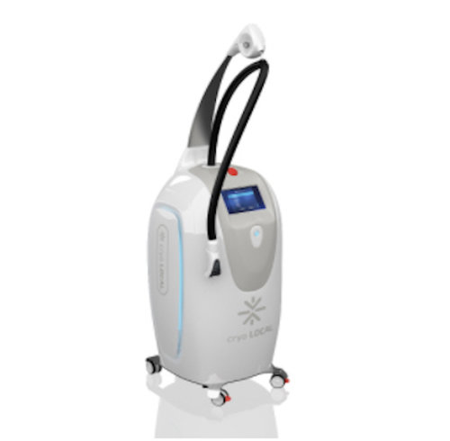

The Polar Bear Localised Cryotherapy

WHAT IS LOCAL CRYO STIMULATION?
Local Cryo stimulation involves the exposure of extreme low temperatures (approximately -160°C or 256F) to a specific area of the body and face. The skin is cooled sufficiently using nitrogen vapor (LN2) to provoke the vasoconstriction of blood vessels, which is then followed by rapid vasodilation post treatment, Cryo stimulation activates the body's optimum defense mechanism. During the short session only the skin is cooled superficially and the body responds by raising it's internal temperature through increased rates of micro-circulations across the treatment area. The metabolic surge continues for over 4 hours after each procedure.
At extreme low temperatures, thermo receptors on the skin are stimulated due to the intense energy in the stream. Strong signals are sent to the brain, which are faster than pain receptors. As the skin is cooled to the necessary temperatures, the trauma cycle is activated. Local Cryo stimulation triggers vasoconstriction followed by rapid vasodilation providing the patient with a natural analgesic effect alongside ongoing micro-circulations being driven around the treatment area.
https://www.youtube.com/watch?v=MvLArZxRoCY
KEY BENEFITS OF LOCAL CRYO STIMULATION
- pain relief
- reduction of spasms
- reduced muscle tension
- improvement of joint function
• after surgery recovery therapy
• overall quicker return to training
• decreased localized muscle fatigue
• improves blood and lymphatic circulation in treated area
• effective during post operative rehabilitation stages
• decreases inflammation
• muscle and ligament strains
• tendon injuries
• supports the treatment of excessive weight and obesity by increasing cellular metabolism
• skin rejuvenation

HOW QUICKLY WILL I SEE RESULTS?
Results are immediate and most noticeable a few days after the first treatment. A Local Cryo stimulation session post training (wait a minimum of a 1 hour) will instantly reduce fatigue and muscle pain. Sports injuries also respond immediately as each session reduces both pain and inflammation, allowing for more rapid and effective kinesiotherapy protocols.
The number of treatments varies depending on what the patient is trying to achieve and how the body responds to the treatment. Using Cryo stimulation for muscle recovery is a routine method of support and can be carried out in cycles of a 10-20 sessions to gain the full long lasting benefits of the treatment. Injuries vary in severity so the number of treatments is difficult to quantify. The physiotherapist and the patient will assess when they feel that the injury has been fully rehabilitated

WHAT TO EXPECT

