Front
25% OFF
Quality Custom Made Roller Blinds
Blockout – Screen – Light Filtering

Call 0414 816 678 Today!

Back
Roller Blinds
FREE in Home Measure & Quote

Call 0414 816 678 Today 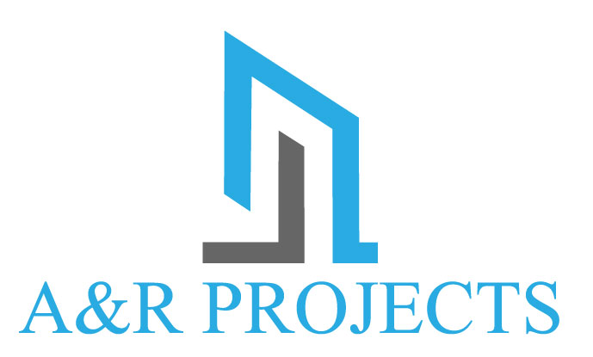

Huge
Selection
Of
Fabrics

Image

The above is just an idea of what we were thinking, obviously it needs to be designed and layed out professionally. I have also listed some points below.

Front of card
- Heading “25% Off” can this be large and bold taking up most of the top of the card.
- Writing below heading as per sample above.
- We would like something similar to the 3 best price images as per above but with the below information.
  - Image 1 “FREE in Home Measure & Quote”
  - Image 2 “Best Price Guarantee”
  - Image 3 “Family Owned & Operated”
- Phone number as above.

Back of card
- Heading “Roller Blinds” can this be large and bold taking up most of the top of the card.
- Writing below heading as per sample above.
- Images will be uploaded.
- Can you please put “Huge Selection of Fabrics” in some kind of bubble.
- Phone number as above
- Logo will be uploaded.

