Below is information from a 2015 talk given by Dr. David Sinclair, who is the Harvard genetics professor;

In this talk, Dr. Sinclair shares the endless potential of his age-reversing discoveries and the potential future for us all.

“I hope you're doing well and feeling fine, I've made it my mission to keep you that way and let me tell you how I'm doing it.
I am here to talk about a big developments and let me start by showing you this, the average person, most people will only live thirty thousand days.

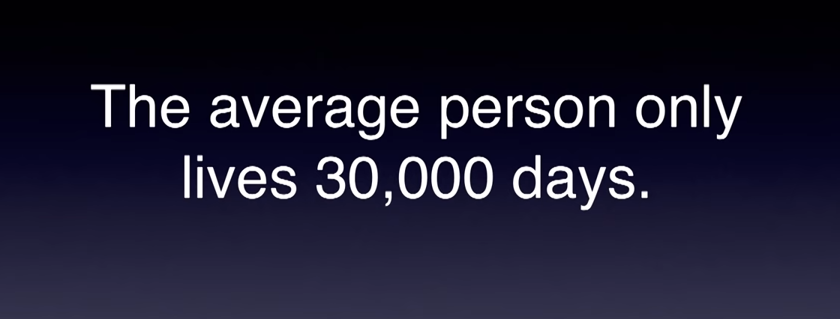

It does not have to be this way, we can not only live longer than thirty thousand days, we can live
healthier much more productive lives and compress that last period of our lives the morbid state into maybe a few weeks.”.

“Sounds crazy right but scientists like myself around the world are doing this all the time in their labs in model organisms like mice and rats and even monkeys so it's not crazy.

A Matter of Time;
“It is just a matter of how soon will this actually happen and we're very very close. Let me tell you how close we are.”.

“I come from Harvard Medical School, I have a team at Harvard and also in Sydney Australia of about 30 young scientists that are working very hard to make this a reality and if you haven't been convinced by other speakers today, maybe I can convince you that we should really look at aging as though it were a disease a treatable disease and that one day people will take a pill that will be able to lengthen the productive and healthy period of their lives you might say well why take this approach why don't we just do medicine and medical research the way we've always done it haven't we been great at that so far well the problem with current medical research is that we've been very good at
protecting some parts of the body such as the cardiovascular system but very poor at protecting other parts of the body like the brain and so even though we're living longer and longer we're spending more and more of a percentage of our lives in an unhealthy state and this is just not the way to go about improving the world the way I see it is that we have to keep all parts of the body healthy for longer and only then can we look forward to playing tennis with our great-grandchildren and seeing them graduate from college. ``

“In 1994 I was studying little yeast cells getting my PhD in Sydney Australia so here's a picture of a yeast cell and what I was noticing was that some of these yeast cells were getting old and this is an example of an old yeast cell”;

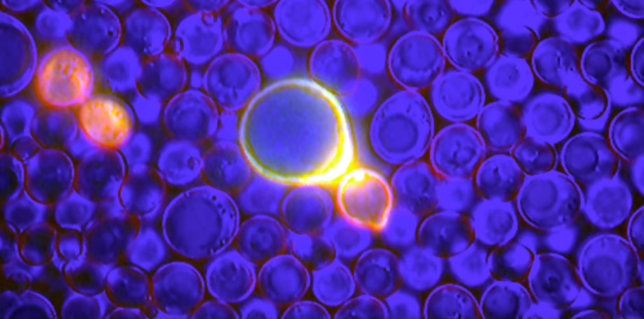

“The yeast cell was getting larger and slowing down and would become sterile, pretty similar to to many of our lives and the idea was, back in the early 90s that maybe we could understand aspects of Aging in our own bodies by studying these little yeast cells.”

“These are exactly the same cells that are used to make bread and beer and I learned about a professor who had just started up a project at MIT and I asked him could I please come study with him and I was the first a postdoctoral researcher to join the lab of Lenny Garantie at MIT to try and figure out why do yeast cells get old and how can we slow the aging down and I've been working on this ever since.
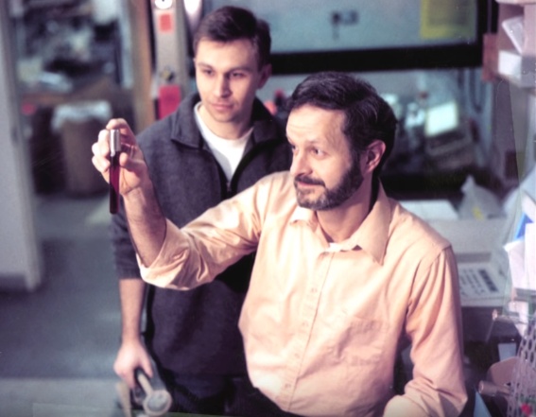

Clearly some of us have aged since then so what did we discover”?

“There has been a remarkable advance in our understanding of what causes aging and how we can regulate it and what we learned from those yeast cells that also appears to be true for ourselves in our bodies is that aging isn't old genetics, it's not just about how many mistakes are in our DNA or even what genes we have.”

“There is a new phenomenon known as epigenetics and that's basically a term that describes things that happen above the genetic landscape how the genes are actually switched on and off and what we found with the yeast cells is that when they're young they have a certain program of which genes are on and off and that keeps them youthful but as they get older the genes that are supposed to be on, some of them get switched off and vice versa and that was what was causing Aging in these yeast cells;

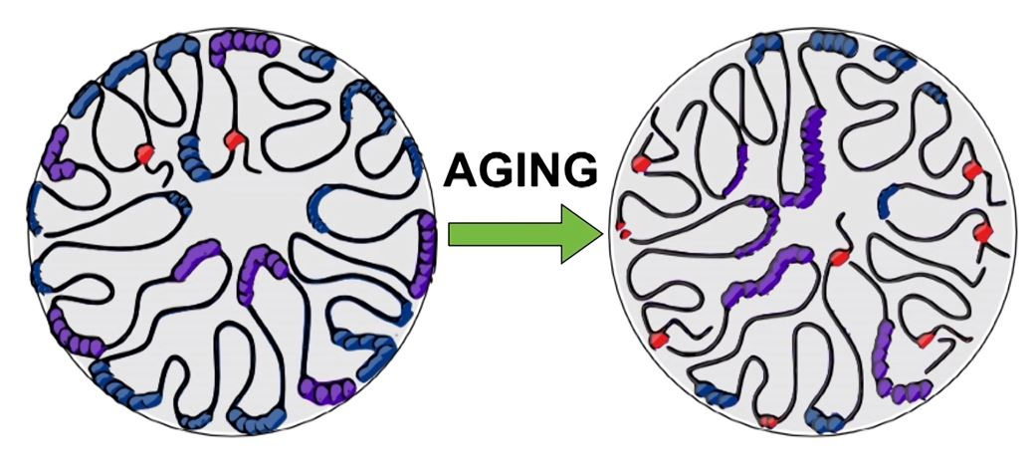

and we could very rapidly, now that we understood what was going on, we could counteract that and slow down aging in these yeast cells.

So now fast-forward 2015 some 20 years or so on, we now have a much better idea of how this all works not only in those yeast cells but in our own cells, something very similar is occurring,

What is going on inside our own cells;



Inside each of our cells we have a nucleus;

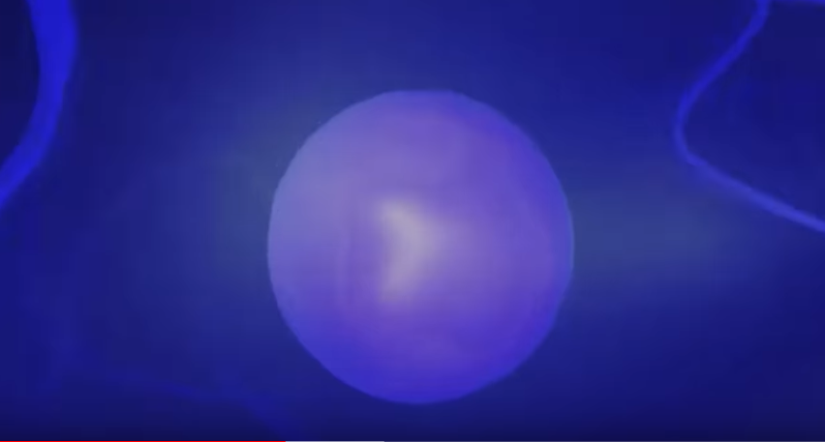

Inside each of our cell nuclei chromosome;



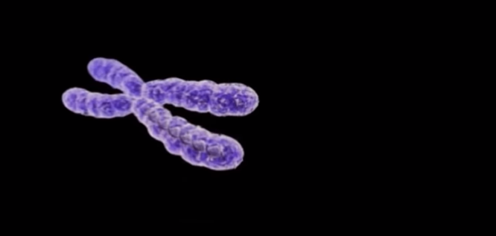

If we unravel a chromosome what we actually get isn't just a string but
actually beads on a string;

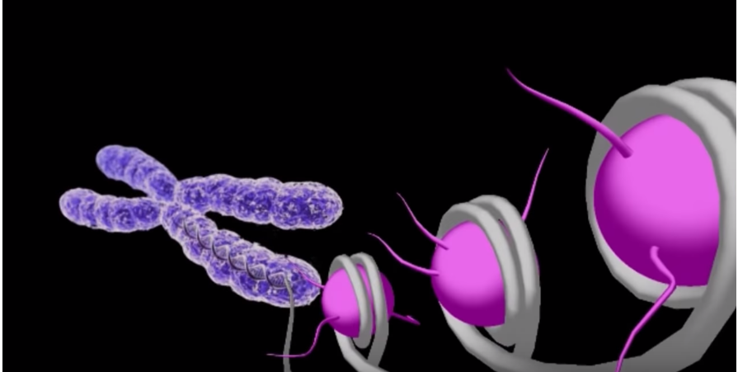

Our DNA is wrapped up in these proteins called histones, shown here in pink, what's interesting about that is that these histone proteins control which genes are switched on and off;

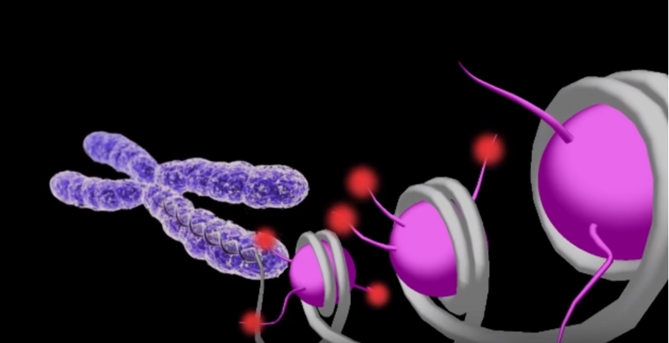

When we're young important genes get switched off and certain genes get switched on so if you're a gene that should be on in the liver you want it on in the liver you don't want to run in the brain what happens over time we found is that as you can see in the diagram, indicated by the red bulbs these proteins that hold the DNA together become chemically modified and now a gene that should be off become switched on and the opposite as well can happen.

The major implication is that aging should be reversible if we can bring that DNA back into a closed conformation we can reverse this process we should be able to make an old cell young again and that's what we've been working on for about the last 10 years in mice and human cells.

One of the molecules that we found about 10 years ago now is or was called Resveratrol I'm sure many of you have heard of Resveratrol it's this molecule in red wine and we found that Resveratrol turned on the pathways that controlled these histone proteins and packaging of the DNA. We fed Resveratrol to yeast cells and they lived longer about 30% longer we fed Resveratrol to worms and flies we fed it to mice and the mice were healthier they were impacted seemingly immune to the effects of obesity and later molecules that were even more potent powerful than Resveratrol more drug like molecules were able to extend the lifespan of those mice and keep them healthier and younger for longer it was a really exciting time you can see that even Fortune Magazine put story on the cover yes I was feeling pretty good;

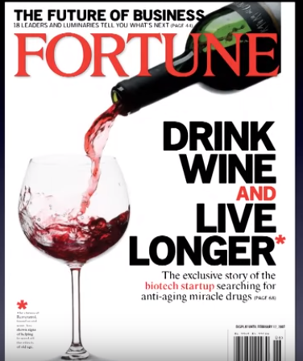

It was 2006 I started a company that was working on this these drugs were being developed they were entering human trials so here's the molecule this is the Resveratrol molecule from red wine,
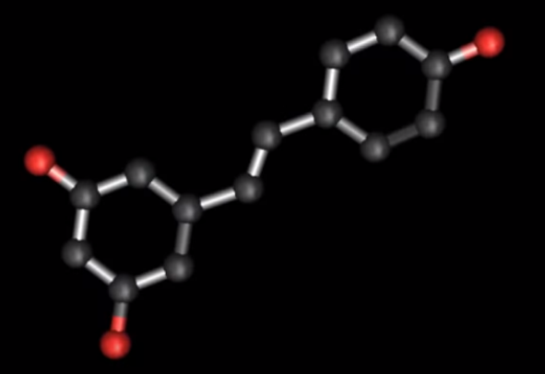

as soon as we made this discovery I started taking this molecule I figured what have I got to lose, I know what's going to happen if I don't take it and not surprisingly my wife insisted, demanded that she have access to this molecule my mother my father they all insisted in fact my brother was quite upset with me, recently he said, “what am i? the negative control in your experiment”, so he's on it now too, so we have no negative control anymore but my whole family has been on this molecule, in the case of my parents and wife over 10 years now we don't know if it's working, it's a small sample of course but we do know that it helps animals and even monkeys so we're optimistic that it's going to help.

There's a new study that we just put out just at the end of last year (2014) and we think we've found an even better way to activate these anti-aging pathways to put the genes back in their youthful configuration and this is a molecule called NMN it's full name is, Nicotinamide Mononucleotide what is important to know is that NMN boosts a molecule in our bodies called NAD and NAD is critical for life;



NAD is needed for every reaction, every important reaction in the cell but it's levels decline as we age to about 50% when you're elderly and this is a really bad thing, so what we did was an experiment where we took old mice that were 2 years old the equivalent of about a 55 year old human and injected it for a week with this NMN molecule and raised the nad levels up to and behold those male mice became more youthful in fact when we looked at the muscle of those mice we could not tell the difference between the two-year-old muscle and a 6 month old and we were able to report in the journal Cell which is a decent journal that we were able to for the first time reverse aging in a tissue and we think this is just the beginning so NMN is very exciting.
The other thing that's amazing about NMN is that it doesn't just work to reverse aging but we also have tried it and this is from the lab in Australia where we fed mice that have induced cancer in the liver;

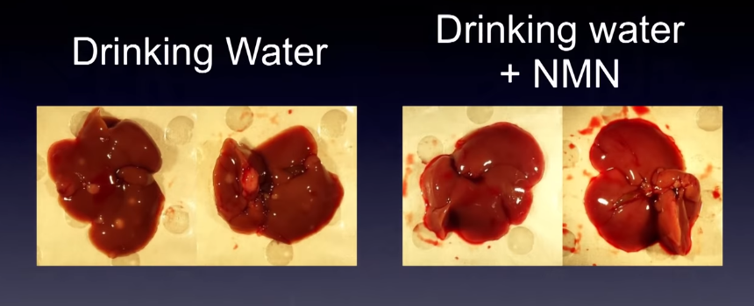

By adding NMN just in the drinking water of mice is extremely protective against this very aggressive cancer in the liver so we're excited about the possibility of this new molecule and molecules like it to treat diseases of Aging but also to lengthen healthy lifespan and these molecules are entering clinical trials next year 2014, so this led to some headlines, headlines about reversing aging.

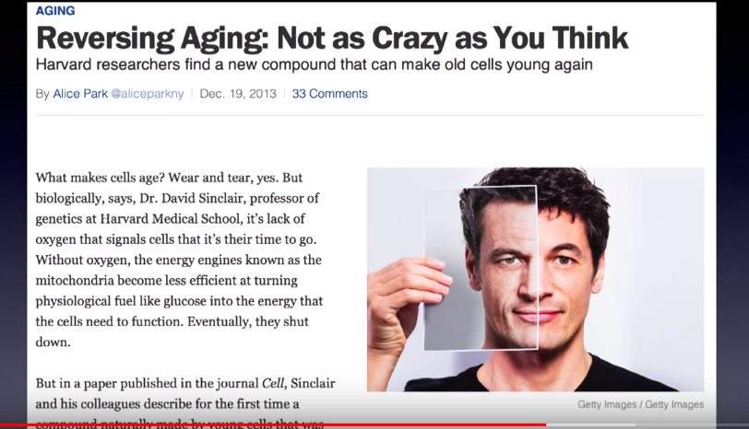

I again it was very fortunate to have lived through this and seen my science I reached the cover even of Time magazine.

I'm reminded that people only get 30,000 days to live and many of those days are not in perfect health by any means and I believe that it doesn't have to be this way it doesn't have to be like that for
any of us;

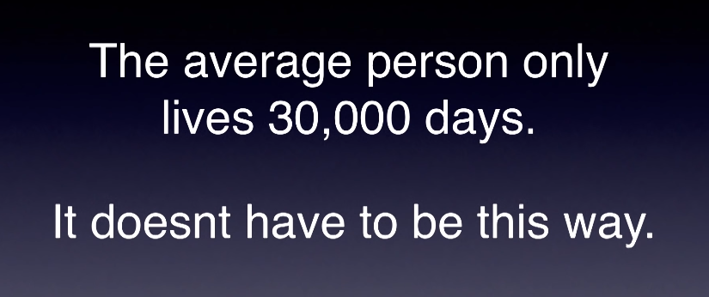

I am hoping that our generation will be the first to reap the benefits of this new technology so what is this new technology I've told you a couple of compounds that I'm working on but there's now a worldwide effort of scientists to try to slow down aging and improve health we have Google investing in this we have GlaxoSmithKline who have invested close to a billion dollars in my research and these molecules;

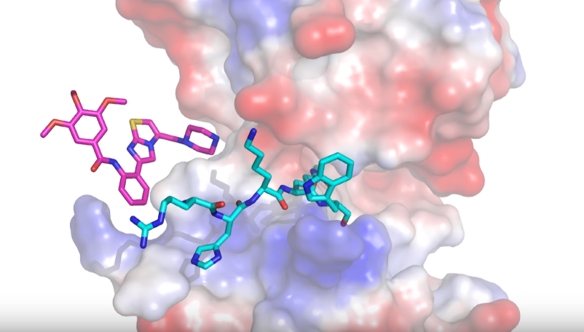

Are currently in human clinical trials these are some of the first ones that were based on the Resveratrol molecules from red wine but we can do better it's a race against time for all of us and we may be too late for it to help ourselves in fact less than half a percent of the research budget that the National Institutes of Health goes towards understanding aging at a fundamental level which I think is crazy given that it is one of the biggest problems that faces all of us on the planet both in economic terms and social terms so I'm very optimistic that the technology that's coming down the line just makes my head spin the ability to genotype yourself to predict your health to be able to now manipulate certain genes in your body just a year ago there's been a big breakthrough you may not have heard about it it's called CRISPR technology it's going to you know I will bet lots of money that this will lead to a Nobel Prize we now have the ability to go into cells and just turn specific genes on or off at will, we couldn't do that a year ago and now we can reprogram cells so that they're younger again and we're working on that as well in my labs.

An Example of, For Health and Long Life, We securely store Data. For Health and Long Life, takes your results from, for example 23andMe, a genetic test that is able to look at what genes are passed from parents, for example, as in the case of Dr. David Sinclair who found a mutation in his mother's genome that predisposes her to lung cancer which Dr. David Sinclair also carries.

We think the future is bright as does Dr. David Sinclair, with the advancements in gene splicing and data manipulation progressing at the rate it is, For Health and Long Life, as per our mission statement plan to find and be aware of the latest developments and make them available to our clients and the world.

Dr. David Sinclair and many other Drs. and Scientists in these fields are at the cutting edge of in our opinion taking human beings to the next step of evolution, which is not to have our evolution selected by nature but by conscious design of the human genome.

