Design logo and flyer for 2019 3DMed Australia Conference
Title
The 3DMedLab is hosting its 5th Annual medical conference on 14-16 November 2019 in Melbourne, Australia. The title of the conference is 3DMed Australia 2019.
Audience
The conference audience is aimed at people who have an interesting in 3D printing to benefit their work as well as printing for a hobby. Mostly professionals in the medical, bioengineering, VET sciences fields who are 3D printing models for patients and simulation will attend this conference.
This year the conference will bring international and interstate speakers.

3DMedLab logo


Colours
Pink and Blue are the main 3D Med Lab colours. This year we are happy to branch out from these colours. We would like to see a more futuristic theme.

Font
Arial

Picture
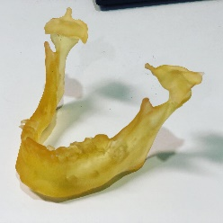
The main focus of this years conference is facial surgery which would require the incorporation of a jaw into the logo & flyer design.

