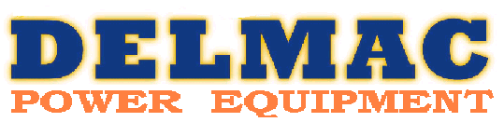
J.D KALMAR & J.L VALENTINE
ABN: 153 493 846 55
Address: 133 NORRIE AVE, WHYALLA NORRIE SA 5608
Postal: PO Box 61, WHYALLA SA 5600
PH: (08) 8645 0415
MOB: (a/h): 0428 800 309
FAX: (08) 8645 9080
Email sales: sales@delmacpe.com.au
Email management: operations@delmacpe.com.au
Trading hours: Mon-Fri 8:30am – 5:30pm, Sat 9:00am – 12:00pm
Statement of Capability

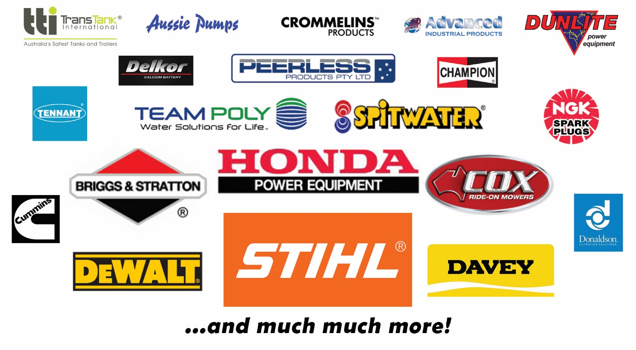

At Delmac we are the local small engine and power equipment specialists and pride ourselves on providing quality products and services to our customers. We employ a team of local mechanics and product knowledge specialists, offering a diverse range of industrial and commercial equipment including generators, compressors, lawn mowers, chain saws, brush cutters, power and pneumatic tools, firefighting equipment, pumps, tanks, engines, industrial vacuum cleaners, and much more. At Delmac we are the only local authorized agents for many of the reputable brands including Honda, Stihl, Davey, Team Poly, Spitwater, Dewalt, and we service everything we sell and more!
Please see below table outlining the products and services we offer that can add value for your business today.
Services | Type | Brands
Mechanical maintenance  - Inspection  - Servicing  - On-site forklift  - On-site work  - Fleet maintenance  - Mine-spec vehicle available | Industrial equipment | We service and repair all brands we sell, along with many more!
 | Welding units
 | Generators
 | Power equipment
 | Small engines
 | Pumps
Hire / rental of equipment | High pressure water cleaners (hot and cold, diesel petrol and electric, trailer mounted) | Spitwater, Stihl
Hire / rental of equipment | Generators up to 500kva | Blue Diamond Isuzu, Honda, Briggs & Stratton
Hire / rental of equipment | Bobcat & attachments (tines, bucket, auger, trenching, backhoe) | CAT
Hire / rental of equipment | Plant trailer up to 4t
Hire / rental of equipment | Garden power equipment  - Lawn mower  - Brush cutter  - Cutquik | Stihl, Honda, Briggs & Stratton
Financing and leasing options* | - Latitude (GEM go / Visa cards)  - Operational leasing, 3,4,5 year terms  *Ts&Cs apply | All brands we sell
Pick up and deliveries

Products | Type | Brands
Generators | - Up to 500kva  - Petrol and diesel | Blue Diamond, Honda, Briggs & Stratton, Dunlite, Kubota
Firefighting equipment | - Full kits including tanks, pumps, hoses, taps etc
Pumps | - Trash, fire, transfer, pressure  - Petrol, diesel, and electric powered | Davey, Aussie Pumps, Alemlube, TTI
Small engines |  | Honda, Briggs & Stratton, Perkins, Yanmar
Compressors, heaters, dryers and accessories | - Up to 6200lpm / 175psi / 200cfm / 15hp / 200l  - Petrol, diesel, electric (single and three phase)  - Stand alone, vertical, trailer mounted options | Peerless, Spitwater, Glenco
Fans |  | Fanmaster
Tanks / storage | - Water up to 360,000L, custom available up to 5,000,000L  - Septic  - Fuel pods (petrol & diesel)  - Fuel cans | Team poly, Kilkee, TTI, Pioneer Water Tanks, Eyre Tank Makers
Garden power equipment | - Lawn mowers  - Ride on mowers  - Brush cutters  - Chainsaws  - Chippers  - Edgers  - Blowers / vacs  - Pole pruners  - Hedge trimmers  - Tillers  - Misters  - Weed sprayers and weed poison | Stihl, Honda, Briggs & Stratton, Victa, Echo, Cox, Masport, Ferris, Rover
Power tools and accessories | - Full range of Dewalt power tools including drills, grinders, torches, circular saws, sanders, radios and more  - Laser measurement equipment | Dewalt, IMEX
Pneumatic tools and accessories | - Full range of Chicago Pneumatic and Shinano tools including grinders, impact wrench, angle grinders, sanders, drills, jackhammers, screw drivers and more | Chicago Pneumatic, Shinano
Hand tools and accessories | - Garden tools loppers, shears, pruners, secateurs  - Hammers  - Axes  - Gloves, Glasses PPE  - Torches, head lamps  - Kneeling boards/pads  - Bolt cutters  - Shovels  - Rubber boots  - Levels  - Tool boxes and belts  - Concrete tools | Stihl, Fiskars, Suprabeam, Flex Tool, Dewalt
High pressure water cleaners | - Up to 4500psi / 30lpm / 1450rpm  - Standalone or trailer mounted  - Petrol, electric (3 phase and 240v), diesel powered | Spitwater, Stihl
Cleaning equipment | - Ride on sweepers  - Push along sweepers  - Pull-along vacuums | Stihl, Spitwater, Tennant
Concreting tools | - Cutquiks / cut off saws  - Mixers  - Plate compactors  - Leg rammers  - Portable vibrators  - Trowels  - Hand tools including trowels, jointers, edgers and more | Stihl, Master Finish, Flex Tool
Batteries | - Light vehicle, trucks, and small engine plant and equipment | Supercharge, Repco, Ultima, Delkor
Water filtration | - Filtration systems  - Filters | Puretec
Irrigation | - Hosing  - Fittings  - Valves | Philmac, Advanced Industrial Products, Normagroup
Consumables | - Filters  - Spark plugs  - Engine oils  - Water additives | Stihl, Donaldson, Briggs & Stratton, Honda, Puretec, NGK, Champion, Bosch
Kitting up light vehicles | - Compressors  - Generators  - Tanks  - Pumps  - Installation certification | Peerless, Aussie Pumps, TTI

Give us a call or email, we are always eager to provide full package solutions for our customers and help add value for your business.
Thank you for this opportunity and we look forward to assisting you in providing further products and services in future.
Kindest regards,
The team at Delmac Power Equipment.
Jordan Kalmar & Jennah Valentine
Owners

