Referral Partnerships
Because Together We Achieve More

We are here to help our clients get back on their feet.



Let’s combine our skillsets so we can achieve even better results.

About Us:

COURAGE INSPIRATION FUN CREATIVE WOW TEAM
Courage gives us the strength and confidence to take risks and embrace challenges
Inspiration is our energy, our fuel for success, that life force that feeds us as we grow and develop.
Fun generates happiness, and we all function at our best when we are happy.
Creativity sets us as an innovative leading-edge business.
Wow means being the very best we can be and realise our true potential. We are not your average business, our service is not average, and our people are not average.
Team and in particular high-performance team means we perform at our very best. Great teamwork creates unity and we accomplish much more than each of us alone.

At The Foot Clinic, we are passionate about building strong postural foundations, from the feet up.

The top 3 things our clients love about us (and hopefully yours will too!):
- Positive energy, enthusiasm and outcomes
NPS average score >9 out of 10
- Trusted leader in the practice of podiatric medicine
established 1999, elite experience, latest high-tech equipment
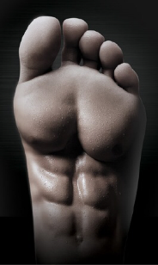
- Focus is on strong feet, not just orthotics!
EBFA Barefoot Technology, Anatomy Trains, Foot Manual Therapies

Our Team:
Dr Suresh Sivacolundhu (Principal Podiatrist)
Dr Lauren Merritt (Senior Podiatrist)
Dr Harriet Berman (Podiatrist)
Dr Aloysius Ong (Podiatrist)
Shari Norrish (Practice Manager)
Vicki Thomson (Front Office Administrator)

(photos, contact details)

The Foot Clinic Way
Our pathway to strengthen postural foundations, to create lasting changes for freedom of movement, and ultimately keep us going well beyond what we thought was possible (updated as research and tech changes).

Fix Your Feet
- Fix the pain
Provide analgesia
Reduce inflammation
Corn/callus/foreign body removal
Ingrown/thickened toenail repair and maintenance
Surgery
- Protect the feet (reduce damage, optimise stability, promote healing)
Reduce tissue damage
Optimise Foot Posture
Activate neuromuscular/reflexive balance stability
Promote tissue repair/cellular regeneration
- Strengthen the feet (increase strength and resilience)
Strengthen intrinsics
Connect foot strength to core strength
Stimulate neuromuscular strength
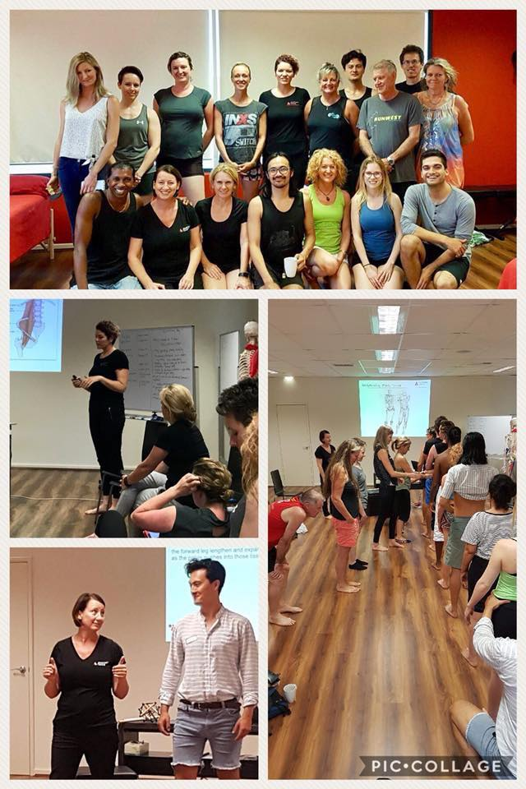
Biohack Your Body
- Protect the whole body (stability)
Optimise Postural Alignment
Activate neuromuscular/reflexive balance stability
Customised corrective exercises
Improve cellular regeneration
Optimise nutrition/healthy gut
Optimise healthy mind
- Strengthen the whole body (strength, elasticity)
Strengthen the deep core (stabilisers)
Strengthen the outer core (mobilisers)
Increase fascial elasticity/strength
Increase functional strength
Increase endurance
Customised nutrition for specific performance
Improve psychological resilience
- Repeat consistently
Our Team Achievements:
- Director, Sports Medicine Australia (SMA)
- Director, Australasian Academy of Podiatric Sports Medicine (AAPSM).
- External Advisor, UWA Podiatric Medical Unit
- EBFA Level 1 Barefoot Rehabilitation Instructor
- Foot Manual Therapies trained
- Anatomy Trains trained
- Class 3b Laser Certified

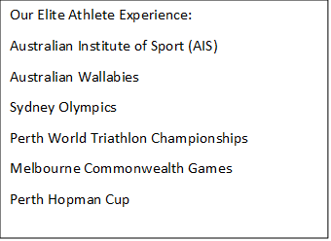
Referral Partners Required:
- Massage therapists
Deep tissue and remedial massage
Therapeutic massage
- Fascial therapists
Anatomy trains fascial releases to reset the alignment of the whole body
- Physiotherapists
Pain relief, protect and strengthen both lower limb and upper limb
- GP, Sports Physicians
General health, diagnostics, treatment support, prescription medications
Specialist referrals
- Osteopaths and chiropractors
Mobilisation and manipulative therapy for the spinal column and limbs
- Dietician and nutritionists
DEXA scan for bone density/lean mass/fat mass
Optimising gut health and nutrition - You are what you eat!
- Psychologists/psychiatrists
Sometimes our physical body cannot get better until we optimise a healthy mind
- Personal trainers, Pilates and yoga instructors
Create awesome body strength, flexibility and resilience
- Surgeons
When conservative methods are ineffective, surgical intervention works well.

TFC LOGO SMA LOGO AAPSM LOGO ANATOMY TRAINS LOGO EBFA LOGO HIVE LOGO

