Rowville Secondary College
Houses
- Mabo (yellow)

Eddie Mabo: known for his role in campaigning for Indigenous land rights and for his role in a landmark decision of the High Court of Australia which overturned the legal doctrine of terra nullius. 1936- 1992
“I laid in bed thinking about the future. How I would like it to be, even if I am not there.”
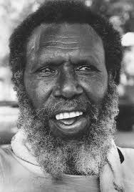
- Stynes (blue)
Jim Stynes: one of AFL’s most prominent figures who won the Brownlow Medal in 1991. Off the field, he was a notable AFL administrator, philanthropist, charity worker and writer. 1966-2012
“I love life. There’s always something to overcome, new people to meet… You’ve just got to find your bliss and go after it. That’s where the drive is, that’s how you find your special place.”
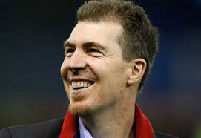

- Walton (green)
Nancy-Bird Walton AO, OBE: a pioneering Australian aviatrix, known as "The Angel of the Outback", and the founder and patron of the Australian Women Pilots' Association. 1915-2009

“As a small child I used to dream I could fly. I could dream I could lift myself up over the telegraph poles when the lions and tigers were chasing me in my childish nightmares”
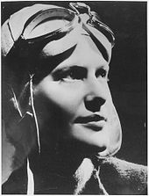

- Aston (red)
Tilly Aston: a blind Australian writer and teacher, who founded the Victorian Association of Braille Writers 1873-1947
“Poor eyes limit your sight. Poor vision limits your deeds.”
