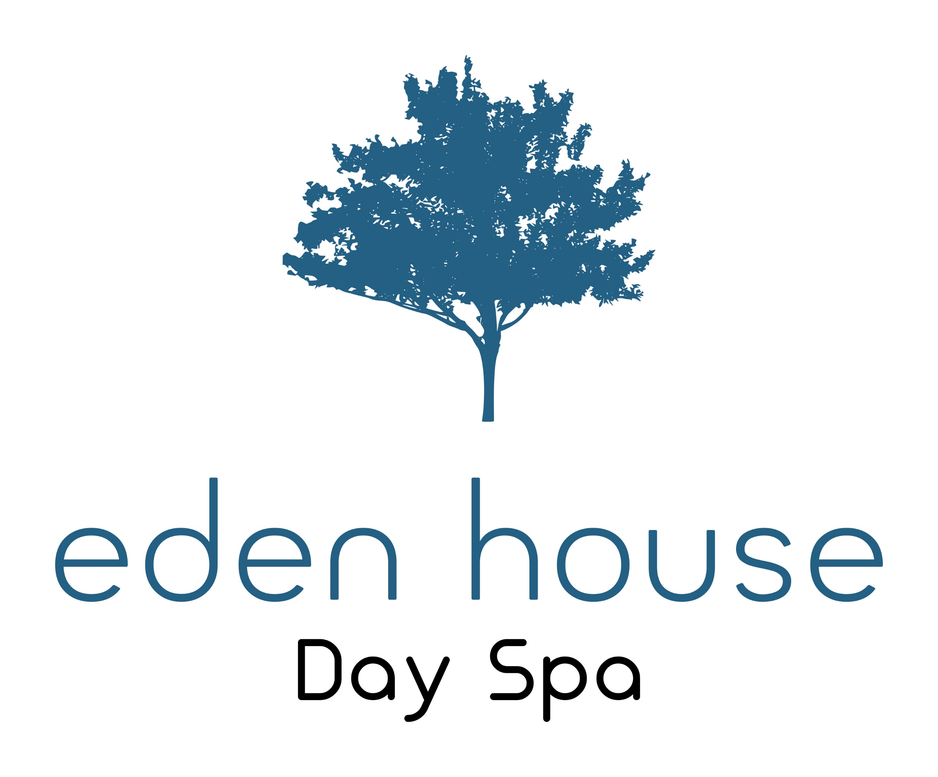

Welcome to Eden House Day Spa. We are situated in the heart of the beautiful seaside town of Hastings in East Sussex. Conveniently placed for access to nearby bars and restaurants, the beach is only a short walk away. Eden House Day Spa invites you to relax and unwind in our peaceful setting, let us pamper you and restore your feelings of calm and wellness.

Our Treatment Menu

Waxing
Eyebrow £12.00
Lip and Chin £7.00
Full Face £12.00
Under Arm £10.00
Half Leg £16.00
Three Quarter Leg £20.00
Full Leg £23.00

Men’s Waxing
Full Back £25.00
Chest £22.00
Half Back £13.00
Chest and Tummy £25.00

Electrolysis
An electric current is applied using a very fine needle-shaped electrode or metal probe into each hair follicle with the mission to destroy the hair’s root

10 minutes £15.00
Course of 1 hour £80.00

Laser Hair Removal
Our laser treatments will give you hair free results within 6 to 12 sessions, dependent on your hair type. We offer a free consultation to discuss your individual needs.
A Patch Test is required
Book for a course of 6 treatments only pay for 5

Facial One Area £27.50
Facial Two Areas £44.00
Facial Three Areas £66.00
Full Face £82.00
Under Arm £44.00
Standard Bikini £55.00
Brazilian £66.00
Hollywood £77.00
Half Leg £88.00
Full Leg £120.00
Half Back or Chest £120.00
Half Arm £70.00
Full Arm £100.00
Hands and Feet

House Manicure
This relaxing and soothing treatment for your hands includes cuticle care, nail shape, hand and arm massage and is finished with a polish of your choice:
Standard Polish £25.00
Shellac Polish £35.00

House Pedicure
This relaxing foot treatment includes removing the hard skin from your feet, your feet will be exfoliated leaving them softer and smoother, your cuticles will be groomed and your toe nails will be beautifully shaped and polished with a polish of your choice:

Standard Polish £32.00
Shellac Polish £42.00
Why not add a luxury peppermint soak to your pedicure to refresh and revive tired feet….
Peppermint Soak £5.00

Nails

Eyes and Ears

Ear Piercing
Both Ears £25.00
One Ear £15.00

Hopi Ear Candle Treatment
This treatment involves candles for both ears followed by a facial massage concentrating on the sinuses
£30.00

Eyebrows and Lashes
Eyebrow Wax £12.00
Eyebrow Tint £14.00
Eyelash Tint £20.00
Eyebrow Wax and Tint £22.00
A patch test for tinting is required

Eyelash Lift
The lash lift is designed to create the illusion of longer and thicker lashes without the need for extensions. The results are immediate and you can expect the effects to last for up to six weeks.
Eyelash Lift £40.00
Eyelash Lift with Tint £50.00

Classic Lashes
Classic Lashes are one extension applied to one natural lash only, therefore if you only have 50 suitable natural lashes per eye then you will achieve a look of 50 eyelash extensions. If you have 100 natural lashes per eye the you will achieve a look of 100 extensions per eye.
A free consultation before treatment can help determine if this treatment is right for you.

Classic Lashes £40.00

Russian Lashes
Russian lash extensions are fast becoming a very popular treatment and are perfect for those that want fuller, softer looking lashes with amazing depth

A free consultation and a patch test before treatment can help determine if this treatment is right for you

Russian Lashes £75.00

Facials

House Natural Facial
A wonderful facial with our unique releasing, draining and muscle lifting movements. This beautiful treatment incorporates our neck and shoulder release. This is a truly relaxing experience.
£40.00

Herbal Power Facials
When Herbal Power Peel is massaged into the skin it creates a controlled micro irritation that activates a wound healing response. The skin becomes flushed and sensitive due to the increased blood circulation in the treated skin. It is the necessary inflammatory cells that fight aging and eliminate the old skin cells of devitalised tissue. Wound healing responses stimulate new cell growth and improves skin tone and texture. Old debilitated and dead cells are exfoliated from the skin’s outer layer without harming the younger living cells resulting in clearer, softer and smoother skin. This results in cell turnover which normally is a goal of acne and anti-aging therapies.
Herbal Power Peel does not contain any skin lighteners.
Fresh Up Facial £45.00
Deep Peel (includes complementary follow up facial one week later) £125.00

