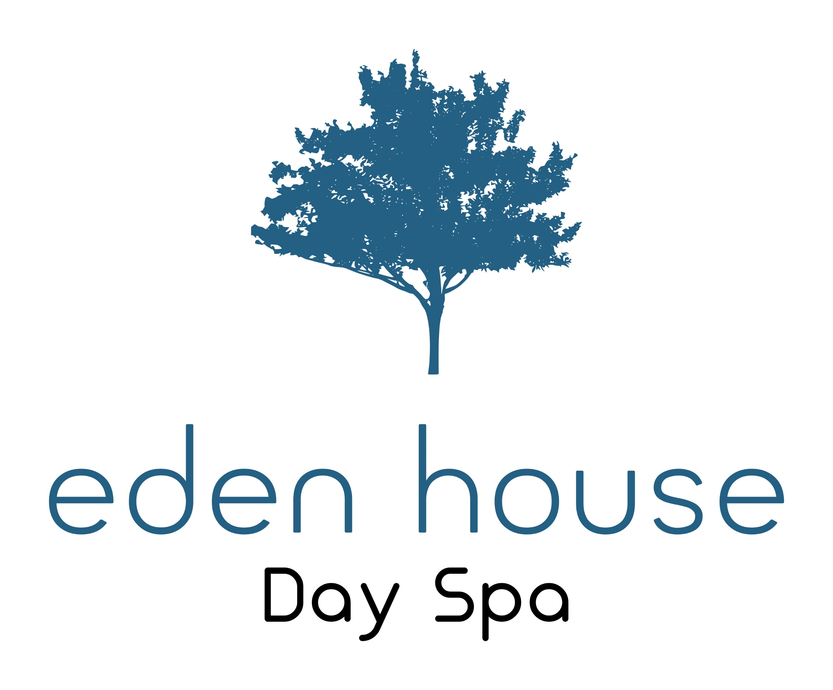

Welcome to Eden House Day Spa. We are situated in the heart of the beautiful seaside town of Hastings in East Sussex. Conveniently placed for access to nearby bars and restaurants, the beach is only a short walk away. Eden House Day Spa invites you to relax and unwind in our peaceful setting, let us pamper you and restore your feelings of calm and wellness.

Our Treatment Menu

Waxing
Eyebrow £12.00
Lip and Chin £7.00
Full Face £12.00
Under Arm £10.00
Half Leg £16.00
Three Quarter Leg £20.00
Full Leg £23.00

Men’s Waxing
Full Back £25.00
Chest £22.00
Half Back £13.00
Chest and Tummy £25.00

Electrolysis
An electric current is applied using a very fine needle-shaped electrode or metal probe into each hair follicle with the mission to destroy the hair’s root

10 minutes £15.00
Course of 1 hour £80.00

Laser Hair Removal
Our laser treatments will give you hair free results within 6 to 12 sessions, dependent on your hair type. We offer a free consultation to discuss your individual needs.
A Patch Test is required
Book for a course of 6 treatments only pay for 5

Facial One Area £27.50
Facial Two Areas £44.00
Facial Three Areas £66.00
Full Face £82.00
Under Arm £44.00
Standard Bikini £55.00
Brazilian £66.00
Hollywood £77.00
Half Leg £88.00
Full Leg £120.00
Half Back or Chest £120.00
Half Arm £70.00
Full Arm £100.00
Hands and Feet

House Manicure
This relaxing and soothing treatment for your hands includes cuticle care, nail shape, hand and arm massage and is finished with a polish of your choice:
Standard Polish £25.00
Shellac Polish £35.00

House Pedicure
This relaxing foot treatment includes removing the hard skin from your feet, your feet will be exfoliated leaving them softer and smoother, your cuticles will be groomed and your toe nails will be beautifully shaped and polished with a polish of your choice:

Standard Polish £32.00
Shellac Polish £42.00
Why not add a luxury peppermint soak to your pedicure to refresh and revive tired feet….
Peppermint Soak £5.00

Nails
File and Paint Hands or Feet £15.00
File and Paint Shellac on Hands or Feet £18.00

Full Set of Gel Nail Extensions £35.00
Infills (from) £20.00
Individual Nail Repair £3.00

Eyes and Ears

Ear Piercing
Both Ears £25.00
One Ear £15.00

Hopi Ear Candle Treatment
This treatment involves candles for both ears followed by a facial massage concentrating on the sinuses
£30.00

Eyebrows and Lashes
Eyebrow Wax £12.00
Eyebrow Tint £14.00
Eyelash Tint £20.00
Eyebrow Wax and Tint £22.00
A patch test for tinting is required

Eyelash Lift
The lash lift is designed to create the illusion of longer and thicker lashes without the need for extensions. The results are immediate and you can expect the effects to last for up to six weeks.
Eyelash Lift £40.00
Eyelash Lift with Tint £50.00

Classic Lashes
Classic Lashes are one extension applied to one natural lash only, therefore if you only have 50 suitable natural lashes per eye then you will achieve a look of 50 eyelash extensions. If you have 100 natural lashes per eye the you will achieve a look of 100 extensions per eye.
A free consultation before treatment can help determine if this treatment is right for you.

Classic Lashes £40.00

Russian Lashes
Russian lash extensions are fast becoming a very popular treatment and are perfect for those that want fuller, softer looking lashes with amazing depth

A free consultation and a patch test before treatment can help determine if this treatment is right for you

Russian Lashes £75.00

Facials

House Natural Facial
A wonderful facial with our unique releasing, draining and muscle lifting movements. This beautiful treatment incorporates our neck and shoulder release. This is a truly relaxing experience.
£40.00

Herbal Power Facials
When Herbal Power Peel is massaged into the skin it creates a controlled micro irritation that activates a wound healing response. The skin becomes flushed and sensitive due to the increased blood circulation in the treated skin. It is the necessary inflammatory cells that fight aging and eliminate the old skin cells of devitalised tissue. Wound healing responses stimulate new cell growth and improves skin tone and texture. Old debilitated and dead cells are exfoliated from the skin’s outer layer without harming the younger living cells resulting in clearer, softer and smoother skin. This results in cell turnover which normally is a goal of acne and anti-aging therapies.
Herbal Power Peel does not contain any skin lighteners.
Fresh Up Facial £45.00
Deep Peel (includes complementary follow up facial one week later) £125.00

House Booster Facial
A little taster of our products and massage. A perfect add on to any massage
£27.50

Microdermabrasion
Using the diamond method, one of the most popular cosmetic skincare treatments available is microdermabrasion – a procedure that is praised by women and men alike. No chemicals or aesthetics are used in the procedure, which is known for being simple and pain free. It’s appropriate for most skin types because it is non-invasive and can effectively reduce or eliminate wrinkles, acne, age spots, stretch marks and more…

Microdermabrasion £42.00

Micro-Green Facial
This treatment incorporates Power Herbs and Microdermabrasion and is only suitable for thickened, acne scaring or heavily damaged skin.

Micro-Green Facial £49.00

CACI Non-Surgical Facelift
An Award Winning Anti-Aging Treatment
The most advanced multifunctional face toning system available. Micro-current regenerates muscle tone and encourages cell repair.
Non-Surgical Facial £50.00
Eye CACI £22.00
Jowl CACI £22.00
Super CACI £65.00

Hydratone
Hydratone combines active micro-current rollers with a unique, electrically conductive silicone gel mask that has been infused with powerful hydrating properties. The energy delivered by the rollers:
- Recharges and replenishes the bio-electrical energy within the facial muscles
- Restores tone and firmness
- Drives the hydrating actives contained within the gel mask deep into the skin tissue
The gel mask has a dramatic softening action helping to plump put and smooth deep lines and wrinkles.

Hydratone Facial £30.00
Hydratone mask added to CACI Non-Surgical Facial £15.00

Cryosthetics

The Coolifting gun shoots the facial tissues with a powerful CO2 flow at a very low temperature and a high pressure combined with an extremely high concentration of atomised actives. This is a spectacular and fast treatment.
After this treatment we recommend that you do not touch your face or apply make up until the following day.
Individual treatment £50.00
Course of six £250.00

Pigmentation Removal
The Accurett Pen is an advanced Cryotherapy innovation that is fast, effective, safe and a new solution for removal of superficial skin imperfections. Treatments are priced per vile used.

Per Vile £40.00

Thread Vein and Skin Tag Removal
Using advanced electrolysis, a wide variety of skin blemishes can be quickly treated with effective and often immediate results.
20 Minute Treatment £40.00

Microblading
Microblading is the latest and hottest technique within the semi-permanent make up industry and has taken the beauty world by storm!
Microblading is a semi-permanent eyebrow procedure that implants pigment under the epidermis using a specially designed hand tool which holds sterile disposable microblades.
Microblading deposits colour closer to the surface than a conventional machine, leaving very fine and crisp hair strokes with no spilling under the skin.
Microblading is ideal for anyone wanting to enhance the look of their eyebrows regardless of the amount of hair present.
People suffering from Alopecia, undergoing Trigonometrical Chemotherapy or any other condition that causes hair loss may benefit greatly from Microblading, as well as people who are simply not happy with their eyebrow shape.
Microblading can create almost any look, from a very natural light finish to beautifully bold brows.

A patch test is required 48 hours before treatment

The complete treatment is divided up into 4 or 5 appointments:
Initial Consultation and Patch Test £50.00 (Deposit for rest of treatment)
First Treatment £110.00
Follow Up (4-6 weeks later) £50.00
Fresh Up (4-11 months later) £75.00
Fresh up (1 year later) £99.00

Semi-Permanent Make Up (Digital)
Semi-permanent make up may last between 9 and 18 months. The pigment we use is natural, mineral based and non-toxic meaning the treatments are hypoallergenic.
We use 3D effect strokes to produce the most natural enhancement. The treatment is in 2 stages, the first treatment is followed 4-6 weeks later by a top up treatment to perfect the look.
There are different looks that can be achieved

Ombre Brows (Full Shading) £165.00
Hair Stroke Brows £165.00
Ombre Brow with Hair Strokes £195.00
Lip Liner £165.00
Full Lip Colour £195.00
Full Lip Follow Up £80.00
Follow up visit (4-6 weeks later) £60.00
Fresh Up (4 – 11 months later) £75.00
Fresh Up (1 – 2 years later) £99.00

Massage
Our aim is to transport you to a magical place of deep relaxation, far from the stresses of everyday life…..
We incorporate Deep Tissues, Aromatherapy and our unique neck and shoulder massage.

Back, Neck and Shoulder Massage £25.00
Back of Body Massage £35.00
Full Body Massage £46.00
Indian Head Massage £35.00
Full Body Massage and Indian Head Massage £70.00

Aroma Stone Massage
Hot Stone Massage is a speciality massage where the therapist uses smooth, heated stones as an extension of their own hands or by placing them on the body. The heat can be deeply relaxing and help warm up tight muscles so the therapist can work more deeply.
Aroma Stone Full Body Massage £56.00
Aroma Stone Back of Body Massage £40.00
Aroma Stone Back Massage £30.00

Lava Shell Massage
The warming Lava Shells back massage uses a gentle heat in porcelain shells in conjunction with your therapist’s hands to promote a feeling of relaxation and improve wellbeing. A beautifully pampering warm experience.
Warming Back Massage £35.00

Face and Body Sensation
Drift off with this Back of Body Hot Stone Massage followed by our Booster Facial
£60.00

Face and Body Condition
Full Body Brushing, all over exfoliation, warm mitt removal and all over moisturise followed by a facial cleanse exfoliation and moisturise.
£60.00

Spa Packages
The Uplifter £62.00
Back Massage
Facial Massage
Indian Head Massage

Time Out £50.00
Indian Head Massage
Lower Leg Massage
File and Paint Toes

Holiday £100.00
Face and Body Condition
Manicure
Pedicure

Pamper £40.00
Booster Facial
Arm and Leg Massage
Perfect for Mum to Be!

Hen Party Packages
Prices are per person

Bronze £75.00
House Natural Facial
Back, Neck and Shoulder Massage
Manicure Shellac File and Paint

Silver £90.00
Back of Body Massage
Booster Facial
Manicure Shellac File and Paint

Gold £110.00
Full Body Massage
House Natural Facial
Manicure Shellac File and Paint

Platinum £150.00
Aroma Stone Full Body Massage
House Natural Facial
Manicure Shellac File and Paint
Pedicure Shellac File and Paint

