Overall: We want to have a professional look with the website. We want it to feel family friendly, but not with a super over-the-top cartoony look. We’d want to be more on the corporate side while still being approachable.

Pages:
- Home page
- 1 inner page
- 1 FAQ style page
- 1 contact page

Sitemap:
- Home
- Why Pinch Home Buyers
- How It Works
- Reasons to Sell
- Locations
  - Southern California
    - Los Angeles County
    - Orange County
    - San Bernardino County
    - Riverside County
  - Northern California
    - Contra Costa County
    - Alameda County
    - Stanislaus County
    - Sonoma County
    - Napa County
    - Solona County
    - Santa Clara County
    - Merced County
    - Sacramento County
    - San Joaquin County
    - San Mateo County
7. FAQ
8. Contact

Homepage Wireframe:
- Above the fold
- Reasons to Sell
- Why Us / Value Props
- Single Call Out
- How It Works
- Video
- Reviews
- FAQ
- Contact Form
- Footer

Good Competitor to look at:
https://www.opendoor.com
https://www.homelight.com/
https://highestcashoffer.com

--- START SPECS ---



Color Palette:

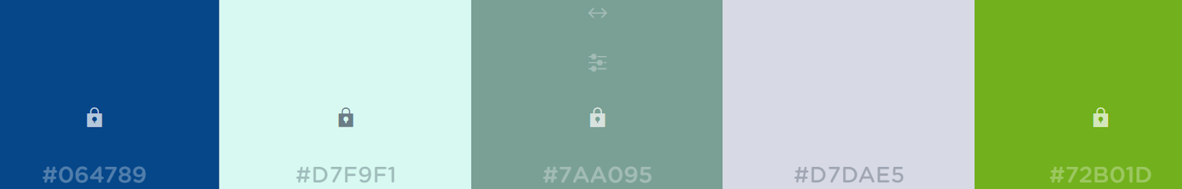

Above the Fold:
How we design the section above the hold will play a lot into that.]
- Logo in the top left corner
- Page names across the top nav
  - Home
  - Why Pinch Home Buyers
  - How It Works
  - Reasons to Sell
  - Locations
  - FAQ
  - Contact
- Phone number in the right corner: (888) 888-9999
- Main tagline will be: We Buy Homes From People in a Pinch!
- Supporting text will be: Get your cash offer today.
- Seach: We want to have a search field, but again not have it visually look like The Nerds
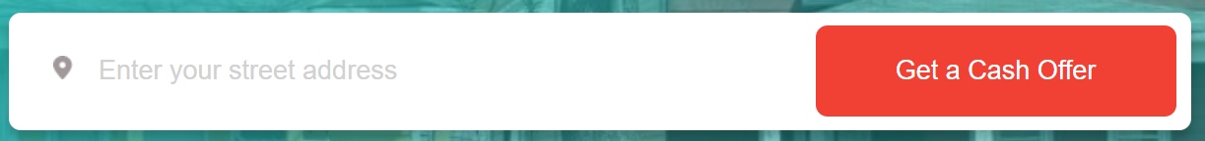
- Here are some ideas of other search bars we found that we could play around with:
  - Different box shape: https://www.awwwards.com/sites/vkb-immobilien
  - Inverted colors: https://www.awwwards.com/sites/oboosho
  - Another different shape: https://www.awwwards.com/sites/intercontinental-wharf
- Imagery: We want to find a nice stock image of a home you’d see in California. We can look for something in Southern California (i.e. spanish tile roof, non-brick, etc.). If we can incorporate the pinch concept from their logo somehow that would be cool.

Reasons to Sell:
[I like how the information is displayed in this section. I feel like our content will work great in this space. You are of course have creative freedom should you think something else would look better.]
- Title: Thinking of Selling?
- Subtext: No matter your situation, we will buy your home. No need to worry about the condition of the house either - we’ll make this a stress-free process and get you cash quickly.
- Points:
  - Retirement -
  - Downsizing or Upsizing -
  - Divorce -
  - Inheritance - Have you inherited a home and you don’t want to worry about the headache that comes with it? Sell it to the Pinch Home Experts!
  - Massive Repairs - Is your home too much to manage? No problem; our team is happy to take it off your hands.
  - Bad Mortgage - Selling your home is a great way to get out of your current mortgage quick.
  - Probate -
  - Moving - Sometimes you just want to move and that’s okay too! Let us help you get into your dream home.
- Call to Action Button: More Reasons to Sell

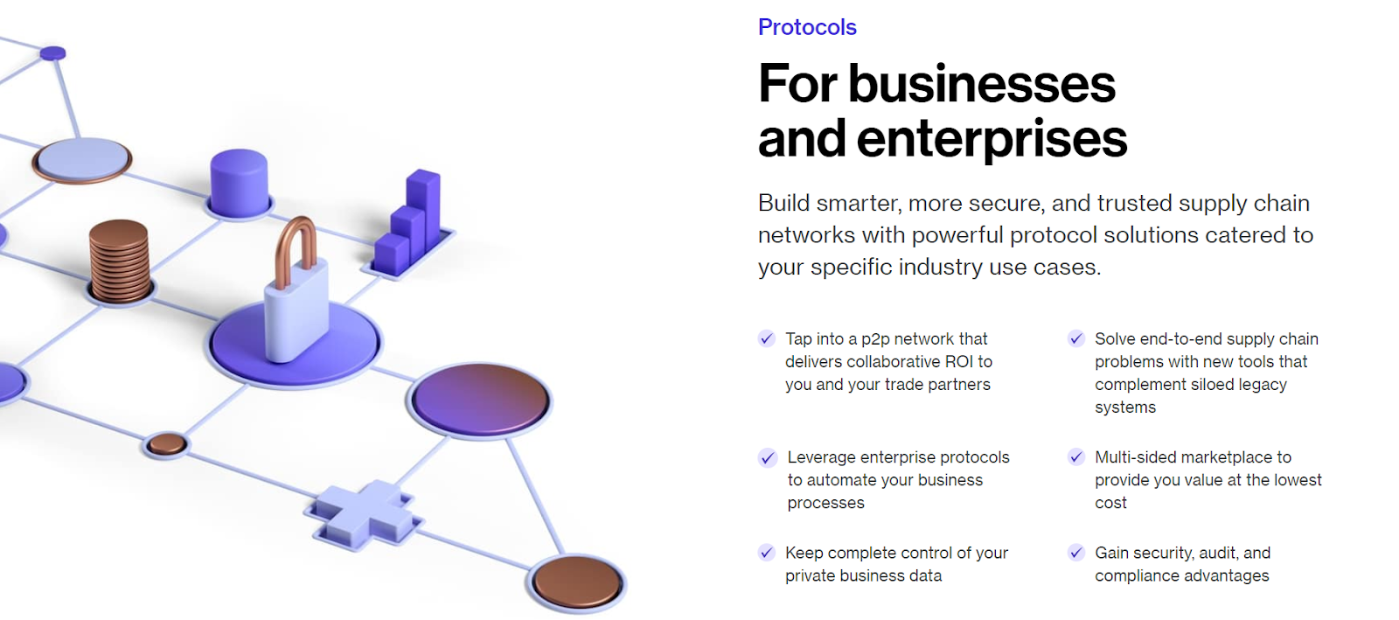

Why Us?
- Header: Reasons People Work with Pinch
- Subtext: Benefits of working with us over a realtor.
- Points:
  - Quick Turnaround
  - Zero Fees
  - Stress & Hassle Free
  - Cold Hard Cash Fast
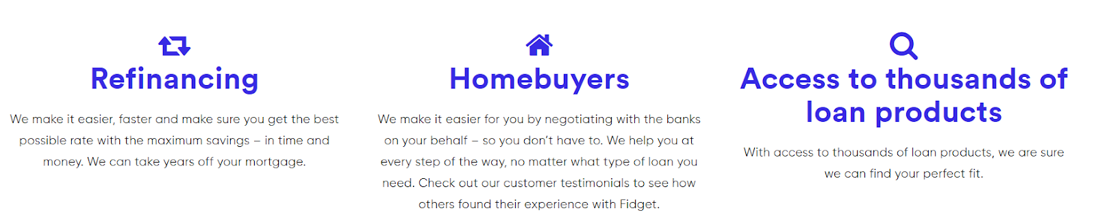

Single Call Out:
[Depending on how you’ve designed things so far, it may be good to invert this section so it has a solid color background to break up the space, if you’ve been designing with a lot of white. We want this call out to stand on its own and be bold.]
- Large text: We’re the experts you turn to in a pinch.
- Button text: Get Started
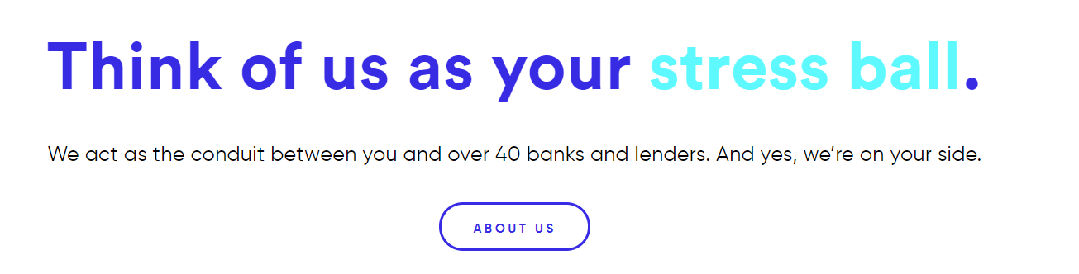
How It Works:
- Header: How It Works
- Points:
  - Call or Email Us
  - Speak to a Pinch Expert
  - Schedule a Quick Walk-Through
  - Receive a Cash Offer
  - Get Paid

Video:
[If it makes visual sense to combine the video with the how it works section we’re open to that.]
- Header: Close as Fast as 7 Days!
- Client will be providing us with a BA video to use!

Reviews:
[Let’s get a scrolling feed here. They have a ton of reviews we can use. Feel free to use placeholder lorem ipsum text if you want to showcase more in the meantime. Example testimonial below.]
- Header: Reviews
- Subtext: Hear from satisfied sellers.
- Example Review: “Smooth, easy, fast.”
I was hesitant of the whole deal, because it seemed too easy. And now that I’m at the final sale, if Todd tells you he’s doing it, he’s doing it. It’s that simple.” - Ryan

FAQ:
- Header: Questions?
- Subtext: We have the answers.
- Points:
  - How fast does this work?
  - What are your fees?
  - What if my home is not in good shape?
- Button text: More FAQs

Contact Form:
- Title: Contact Us
- Subtext: Speak with a Pinch Expert today.
- Fields:
  - Full Name
  - Phone
  - Email
  - Street Address
  - City
  - State
  - Zip
- Button: Get a Cash Offer

Footer:
- We’ll list all of their basic contact information:
  - Business Name
  - Phone #
  - Social Links: Youtube, Facebook, Instagram, BBB
- At the bottom you can add a copyright and a generic disclaimer.

Additional Color Options:

