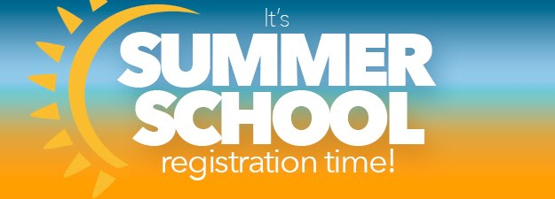

June 22 & 23, 2019

Lose the dunce cap and put on your helmet, it’s time for Summer School! Get your summer kicked-off right with two days of High Performance Drivers Education at High Plains Raceway! We will have space for up to 30 first-time drivers, in addition to the usual run groups. We also plan to walk the track Saturday night, which will be a great opportunity to learn High Plains Raceway up close and personal, and get insider tips from some of RMR’s most experienced drivers.

Our charity for this event is The Cottonwood Institute- Your donations empower students to be environmentally aware and civically engaged. Cottonwood Institute believes that students can't be expected to care about the environment if they never have a chance to explore the outdoors.

