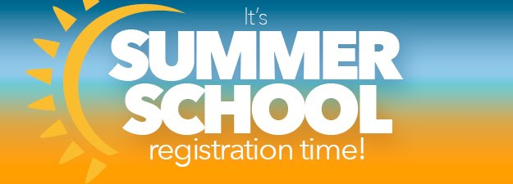

June 22 & 23, 2019

Registration is now open on motorsportreg !!

Lose the dunce cap and put on your helmet, it’s time for Summer School! Get your summer kicked-off right with two days of High Performance Drivers Education at High Plains Raceway! We will have space for up to 30 first-time drivers, in addition to the usual run groups. We also plan to walk the track Saturday night, which will be a great opportunity to learn High Plains Raceway up close and personal, and get insider tips from some of RMR’s most experienced drivers.

So, if you missed our May event, here’s your chance to knock the dust off those race tires! We also need volunteers to help us run the event. If you’ve been curious about the track, volunteering is a great way to see what goes on, and help the Club! Also, check out our lower cost option for early registration!

Our charity for this event is The Cottonwood Institute- Your donations empower students to be environmentally aware and civically engaged. The Cottonwood Institute believes that students can't be expected to care about the environment if they never have a chance to explore the outdoors.

Event Co-Chairs: Brian Bobich snobdr82@aol.com and Brian Lay brian.g.lay@gmail.com
Chief Driving Instructors: Dave Stribling strib81@yahoo.com, Dan Carlson dcarlson@rgare.com, and Brian Leary beleary36@yahoo.com

Please contact the Co-Chairs or Chief Driving Instructors with any questions.

Location: High Plains Raceway, 17 miles east of Byers on US-36 (Deer Trail)
Event Registration Fees
Saturday or Sunday-only Each Driver $205
Both days Each Driver $325
A Saturday night dinner is also available for $15

