Why Dritech?

Today’s communication landscape is dramatically different than it was a mere ten years ago. We use our phones less and less for making calls. In fact, it is reported that 70% of direct communication is through text messaging, not phone calls; with text messaging increasing in use by %7,700 since 2008. No surprise here.
Think of the phone call process; auto attendant, “…choose 1 for…”, “…if you know the extension…”, “…spell the name…”, “…to hear a directory…”, etc.; ugh. I don’t know about you but when I finally get to the person I want to speak with, I often forget why I called in the first place. And let’s not get started on voicemail; I mean really, who likes leaving a voice message let alone retrieving one.
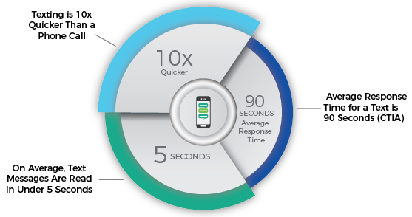
The average length of a phone call has sharply decreased since 2006. That’s because it’s easier to swap a bunch of short messages than it is to interrupt each other’s work at hand with a phone call. Furthermore, 99% of text messages are read while only 33% of voicemail messages are heard; 95% of text messages are read within 3 minutes and, on average, responded to within 90 seconds.
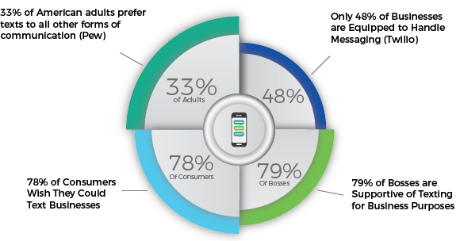
One of the many ways that Dritech is bringing technology to its trade is through communication tools. A single point of contact gets you where you want to go. We distribute the text and email internally. Not only that, we share equal access to our communication points to hold each other accountable for their respective responsibilities. This flow of information is a more efficient, effective, and direct.

Try it now!
TEXT
604-300-6744
EMAIL
dritech@dritechwallsandceilings.com

