

ErrorCast™

The Bureau of Internet Accessibility (BoIA) has been helping eliminate the digital accessibility divide since 2001. We have analyzed more than 51,000 websites and our reports, tools, and services help our clients ensure that their sites are accessible to everyone, regardless of any particular disability or impairment.

Now, we’re offering our exclusive ErrorCastTM report, custom-tailored to your website, to help your organization identify and rectify digital accessibility risks.

ErrorCast™ is the most cost-effective first step on your path to compliance.

Quick facts:

- Failure to comply with Web Content Accessibility Guidelines (WCAG) 2.1 Level A/AA could result in tens of thousands of dollars (per incident) in legal fees from pending lawsuits.
- Last year the number of website accessibility lawsuits increased by 177% vs. 2017.
- In New York state alone, 1,564 lawsuits were filed alleging websites were not accessible to the blind or visually impaired.
- The cost of making websites accessible ranges from several thousand dollars to a few million dollars, depending on the complexity of the site.
- And while numerous big-name companies have been sued (CNN, Burger King, Amazon, Hershey, Nintendo, Pandora, Mitsubishi, Bed Bath & Beyond, Dow Jones, Kmart, Grubhub, Blue Apron, CVS, Domino’s, Hulu, Reebok, eHarmony, Bank of America, Safeway, Ace Hardware, and hundreds more), small businesses also face great risk.
- Trying to meet WCAG guidelines without the advantage of ErrorCast™ could result in a tremendous amount of wasted time, money and effort. Don’t go it alone.

The Americans with Disabilities Act (ADA) is a comprehensive federal civil rights law prohibiting discrimination on the basis of disability, enforced by the Department of Justice (DOJ). The ADA prohibits discriminatory lack of access for individuals with disabilities to goods and services of public services and accommodations. Websites are considered places of public accommodations. The DOJ currently uses WCAG 2.1 Level A/AA as an accepted standard by which to measure a website’s accessibility.



WCAG 2.1 Level A/AA consists of 13 guidelines with 50 checkpoints that are organized under four principles:

Principle 1: Perceivable
Information and user interface components must be presented to users in ways they can perceive. This means that users must be able to comprehend the information being depicted: It can’t be invisible to all their senses.

Principle 2: Operable
User interface components and navigation must be operable: The interface cannot require interaction that a user cannot perform.

Principle 3: Understandable
Information and the operation of a user interface must be understandable: Users must be able to understand the information as well as the operation of the user interface.

Principle 4: Robust
Content must be robust enough that it can be interpreted reliably by a wide variety of user agents, including assistive technologies: As technologies and user agents evolve, the content should remain accessible.

Start your journey to a fully compliant website with ErrorCast™. This detailed compliance and remediation report is generated based on scanning your website against hundreds of carefully-crafted rules, logging failures, and then generating feedback and recommendations on how to fix the problems based on our years of experience and proven best practices.

The ErrorCast™ report is designed to be shared with your executive team and stakeholders. It is divided into two sections to build knowledge and self-sufficiency.
- The first section provides a detailed analysis of your website per the WCAG 2.1 A/AA principles and includes an at-a-glance Summary Chart for your executive team.
- The second section is designed specifically for your website development team, providing them with detailed examples of problematic issues, suggested ways to fix them, and links for more detailed training.

Section 1
The first section of the report begins with a Summary Chart that breaks down WCAG 2.1 A/AA issues by principle:

Example WCAG 2.1 A/AA Summary Chart
Checkpoints with failures detected are identified in the "Issues Discovered" column. The detail behind these failures is available in the next section.

Principle | Guideline | Issues Discovered
Perceivable | Guideline 1.1 Text Alternatives | 1.1.1
Perceivable | Guideline 1.2 Time-based Media | 1.2.1 1.2.2 1.2.3 1.2.4 1.2.5
Perceivable | Guideline 1.3 Adaptable | 1.3.1 1.3.2 1.3.5
Perceivable | Guideline 1.4 Distinguishable | 1.4.1 1.4.3 1.4.4 1.4.11
Operable | Guideline 2.1 Keyboard Accessible | 2.1.1 2.1.2
Operable | Guideline 2.2 Enough Time | 2.2.1 2.2.2
Operable | Guideline 2.4 Navigable | 2.4.1 2.4.2 2.4.4 2.4.7
Understandable | Guideline 3.1 Readable | 3.1.1
Understandable | Guideline 3.2 Predictable | 3.2.1 3.2.2
Understandable | Guideline 3.3 Input Assistance | 3.3.2
Robust | Guideline 4.1 Compatible | 4.1.1 4.1.2

The report then provides full detail about the specific infractions organized by each of the four principles and explains exactly what the problems are. Example:

Principle 1 - Perceivable
Information and user interface components must be presentable to users in ways they can perceive. This means that users must be able to perceive the information being presented (it can't be invisible to all of their senses). Provide text alternatives for non-text content. Provide captions and other alternatives for multimedia. Create content that can be presented in different ways, including by assistive technologies, without losing meaning. Make it easier for users to see and hear content.

Guideline 1.1 Text Alternatives
Provide text alternatives for any non-text content so that it can be changed into other forms people need, such as large print, braille, speech, symbols or simpler language.

Issue: Field Element Labels

Each form control should be explicitly associated with its label.
Form fields must be associated with their labels. Issue is relevant to checkpoints: 1.1.1 (A), 1.3.1 (A), 4.1.2 (A), 3.3.2 (A)
The specifics of the failure and a code snippets pinpoint within the code where the issue resided.

Example: http://www.un.org/en/events/childrenday/
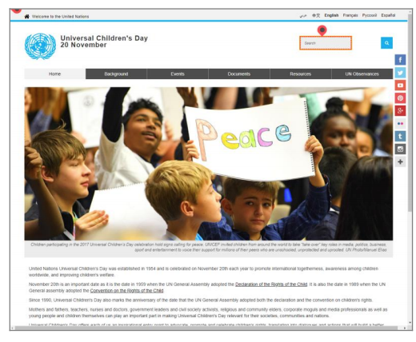  Actual screen shots of your website pages are shown so you can see exactly where the “Issues Discovered” are present | Specifics:  Each form field should be explicitly associated with its label. Found No explicit Label provided <INPUT> Tag type=text id='search-sm' .  Code snippet  <input class="search-control form-control" type="text" name="q" id="search-sm" onfocus="this.value='';" value="Search">

Section 2
The next section of the report is designed specifically for your developers and programmers who will be in-the-trenches fixing the actual issues. The issues are prioritized and organized by six themes:

- Media: problems related to imagery, video and plug-ins.

- Structure: problems related to HTML layout markup and positioning of data.

- Text: problems related to actual textual content and its comprehension.

- Scripting: problems related to Scripting. e.g. in JavaScript code.

- CSS: problems related to Cascading Style Sheets & inline Styles.

- Form: problems related to Form controls, navigability & comprehension.

Within each classification above, we provide specific details about each violation found, which URLs they were present on, code snippets, and screenshots showing you the actual violation.

Remediation advice is then given to you with resource links and explanations of the guidelines your website doesn’t meet.

The following pages provide six examples of how our ErrorCast™ report shows you how to fix the violations based on the classifications listed above.

Media
Ensure that all Media items such as animations/video and audio have an alternative means of understanding the content.
- Provide a text alternative for either via a transcript, audio description, sign language, or captioning (open or closed.)
- Additionally, any content provided through an object, Embed, or Applet (or similar 3rd party plugin) must be checked for appropriate keyboard accessible controls.
We test for hundreds of issues. Each issue that is discovered is detailed under its specific classification

Issue: Image Link Text (priority 2)

Image ALT attribute text of images within links should not duplicate the text of the link body (link text.).
Don't use the same text in an image ALT as the link containing the image. If the link text and the image alt are the same, this creates a "stutter" when screen readers read the content of the link and then the image. When the image doesn't describe any additional information beyond the link text, authors should set the image alt to "".
Issue is relevant to checkpoints: 1.1.1 (A), 2.4.4 (A), 4.1.2 (A)

General Remediation Advice:
When dealing with images directly contained within links with link text, don't use the same text in the image alt text as the link text.
Before:
<a href="products.html"><img src="products.gif" alt="Products page"/>Products page</a>

This leads to a "stutter" as screen readers will read "Products page" twice: once for the image and
once for the link. Replace the alt text with "".
After:
<a href="products.html"><img src="icon.gif" alt="" />Products page</a>

Suggested Reading:
The specific issue discovered provides detail needed to understand the issue
Compatible
Link Purpose (In Context)

Example 1 of 7: https://www.un.org/development/desa/disabilities-es/
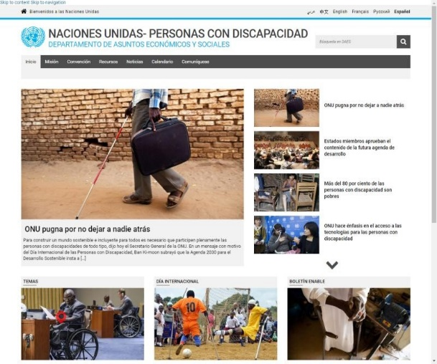 | Specific Issue:  Image links should not duplicate link-text with the 'ALT' attribute. Found link text ' MÁS INFORMACIÓN ' within ALT of <IMG> Tag  src='http://www.un.org/development/desa/disabilities-fr/wp-content/uploads/sites  /28/2015/10/ico_en.gif'.  Code Snippet  <img style="vertical-align: baseline" src="http://www.un.org/development/desa/disabilities-fr /wp-content/uploads/sites /28/2015/10/ico_en.gif" alt="M&#193;S INFORMACI&#211;N">

Structure
Ensure that your HTML layout structuring is necessary and informative.
- Use tables appropriately; layout tables should not use table grouping/organization tags but data/list-like content tables should use grouping tags.
- Frames should be properly organized, titled and identified. Aria Roles should be used where relevant.
- Layout or structural imagery must not have a title-attribute and should have an empty alt-attribute.
- Instructive content should be provided along with skip-links as necessary.
Each issue is detailed with links to the specific WCAG checkpoint

Issue: Layout Table with Summary (priority 4)

The summary attribute on a layout table should be empty.
The purpose of a layout table is simply to control the placement of content; the table itself is transparent to the user. A summary attribute would break this transparency by calling attention to the table. A null summary (summary="") on layout tables is acceptable. Issue is relevant to checkpoint: 1.3.1 (A)

General Remediation Advice:
Remove the summary attribute from tables used solely for layout. It should only be used for tables that present tabular data. In HTML 5, you can use the role attribute on the TABLE with a value of "presentation" to explicitly mark the table as being used for layout.
Appropriate screenshots with the issue highlighted are shown where the issue resides on the webpage

Suggested Reading:
Adaptable
Info and Relationships

Example 1 of 6: http://www.un.org/es/documents/sc/xchgesc.shtml
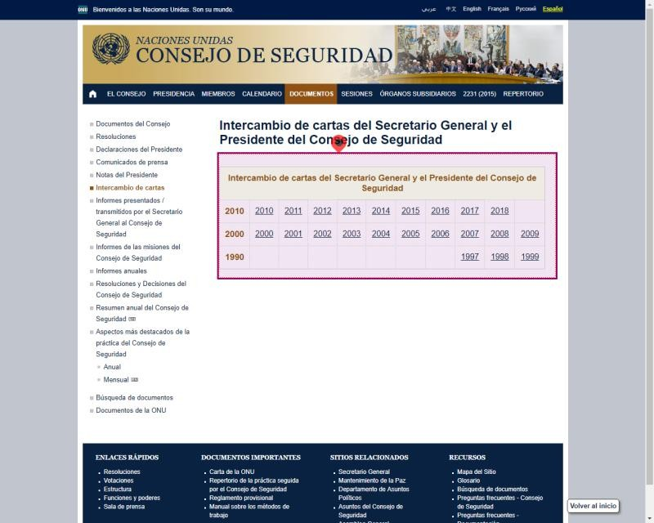 | Specific Issue:  Layout tables should not have a 'SUMMARY' attribute; or it should be an empty text value. <TABLE> Tag found summary='La tabla debe ser leída por fila. Tiene tres filas, cada una representa u...  Code Snippet:  <table class="yrlist" summary="La tabla debe ser le&#237;da por fila. Tiene tres filas, cada una representa una d&#233;cada, la fila de arriba es de la d&#233;cada actual. Los v&#237;nculos de los a&#241;os en cada celda de la tabla abrir&#225;n una p&#225;gina con la lista de cartas intercambiadas durante ese a&#241;o en particular."> <tbody><tr> <th colspan="11" class="tbltitle">Intercambio de cartas del Secretario General y el Presidente del Consejo de Seguridad</th>

Text
Text should be readable, understandable and appropriately marked up.
- Abbreviations and acronyms should be identified, and their first instance marked with an <ABBR>.
- Textual content should be well defined, described and adjustable by zooming and/or changes to employed browser style-sheets.

Issue: Meaningful Link Text (priority 3)

Clearly identify the destination of each link with meaningful text.

Users should be able to determine the purpose of each link from the link text alone or from the link text together with its programmatically determined link context, which can be provided via the title attribute. Issue is relevant to checkpoint: 2.4.4 (A)

General Remediation Advice:
Make sure the link text — the text bounded by the link start and end tags — clearly describes the destination of the link.

Before:
<a href="toc.html">click here</a> to go to the Table of Contents.

After:
<a href="toc.html">Visit the Table of Contents</a>.
Links to additional resources are provided for developers to learn more about the issue and how to prevent them in the future.

Suggested Reading:
Navigable
Link Purpose (In Context)

Example 1 of 8: http://www.un.org/en/essential-un/
The specific issue discovered provides detail needed to understand the issue

Specific Issue:
Clearly identify the destination of each link with meaningful link text. Found Link text '' Title attribute missing within In-page Link href=' https://twitter.com/intent/tweet?url= https://www.un.org /en/essential-un/index.shtml?filtervalue=factsfilter-Essential&original_referer=' .

Code Snippet:
Scripting

<a target="_blank" class="share-btn share-btn-twitter" href=" https://twitter.com/intent/tweet? url=https://www.un.org/en/essential-un/index.shtml? filtervalue=factsfilter-Essential&amp;original_referer=" data-network="Twitter"><i class="fa fa-twitter fa-lg"></i></a>
Pages that include one of the listed scripts should be checked to make sure they're still usable without the script. All Webpage content should be accessible without the use of JavaScript. (even if it takes the user additional or alternative steps.)
- Each script should be checked to make sure it doesn't cause unexpected changes in context and doesn't impose timing burdens on the user; such as automatic refreshing or changes of content. The user must have the ability to ignore, pause or somehow control such timed responses so they do not adversely affect the visitor reading experience.
- Scripting should not be a requirement to access essential Webpage content.
Detailed explanations of the classification to be fixed

Issue: Click Event (priority 3)
OnClick Events may be inaccessible.
If clicking on the element associated with the OnClick event handler triggers a function or performs some other action, developers should ensure that the context makes that fact clear to all users. Issue is relevant to checkpoint: 2.1.1 (A)

General Remediation Advice:
Review the surrounding area/content of the clickable element and ensure that sufficient and
accessible instruction text is provided with regard to the element.
Multiple example including the URL of the issue show developers’ different examples of the issue described

Suggested Reading:
Keyboard Accessible
Keyboard (No Exception)

Example 1 of 3: http://www.un.org/millenniumgoals/
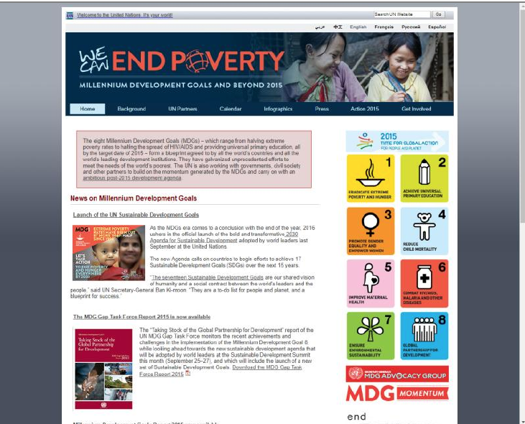 | Specific Issue:  Confirm that information describing the purpose of 'onClick' and 'onKeyPress' events is available and adjacent to the element that activates the event. Found '<A> Tag id='folder01' onclick='showHide('folder01');return false;'  Code Snippet:  <h5>UN Secretariat staff</h5>

CSS
Pages that use stylesheets (CSS) should be checked to make sure they're still readable and well organized without stylesheet(s).
- One way to check this would be to momentarily rename the StyleSheet, and make sure pages referencing it are still readable.
- If renaming a Stylesheet is not possible (e.g. on live systems) then you can disable StyleSheets using your Web browsers built in tools or plugins as follows.
  - Firefox (Select Tools menu at the top of the Firefox browser window, then select Web Developer > Style Editor)
  - Internet Explorer (Press F12 for Web Developer Tools when in an IE browser window) Chrome (Select the Chrome menu at the top-right of the Chrome browser window, then select Tools > Developer tools)
Issue are prioritized where priority 1 is the most critical to fix and priority 5 is least critical.

Issue: Contrast Minimum (priority 1)

The visual presentation of text must have a contrast ratio of at least 4.5:1 for normal sized text and at least 3:1 for large sized text (24px+ or 18.5px+ and emboldened).
Provide enough luminous color contrast between text and its background so that it can be read by people with moderately low vision (who do not use contrast-enhancing assistive technology). The minimum contrast success criterion (1.4.3) applies to text in the page, including placeholder text and text that is shown when a pointer is hovering over an object or when an object has keyboard focus. If any of these are used in a page, the text needs to provide sufficient contrast. Text that is decorative and conveys no information is excluded. Issue is relevant to checkpoint: 1.4.3 (AA)

General Remediation Advice:
Increase the contrast ratio and/or the font sizing and/or positioning accordingly such that the visual luminous contrast ratio between the foreground text color and the multiplied background color meet or exceed the described ratios. Alternatively, provide a user option to switch to a view utilizing sufficiently higher contrast values.

Suggested Reading:
Color contrast failures show the color combinations tested with their corresponding RGB and HEX code
Distinguishable
Contrast (Minimum)
Color.a11y.com

Example 1 of 23: http://www.un.org/en/newtechnologies/

 | Background Color  rgb(136,195,216) / #88c3d8 |  |  | Text Color  rgb(238,238,238) / #eeeeee

Specific Issue:
The text 'UN Secretariat staff' over the background has a contrast ratio of 1.66:1 while the required ratio is 4.5:1. Increase the contrast ratio by at least 171.08% to pass.
The text with the issue is detailed and shows the specific amount of contract required to pass
Code Snippet:

<h5>UN Secretariat staff</h5>

Form
Forms must be usable and properly labeled and identified with tag and attribute-based relationships.
- Forms must contain a Submit control where user input is expected.
- Form-controls must have appropriate, explicit labels associated with them via the ID attribute.
- Properly organize form controls and group options for SELECT boxes by using the <OPTGROUP> tag.

Issue: Form Without Submit Control (priority 4)
Verify that changing the setting of any form control or field does not automatically cause a change of context.
Changing the context of the page can be very confusing to users with cognitive disabilities or people using certain types of assistive technology -- for example, users of screen readers, where the page is read out to the user one part at a time. Issue is relevant to checkpoints: 3.2.2 (A), 3.3.2 (A)
Developers can learn directly from the report by seeing before and after examples of the issue.

General Remediation Advice:
Make sure the user knows when their action will result in a change of context. Don't use scripting that relocates or reconfigures the page based on a select box selection or by clicking a button&dash; use an actual submit type input element, which assistive technology can recognize as something that may change the context on the user.
Before:
The following script and form use an input type of button to invoke a script that automatically submits the form. Assistive technology can't recognize this as a button that will perform a submission.
<script language="JavaScript"> Function checkInput() { ... document.myform.submit(); ... } ...</script> ... <form name="myform" method="post" action="myform.pl"> <input type="button" onclick="checkInput()"> </form>
After:
The form and script have been modified to use an actual submit type of input. The script will still run and perform validation, but assistive technology can now recognize the submit button as something that will do a form submission.
<script language="JavaScript"> function checkInput() { ... } ... </script> ... <form name="myform" method="post" action="myform.pl"> <input type="submit" value ="submit" onclick="checkInput()"> </form>

Suggested Reading:
Input Assistance
Change on Request

Example 1 of 5: https://www.un.org/disarmament/es/

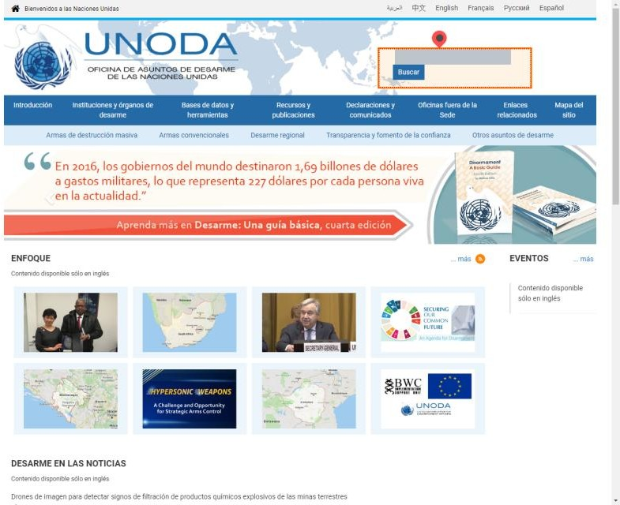 | Specific Issue:  Each Form should have an explicit 'ACTION' attribute as well as provide a valid Submit control. Found ' action= https://www.un.org/disarmament/search/ (number of submit controls=0) ' for ' <FORM> Tag id='cse-search-box' '.  Code Snippet  <form action="https://www.un.org/disarmament/search/" id="cse-search-box"> <div id="searchbox" class="shadow"> <input type="hidden" name="cx" value="017879155571300835259:szhio91zphq"> <input type="hidden" name="ie" value="UTF-8"> <input id="gsearch_q" type="hidden" name="q" style="width:100px"> <label for="search"></label> <input class="textbox" type="text" name="q" id="search" size="14"> <button class="button" type="button" name="SubmitUNODA" value="Buscar" on...

The Code Snippet shows the actual html code that has the issue making it easy for developers to locate.

Start your journey to a fully compliant website with ErrorCast™ today.

Your complete ErrorCastTM report, including both the WCAG 2.1 A/AA website compliance results and the detailed website developer guide, is only $850.

Ready to get started? Act now to receive all of this detailed information and help ensure you aren’t in violation of civil rights laws and in danger of potential lawsuits.

Order your ErrorCastTM report right now at https://www.boia.org/ErrorCast/. For more information or to speak with one of our Customer Success Representatives, email or call us today.

Contact@boia.org 401.830.0075

