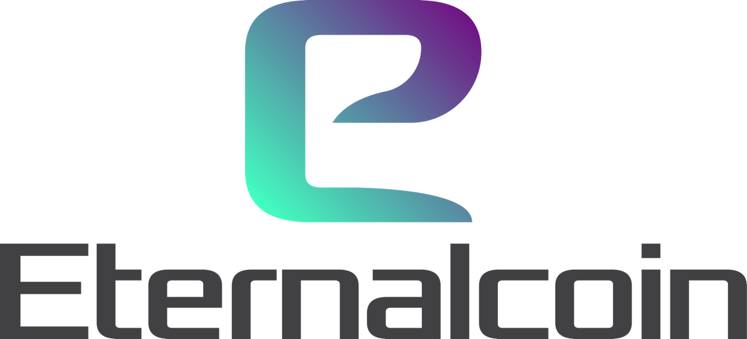

Eternal Inc Whitepaper

V1.3

Abstract
Online card games have been around for many years on PC and mobile. They are commonly known as card collecting games (CCG) or trading card games (TCG). A few card games allow players to trade with one another for different cards and items. These fall under the category of TCG. However, the majority of card games do not allow players to trade and sell their cards, and these are classed more as CCG games. Cards are never owned by players which is a major issue for online card games. Since all assets and cards are licensed by the developers, the developers can choose to revoke that license at any time. A majority of online card games incorporate this idea, some of which are listed below:
• Immortalis (closed on 29th February 2016)
• Rage of Bahamut (closed on 29th February 2016)
• Reign of dragons (closed on 15th December 2014)
The effect of these games closing caused a lot of grief for players, especially those players who had spent a lot of hours and also hundreds, sometimes thousands, of dollars in the game. Eternal Inc will solve this problem with the introduction of Eternalcoins (EIS). EIS will allow players to mint their cards which will allow them to have real world value to the assets they own within our games. They will be free to trade the cards for EIS on our popular trading platform, which currently exists within the game. They will also gain full ownership of every card they have in their inventory. Players will also benefit through entering and winning tournaments, without the fear of cheating and fraud.

Table of Contents
Abstract 2
Goal 5
Market Overview 6
Market Analysis 6
Market Opportunity 7
Market Problem 8
Eternal Inc Solutions 9
Decentralization: The Way Forward 10
About Eternal Wars 11
Target Groups of Services 13
Benefits of Eternal Inc Network to the Gaming Industry 14
Platform Features 16
Eternal Wars Card Minting 16
Smart Contracts 17
The Eternalcoin Wallet 17
Decentralized Card Exchange 17
Decentralized Esports Platform 18
Token Sale 19
What is an IEO? 21
Trust 22
Security 22
Easier for the projects 22
Listing 22
How to participate in an IEO? 22
Will IEOs create the next fundraising boom? 23
Fund Allocation 24
Development Roadmap 26
Strategic Marketing Plan 27
Meet the Team 29
Risks and Disclaimer 32
Risks 32
Disclaimer 32
Forward-looking statements 32

Goal
Eternalcoin (EIS) is the ERC20 based token to be used in connection with the Eternal Inc Network. EIS serves for both trading cards as well as participating in tournaments. With the introduction of EIS on the existing Eternal Wars platform, we intend to offer virtual goods on the Blockchain, mitigate fraud and high fees as well as create an innovative gaming experience with real value.
With EIS, we will have access to the following:

• enhanced engagement with a significant amount of users
•. increase in returns on per user basis due to in-game purchases
• engage in enhanced secure transaction with EIS because of Blockchain technology

Gamers can do the following with EIS:
• engage in tournaments
• pay for digital products and services
• pay for games, in-game items, and trade with hard-to-get, rare and collectible items
• engage in enhanced secure transaction with EIS because of Blockchain technology

Market Overview

Market Analysis

Based on a series of research, it is obvious that eSports is one of the most dynamically developing sectors of the gaming industry. In fact, the market is expected to reach $1.5 billion by 2020.

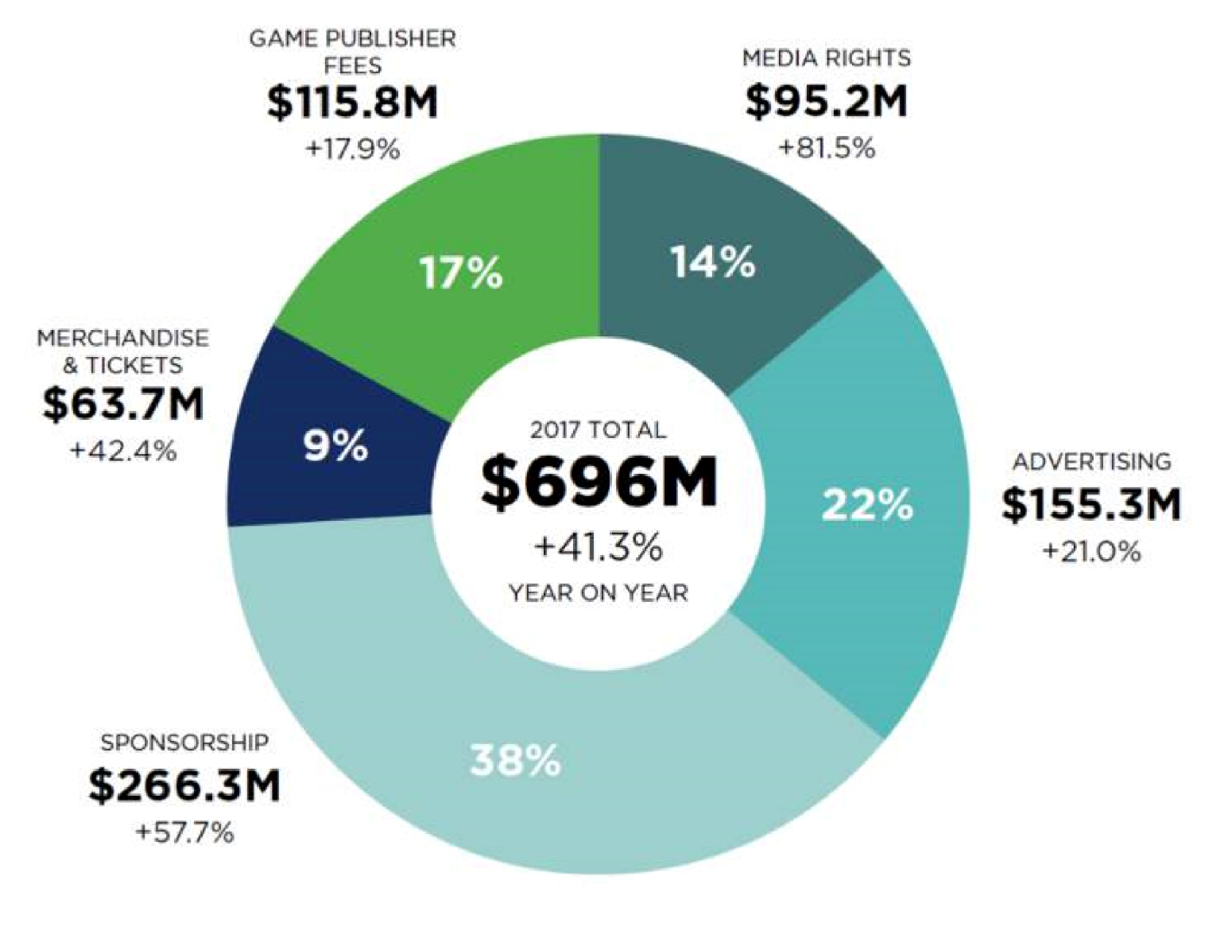

According to 2018 statistics, it was estimated that games would account for 76% of the expected $92.1 billion mobile app revenue in 2018. In fact, generally, it was estimated that about three billion smartphone users would create a global mobile gaming revenue of $70 billion by the end of last year. These estimates would increase exponentially as there would be a decrease in the costs of data plans and hardware: with 3.8 billion smartphone users by 2021 generating a total app revenue of over $139 billion. Also, by 2021, it is expected that games revenue would reach $106.4 billion from the $42.5 billion it was in 2016, thereby having a compound annual growth rate of 20.1%.
The country that would spearhead this market would be China having 783 million smartphones, and accounting for 26.1% of global users. Based on Newzoo's consumer insights, 13.7% of all Chinese mobile players agree to buy new hardware to enhance their gaming experience, compared to just 7.6% in the US, and 2.9% in Europe. This means that China would continue to dominate this market. For brands, Samsung and Apple account for over 50% of the global share of smartphones between them; this makes them the giants within this marketspace.
In 2019, the estimated revenue in the Card Games sector amounts to US$690m, and the market is expected to grow annually by 1.6% (CAGR 2019-2021). Without doubt, card games are here to stay.

Market Opportunity

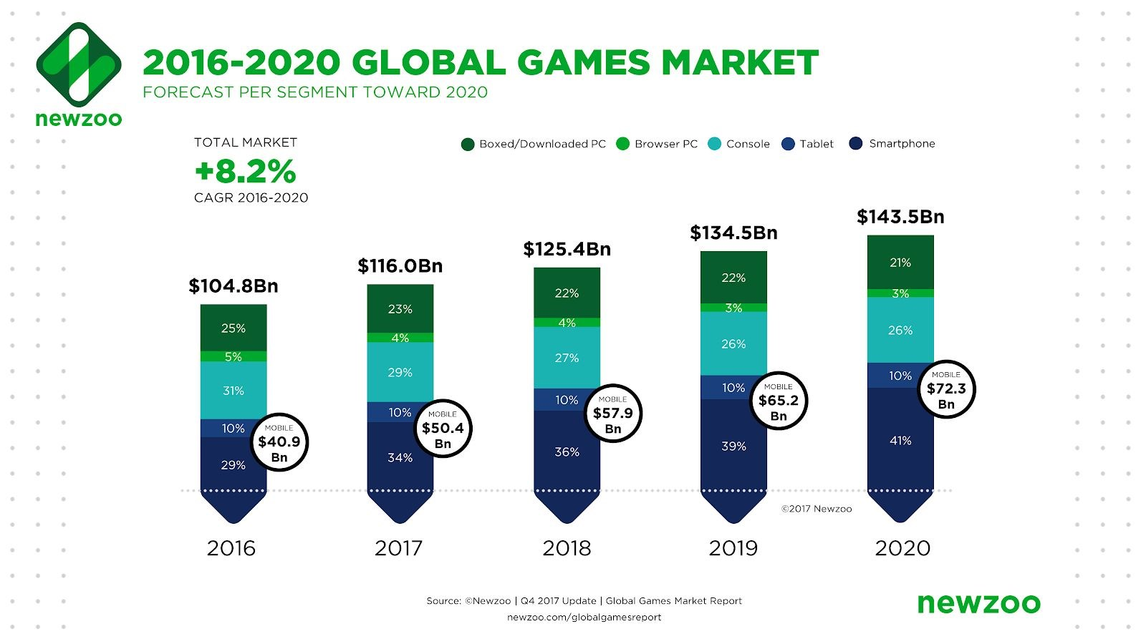

Another study estimates, the games market will reach US$140 billion industry by 2020. It is indisputable to assert that the potential for revenue within the games market is rapidly increasing. Incorporating the Blockchain technology allows developers, publishers and gamers to benefit greatly more than traditional game platforms. We strongly believe that this is a great opportunity for Eternal Inc to revolutionize this market.
Merging mobile gaming and cryptocurrency offers a distinctive opportunity for operators, players and supporters to disrupt the online gaming market. In the last decade, there have been considerable changes in the gambling market with the upsurge of online gaming and the shift from desktop to mobile. Mobile content is now global and accounts for the most Eternal Wars game play. With the surge in mobile gaming and growth in the industry, we would be making a huge impact on the online gaming market with our platform.

Market Problem
The Problem of License
Gamers do not own the cards, only the license to use them. Virtual items are basically just licensed to the gamers, and these items are often only available for use on the proprietary platforms. In fact, they can even be manipulated, lost, or reverted with little recourse for the users.

The Problem of Fraud
Authenticity of cards isn’t known. Based on estimations, for each legitimate virtual purchase made, about 7.5% virtual items are lost to fraud,. It is a common knowledge that assets stored and managed online are often exposed to manipulation or chargebacks. This means that merchants have to deal with extra burdens, and scammers damage the game's reputation.

The Problem of Liquidity
Cards can’t be easily sold or traded with little or no recourse for the users.

The Problem of Constant Spending, High Cost and Slow Transaction
Spend to keep up with new expansions. Developing a platform for managing virtual goods is often time-consuming and costly. Developers pay 30% to platforms. Game publishers and communities​ depend on ​third-party​ ​platforms​ for the processing of ​virtual​ ​goods transactions​. Gamers often experience opaque fund flow, slowness, and high transaction fees⁷.

The Problem of Centralization
Economic benefits are not going to players. Virtual items and digital currencies are usually locked to a single game, and are non-transferable. Also, if a player becomes banned, they can easily lose all their items and currency.

Eternal Inc Solutions
Ownership
We are offering the gamers an opportunity to own their assets on the Blockchain. This means that players can earn and own cards by holding EIS.

Immutability
The nature of Blockchain makes records to be easily identifiable without any form of manipulation.
Card Exchange
We are creating a user-friendly market; where users with EIS can buy and sell cards

Decentralized
As a Blockchain-based system, centralization will be eradicated.

Decentralization: The Way Forward
Eternal Inc supports and enables complete freedom and privacy for its users. We believe in the Blockchain technology and its feature of decentralization as a crucial tool for technological enhancement.
The coming of the internet has been a great blessing to the world as it offers great possibilities and opportunities to the world in general. It has enabled freedom to speak, live and explore beyond one’s imagination. The internet provided the basis for decentralization, especially with the development of the Blockchain technology.
Centralization has been a common feature, and it has been existing with a lot of disadvantages such as unfairness/injustice, fraud, deceit, lack of transparency and abuse of power. This is because power is just focus in a particular place: some people have the power and denied others of it. This set of people with the power tend to take advantage of those without the power. Therefore, there arose the need for decentralization to give freedom and equal division of power the people, especially those who have been denied of power.
Since the Blockchain enables decentralization, Eternal Inc has made it the foundation of its platform. We are blending the technology with online gaming to offer the best user experience to anyone in any part of the world. Everyone has access with no restriction, especially from government rules and regulations.
Eternal Inc is offering freedom and privacy to its users. We also offer a transparent, trustworthy and just platform, which will be highly beneficial to anyone in any part of the world. The Blockchain has made this possible through its element of decentralization. And we strongly believe that this is the way forward for every online gamer and for everyone in general just as we hope for a world, in which everything will be decentralized.

About Eternal Wars
Eternal Inc’s first game is called Eternal Wars. The brainchild of Safiul Syed, an avid gamer himself, Eternal Wars is based on the popular Japanese Gacha theme. The original idea for the game was created in 2012. However, it took several years before the game came into fruition. This was due to the fact finding the right team, via outsourcing and freelancers, to create the idea was proving difficult. In 2015 Safiul decided to bring all the work in-house. Firstly, hiring staff in South Africa for creating the initial assets required and then sourcing programmers to bring everything together in the UK. This allowed him to oversee every aspect of the game, from the algorithm to the functionality of each action and event.
Eternal Wars is a fully-functional cross platform card game, which was released on March 2017 with currently over 10000 downloads both on iOS and Android. Eternal Wars is a trading card game (TCG) in a mythical fantasy universe that features online live multiplayer faction battles (PvP). This multiplayer TCG game will allow you to manage and create your deck, battle with your deck, play games online, participate in Arena PvP and much more.
The game is a free-to-play game, however, players can buy cards via in-app purchases. Players can freely trade cards they own within the game via our trade market. But due to the nature of games, players do not own their cards. This is what Eternal Inc hopes to solve by introducing the EIS. This token will allow users to mint their cards in exchange for EIS, which will hold real world value to them.
60,000,000 EIS will be circulated within the Eternal Wars game. Players will also be encouraged to buy and sell tokens from the exchange where our token are listed. We will be looking to introduce special cards which can only be purchased with EIS. These special cards will be limited in number, which in turn will increase their value over time. An example of this would be something similar to Cryptokitties. A web-based game where several of their ‘Kitties’ have been valued in the thousands of dollars, due to their scarcity.

User Growth | Years | Revenue Gross | Revenue Net
4000 | 2017 | £120,000.00 | £40,000.00
6000 | 2018 | £252,000.00 | £88,200.00
10000 | 2019 | £529,200.00 | £185,220.00
14500 | 2020 | £1,111,320.00 | £388,962.00
19000 | 2021 | £2,333,772.00 | £816,820.20
25000 | 2022 | £4,900,921.20 | £1,715,322.42
35000 | 2023 | £10,291,934.52 | £3,602,177.08
50000 | 2024 | £21,613,062.49 | £7,564,571.87

PLEASE CREATE A LINE CHART FOR THE ABOVE DATA

Revenue model
As with many games on mobile, the pricing we use will be similar to many other games. These range from £0.99 to £99. We currently have over 15 different types of in-app purchases. The pricing is dependent on the type of items we give with each package. The higher the price the more value the player gets. We also have included several growth packs which entice newer players to spend from the start.

Growth pack price range - £0.99 to £29.99 (one-time purchase)
Weekly pack range - £5.99 to £29.99 (can be bought once a week)
Monthly pack range -£49.99 to £99.99 (can be bought once a month)
Daily pack range - £2.99 to £49.99 (player receives goodies on a daily basis for 15 days, much like a subscription)
Gem pack range - £0.99 to £99.99

From the initial start we have found that growth packs have been very successful. The plan is to expand on these packs and bring in a set of ‘value’ packs. Price range for this will £0.99 to £29.99

We have looked at competitor prices and what they have to offer. With this data at hand the products we provide have a better value per £ mark.

Target Groups of Services
Eternal Inc targets three major groups:

Investors: Eternal Inc is created to uphold the innovation and development of the gaming industry with Blockchain technology. We would appreciate the support from any investor.

Gamers: We are providing gamers a form of authority over assets. We are also creating more games in the future to cover all aspects of game types. From first-person shooters (Fortnite, PUBG) to Role-playing games (Final Fantasy, Summoners war). Our second game, World of Iselia, is currently in its development stage. We will be looking at cross networking Eternal Wars and World of Iselia to create one unique and unprecedented world. Where players can own assets, trade between both games and build a huge worldwide community. During our IEO there is a major update coming to all players of Eternal Wars. This will include new gameplay mechanics and events.

Traders: Traders will be able to buy and sell tokens 24/7 on various exchanges. We will create a huge new base of traders via our games. This will increase liquidity for our token as our players will be looking to buy as well as sell tokens on a daily basis.

Benefits of Eternal Inc Network to the Gaming Industry
The gaming industry is worldwide and huge. It is a very wide platform where billions of gamers and millions of developers interacting. Yet, there appear to be some flaws in the traditional system, which has made this interaction to be inefficient. There is a need for players to own their assets as well as collaborate and communicate. Game developers even tend to face the challenge of high fees from marketplaces and high costs of acquiring users.
Eternal Inc Network decentralized ecosystem helps to solve these problems. Eternal Inc is designed to change the way online card gaming industry operates through the use of the programmable logic of smart contracts, the immutability of Blockchain ledger and high speed of transactions with the aid of the Blockchain technology.
For users of our platform, we are offering the following in an attempt to create a better online gaming experience:

Greater Access to Gaming Content
EIS will permit players to own assets. There will also be opportunity for gamers to create and participate in tournaments.

Trust and Transparency
Our platform will offer players visibility to all their information and transactions. It will also allow players to contest and prove the fairness of outcomes. There will be transaction transparency as changes to public Blockchains are viewable by all parties.

Fairness
Eternal Inc is decentralized, therefore, has no benefits to gain from players unlike centralized entities. Operating on a Blockchain ensures that the players have complete fairness and a trustworthy environment as well as complete control over their money and identity.

Highly Responsive Game Play
Gaming on Eternal Inc will be more responsive since it has been built on the Blockchain.

Shared Revenue
Ability to share in the revenue of our full service online card games offers Eternal Wars players and investors the ultimate experience. Eternal Inc gives every player the visibility to their information and transactions while providing a provable fair operation. Combined with no hassle registration, worldwide access, 24/7 activity, Eternal Inc will provide an online card gaming experience that is incomparable.

The videogame industry will be revolutionized thanks to Blockchain technology, which has brought with it many advantages such as the following:
- providing users ownership of their virtual items
- creating a bustling economy within the digital space due to scarcity
- mitigating database manipulation, fraud and hacking
- providing levels of security that is unprecedented
Generally, EIS provides a decentralized platform to interconnect digital economies, and trade digital goods across games. Therefore, our network will greatly contribute to the development of the gaming industry.

Platform Features
The Eternal Inc platform empowers users to:

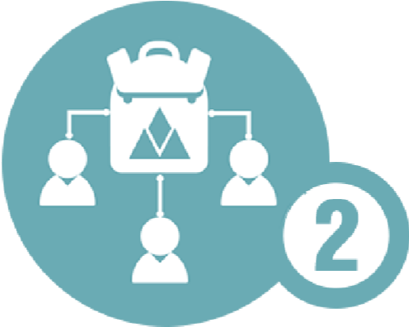

MINT CARDS USE CARDS TRADE CARDS

Eternal Wars Card Minting
Each card will have to be given an individual token value as cards have varying rarity and uses. As new cards come out, older cards will be lowered in price depending on card circulation within the ecosystem. If a card is no longer in circulation and is a rare card, however old, the value may remain higher than that of cards of similar stats. This is purely due to supply and demand. The token valuation as a base for each rarity of card is as follows –

Common (C) – 0.0000001 EIS
UnCommon (UC) – 0.0000003 EIS
Rare (R) – 0.0001 EIS
HighRare (HR) – 0.0005 EIS
SuperRare (SR) – 0.0008 EIS
MegaRare and LegendaryRare (MR and LR) – 0.0013 EIS

Each stage of a card will add value to the end token value. For example:

MR S1 = 0.0013 EIS
MR S2 = 0.0026 EIS
MR S3 = 0.0039 EIS
MR S4 = 0.0052 EIS

PLEASE NOTE: Enhancing cards will not add to a cards token value. Figures above may change in the future; however, a supply of tokens has to last the entirety of the game life.

A new currency will be added into the game to show EIS to players. After a card has been minted the card will be marked with a special symbol to showcase this. Cards can only be minted once. For example, if a card was minted as a stage 1, you can no longer mint the card even if the card has been evolved into its later stages. This will be explained in the game via our FAQ. The player can then log into our website to see stats on their new currency. The website will automatically convert all new currencies into EIS and connect with a players’ wallet. A full video tutorial of the process will be available to all users.

Smart Contracts
As earlier stated, the Eternalcoin is based on ERC20 tokens on the Ethereum network, which is known as the most widely supported smart contract Blockchain, with a massive development community and vast language support. We strongly believe it has a strong future in game development and in creating the new decentralized internet, and this is why we are deploying it for our token.
Our aim is to create smart contracts with a decentralized name/value store directly into the Blockchain. These smart contracts will store everything from a players’ data, any virtual assets they may own and their inventory. The basic functions of smart contract on our platform include the following:
- Buy & sell cards
- Create Cards
- Claim Cards
- Create Tournaments

The Eternalcoin Wallet
Token buyers will need to have a valid ERC20 compatible wallet that is not on an exchange to receive their tokens in exchange for their donation. Valid digital wallets include https://www.myetherwallet.com/ and https://metamask.io/

There will be links to tutorials added to our webpage so anyone new can learn about the Blockchain and how to install and use a digital wallet.

Decentralized Card Exchange
An interesting feature on the Eternal Inc Platform is the Ethereum-based Card Exchange, which permits secure and seamless card trading. On our Exchange, users are guaranteed of low fees, high-level security and a robust transaction environment that will enable all players to benefit more from our platform.

Decentralized Esports Platform
We also feature Ethereum-based decentralized Esports and tournaments on our platform. This means that players are allowed to host their own tournaments. With this, we have eradicated any chance of cheating or fraud, as every tournament is adjudicated and reported by the game software, then tracked on the Blockchain.

Token Sale

The main objective of the token sale is to raise capital to develop the Blockchain architecture, the webpage, associated digital wallets to hold the tokens and for future games.
EIS can be spent in game, for in-app purchases, to buy Cards, or to enter tournaments. Tournament prizes are paid out in EIS.

EIS IEO Summary

Symbol: EIS | Total Supply: 300,000,000 EIS
Token Format: ERC20 | Hard Cap: $3,783,000
 | Conversion Rate: $0.02 per EIS

**All left over tokens will either be burnt or used within the game.

Funds Breakdown

65% (195,000,000) | IEO
25% (75,000,000) | Eternal World
4% (12,000,000) | Team
4% (12,000,000) | Advisors
2% (6,000,000) | Bounty

**Founders will not receive any EIS

IEO Breakdown

First phase | Private sale
Second phase | Public sale/IEO

Prices for each phase as follows –
1st phase $0.016 (15% of tokens to be sold here) (29,250,000 EIS) 20% bonus $468,000
2nd phase $0.02 (85% of tokens to be sold here) (165,750,000 EIS) $3,315,000

Hard cap is $3,783,000

During the Eternalcoin sale, early backers and contributors will receive a quantity of tokens issued by the company which have been pre-allocated. These will be given in exchange for ETH. The total circulating supply of our ERC20 token will be capped at 300,000,000 (three hundred million), which will be made available to contributors and early backers, at a rate of $0.02 per EIS.

Here’s what token buyers will receive in EIS, depending on the stage of the token sale:
$ 0.02 = 1 EIS $1 = 50 EIS
Our smart contract will exchange ETH directly into EIS. The EIS tokens will be sent to the token buyers ERC20 wallet, but non-transferable, until the end of the IEO.

The token sale will be split over the course of time:
Private sale Q2 2019 date tbc 29,250,000 20% bonus
Public Sale Q2 2019 date tbc 165,750,000 $0.02
PLEASE NOTE: The token is not available to citizens of the USA and China until further notice.

What is an IEO?
An Initial Exchange Offering, as its name suggests, is conducted on the platform of a cryptocurrency exchange. Contrary to Initial Coin Offerings (ICOs), an IEO is administered by a crypto exchange on behalf of the start-up that seeks to raise funds with its newly issued tokens.
As the token sale is conducted on the exchange’s platform, token issuers have to pay a listing fee along with a percentage of the tokens sold during the IEO. In return, the tokens of the crypto start-ups are sold on the exchange’s platforms, and their coins are listed after the IEO is over. As the cryptocurrency exchange takes a percentage of the tokens sold by the start-up, the exchange is incentivized to help with the token issuer’s marketing operations.
IEO participants do not send contributions to a smart contract, such as governs an ICO. Instead, they have to create an account on the exchange’s platform where the IEO is conducted. The contributors then fund their exchange wallets with coins and use those funds to buy the fundraising company’s tokens.
After observing the success of Binance Launchpad, other notable exchanges announced launches of their own IEO platforms. Among the IEO platforms are Bitmax Launchpad, Bittrex IEO, OK Jumpstart (OKEx), KuCoin Spotlight, and Huobi Prime.

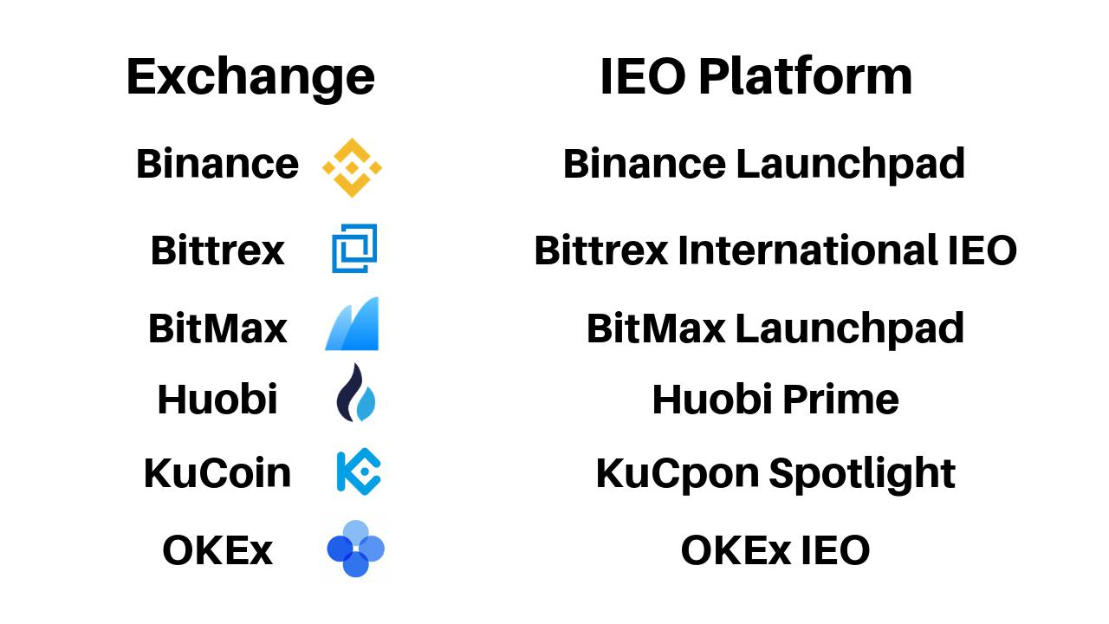

Trust
One of the main advantages of IEOs is trust. As the crowdsale is conducted on a cryptocurrency exchange platform the counterparty screens every project that seeks to launch an IEO on its website. Exchanges do this to maintain their good reputation by carefully vetting token issuers.
Therefore, IEOs can eliminate scam and dubious projects from raising funds via cryptocurrency exchange platforms, and it becomes much harder to scam contributors with IEOs.

Security
Token issuers do not have to worry about the crowdsale security as the exchange is managing the IEO’s smart contract. The KYC/AML process is also handled by the crypto exchange as most service providers do KYC/AML on their customers after they create their accounts.

Easier for the projects
Token issuer start-ups benefit from the more flawless process of launching IEOs on exchange platforms – compared to doing their ICOs “on their own.” While the fundraising organizations have to pay fees for listing and a percentage of their tokens, the exchange will help them with marketing. So, start-ups launching their IEOs require a lower marketing budget than if they decide to go with an ICO. Moreover, token issuers can take advantage of the exchange’s stable customer base to receive more contributions to their projects.

Listing
As token listings are also “in the deal,” it is a natural process that the cryptocurrency exchange where the IEO is conducted lists the coin of the start-up after the crowdsale is over.
While IEOs seem like a more secure and efficient alternative to ICOs, the costs associated with token sales can be high for start-ups. Listing fees can go as high as 20 BTC, while exchanges can even take a 10% cut from the tokens of the fundraising companies.

How to participate in an IEO?
As IEOs are currently, relatively rare in the crypto community, it is not that hard to find one that you like. After you’ve found your IEO of choice, you need to find which exchanges are hosting the crowdsale.
The next step is to register an account on the cryptocurrency exchange and complete the KYC and AML verification process.
After you are done with that, check out the cryptocurrencies you can use to contribute to the IEO, and fund your account with a coin that is accepted in the crowdsale. The last step is to wait until the IEO starts to buy your tokens.

Will IEOs create the next fundraising boom?
ICOs created a fundraising boom in 2017 and 2018. However, a significant percentage of the crypto projects were operated by scammers or were of a dubious nature. Because of this, as well as ICO bans, we can say that this is not an efficient fundraising model for cryptocurrency start-ups.
On the other hand, IEOs provide an increased level of trust among cryptocurrency projects, because the exchanges hosting the crowdsales actively participate in the fundraising process, which improves the efficiency of the crowdsale. Therefore, IEOs have the potential of becoming the standard model for raising funds in the crypto space and maybe even creating the next fundraising boom.
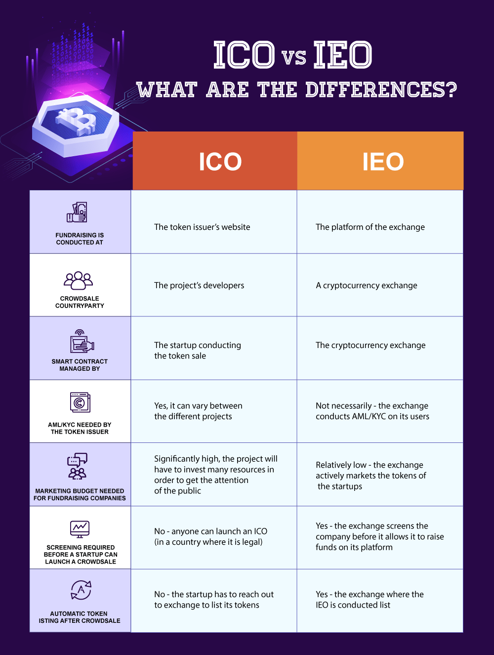

Fund Allocation

Breakdown of Fund allocation

25% | Marketing & PR | We will focus on growing the Eternal Inc user base by reaching out to as many people as possible through different marketing means.
30% | Programming | Since we want to create a platform with all the necessary tools for creating a better gaming experience, we will pay attention to the programming aspect of our platform.
30% | Art and Animation | We know the captivating power of aesthetic-pleasing platforms, and we would like to design our platform in a way that is definitely eye-catching.
10% | Technical Development | To help grow the ecosystem as well as ensure constant secure and user-friendly gaming environment, we will focus on technical development.
5% | Admin (Business, Legal and HR) | This is allocated to ensure the effective and continuous running of not just the platform, but also the company as a whole.

Depicted above, it is obvious that we are giving high emphasis on the actual platform and majority of the funds will be on marketing Eternal Wars globally and also the continued development of future games.

Development Roadmap

July 2013 - Initial idea for Eternal Wars

August 2015 - In-house development team created. Initial funds raised via founders’ personal savings, friends and family

March 2017 - Global launch of Eternal Wars on Appstore and Playstore

Q3 2019 - Begin development of the EIS economy into Eternal Wars
- List on exchanges

Q1 2020 - Work on syncing data from game server to web wallet
- Begin work on World of Iselia

Q3 2020 - Alpha release of World of Iselia
- Create SDK on unity for wallet

Q1 2021 - Global launch of World of Iselia
- Development of Eternalcoin wallet
- Implement Eternalcoin into World of Iselia

Q3 2022 - Launch esports World of Iselia
- Begin work on Chaos Drive
- Sync Eternal Wars, World of Iselia and Chaos Drive ecosystem

CREATE A ROADMAP OF THE DATA PROVIDED ABOVE

Strategic Marketing Plan

Target Market | Gamers, investors, cryptocurrency enthusiasts, crypto community
Geography | Global
Activities | Social media, registration campaign, community building, Online marketing campaigns, PR and branding, roadshows, airdrops. Community management, organic influencer marketing
Channels | Facebook, Twitter, Reddit, LinkedIn, Medium, Telegram, YouTube, cryptocurrency forums, technology press, other PR channels/blogs, Product roadshows, webinars, workshops, podcasts

WE STRONGLY BELIEVE IN AND INTEND TO CARRY OUT PROACTIVE MARKETING
Our exceptional initiative will bring people from all over the world together so that they can have a better experience of gaming experience on the Blockchain. We strongly believe that these people will come to us with our strategic marketing plan, social media communication, blogs, and articles.

Below are some of the marketing techniques we will be deploying:
Link Referral system
People know the power of word-of-mouth advertising. Yet what a number of marketers usually miss is that word-of-mouth advertising is not something that always has to occur entirely organically. With some great strategies, you can convince your customers to spread the word about our project.
We intend to come up with referral programs that can do a number of things such as track our brand advocates, incentivize satisfied customers to promote our products, and boost both customer acquisition and retention.
We believe that referral programs are a great help with lead generation. We will be rewarding people for helping us to find leads. A referral program is really a good way to generate leads, and not just any leads, but highly-qualified, niche-specific leads that will more likely lead to in sales.
In the world of referral programs, there is usually no getting without giving. So we first have to come up with an offer that works for our brand.

Landing Page and Email List
Using our website landing page as well as email list, we will be reaching out to as many people as possible. With emails, we believe we can easily reach our audience more directly than many other marketing channels. Therefore, we intend to have own email service.
Social Media
Marketing campaigns for almost every type of product often has to do with some kind of social media activity. We believe that social media is a useful marketing tool because it would help us to directly connect with potential users easily. We will be using social media channels such as Facebook, Twitter, etc. We plan to launch targeted social media campaigns, meant at the gaming and cryptocurrency community. A mixture of information and education of our platform should get the essential purpose and grip.
Content Marketing
For this, we will make use of different blogs to promote our platform. We will engage with a marketing agency to use current search engine optimization techniques and paid search engine marketing to help move the project forward.

Multimedia Materials
We will also make use of multimedia materials such as video and images, which can also be useful for sharing online or sending to the press.

Press
Without doubt getting the press is one of the best ways to tell people about your platform. So we will be making use of the press as well.
Getting Reviews
We cannot undermine the role of getting reviews for our platform as we believe this is also a great marketing strategy.

Meet the Team


Safiul Syed
http://linkedin.com/in/safiul-syed-0a08a212b
Chief Executive Officer (CEO) and founder
- Business management for over 15 years
- 15 Years of experience in the hospitality industry
- Electronic engineering background
- Over 5 years experience in game and level design
- Gaming hobbyist and loves watching and playing football


Rizwan Khan
Senior Developer
- 8 years of experience in programming
- Over 100 projects, including games, apps and websites completed
- Experienced in multiple programming languages including Java, C#, PHP, MySQL, Nodejs, c++ to name a few
- Hobbies include learning new programming languages, playing cricket and also competitive Esports gaming


Kevern Pretorius
https://www.linkedin.com/in/kevern-pretorius-576b1212b/
Project Manager
- 4 years as project manager of Eternal Wars
- Programming knowledge includes C# and java
- Experienced user of Unity3D
- Hobbies include mobile and PC gaming. Learning programming


Christy Chambers
http://linkedin.com/in/christy-chambers-626675178
Head of Communications
- 13 years experience in legal and family law
- Volunteer at the Wolfsons Children’s Hospital as the Floor Mother
- Master of Law and Juris Doctor
- Currently working on her Doctor of Juridical Science
- Current Game Sage of Eternal Wars, communication between devs and player base
- Hobbies include social gaming and meeting new people


Abiking S. Lirio
https://www.linkedin.com/in/abiking-lirio-65b383b2
Chief Marketing Officer(CMO)
- Over 20 years of experience in business and founder of Multi Trend Lirio Enterprise
- BSc in Business Administration and marketing
- Volunteered as an assistant teacher
- Hobbies include Spiritual energy work, Usui Reiki Lineage and gaming


Sin Eow Sing
https://www.linkedin.com/in/leo-sin-a1521296/
Chief Technical Officer (CTO)
- Over 25 years experience in engineering, including working as a supervisor and as a production manager
- Current tasks include planning, managing, HR, costing and maintenance work
- Graduated at Federal Institute of Technology in Mechanical Engineering
- Leo loves watching sports, listening to music and playing games, mainly PC and mobile


Mitchell Brits
https://www.linkedin.com/in/mitchell-brits-a4b31595/
Developer
- 6 years experience in game development industries specifically targeting mobile and web games
- Full stack development experience in commercial software development for 4 years
- Mitch loves programming and learning new languages, playing football and is a talented PC gamer


Papa Mabotja
https://www.linkedin.com/in/papa-mabotja-0509718a/
Blockchain developer
- 4 years experience in Blockchain Technology
- A firm believer in Blockchain Technology and it's place in the real world, Papa is looking forward to finding new awesome ways to have it work to our advantage
- He is involved in various projects that are aimed at making work easier through computer system applications
- A pro PC gamer, who loves strategy games as much as he loves anything Blockchain related


Najrul Siddique
https://www.linkedin.com/in/najrul-siddique-346767178/
Graphic design
- Software skills include Photoshop, Illustrator, Maya and Spine 2D
- Knowledge of Unity 3D
- Najrul helps creates game assets in both 2D and 3D and helps with animation

Risks and Disclaimer

Risks
Although our management team has taken all measures to lessen any risk to the minimum extent, the following risks may have impact on the long-term sustainability of Eternal Inc:
There may be competition driven DDOS attacks and smear campaigns. Although the management will invest in high-tech DDOS cloud-flare protection services to lessen these attacks, there is always a risk that downtime could happen.
In the event of unforeseen circumstances, the objectives stated in this document may be modified. Despite the fact that we intend to reach all the goals stated in this document, all persons and parties involved in the purchase of EIS do so at their own risk.

Disclaimer
This Eternal Inc Whitepaper is strictly for information purposes only, and we do not guarantee the correctness of or the conclusions provided in this whitepaper. The whitepaper is presented on an “as is” basis.
We do not make and expressly disclaim all representations and warranties, whether express, implied, statutory or otherwise, of any form, including, but with no limitation to warranties of usage, merchantability, suitability, fitness for a specific purpose, title or non-infringement. We offer no guarantee that the contents of this whitepaper are free from error.
Eternal Inc and its affiliates shall not be held liable for damages of any kind resulting from the use, reference to, or dependence on this whitepaper, or any of the content contained in it, even if advised of the likelihood of such damages.
Under no circumstance will Eternal Inc or its affiliates be made liable to any individual or entity for any losses, damages, expenses, costs, or liabilities, whatsoever, whether direct or indirect, compensatory, consequential, actual, incidental, punitive, special, or exemplary, for the use of, reference to, or reliance on this whitepaper or any of the content contained in it, including, with no limitation to, any loss of business, profits, revenues, use, data, goodwill or other intangible losses.
EIS cannot be resold by their holders to citizens, natural and legal persons, with their habitual
residence, location or their seat of incorporation in the country or area listed mentioned below:
USA, China

Forward-looking statements
Every statement, approximation, and financial information enclosed in this whitepaper, on the Eternal Inc website, in press releases, or in any other place/platform, accessible by the public, and oral statements that may be made by Eternal Inc, its founders, team members and any third party that is involved in the Eternal Inc project and acting on behalf of Eternal Inc, that are not statements of historical fact, make up forward-looking statements or information. Such forward-looking statements or information includes known and unknown risks and uncertainties which may induce actual events or results to vary materially from the estimates or the results implied or expressed in such forward-looking statements. These statements may be recognized by words like “anticipate”, “estimate”, “expect”, “intend”, “plan”, “possible”, “project”, “target”, “should”, “will”, “would”, “could”, “if”, “may”, or words of related meaning or form. Nevertheless, these words are not the exclusive means of recognizing forward-looking statements.
The law in some jurisdictions may restrict the sale and purchase of Eternal Inc. These jurisdictions include with no limitation People’s Republic of China and the U.S.A (including Puerto Rico, the U.S. Virgin Islands or other US territories). The EIS are not being provided or distributed to, and cannot be resold by their holders to citizens, natural and legal persons, with their habitual residence, location or their seat of incorporation in the country or area listed mentioned above or where transactions with digital tokens are banned or in any manner restricted by appropriate laws or regulations. If such restricted person purchases EIS, such restricted person has done so unlawfully, and in this regard, will bear negative consequences. Persons described above that engage in the fundraiser by offering false information about their citizenship, residency, and nationality, will violate the Terms of Sale of EIS and would entitle Eternal Inc to request such persons to compensate any damage and/or loss suffered owing to this violation. You accept that you purchase, receive and hold the EIS at your own risk and that EIS are offered on an ‘as is’ basis with no form of warranties, either express or implied. It is strictly your responsibility to ascertain if you are legally permitted to purchase EIS in your jurisdiction and whether you can then proceed to resell EIS to another purchaser in any particular jurisdiction. You assume the full responsibility for determining or assessing the tax implications of your participation in the crowdsale, purchasing, or receiving and holding EIS in all respects and in any jurisdiction. You represent that the contributed funds do not come from any illegal activity and permit us proper Anti-Money Laundering (AML) Checks. You accept that we may at any time and without any explanation reject any contribution on the basis of mere suspicion that the funds come from illegal activities or that AML regulation was not honored.
This whitepaper may be updated or modified with the latest version of the whitepaper prevailing over previous versions. Eternal Inc is not under any obligation to give you any notice of the fact or content of any modification.
The latest edition of this whitepaper in English is available on the website. Nevertheless, there is no obligation to update this whitepaper or any accompanying material in any regard, or otherwise to give you access to any additional information. The information herein may at any time be translated into languages other than English or used in during written or verbal communications with existing and prospective token purchasers, customers, partners, or any individual. If there exists any form of conflict or inconsistency between such translations and communications and this official English language whitepaper, the stipulations of this English language original document will prevail.

https://www.gamesindustry.biz/articles/2018-09-11-games-expected-to-account-for-76-percent-of-global-mobile-revenue-in-2018
Ibid
https://www.gamesindustry.biz/articles/2018-09-11-games-expected-to-account-for-76-percent-of-global-mobile-revenue-in-2018
https://www.statista.com/outlook/14030000/102/card-games/europe#market-globalRevenue
newzoo.com
Emarketer: The rising tide of in-app fraud ​https://www.emarketer.com/Article/Rising-Tide-of-In-App-Fraud/1012731
Apsalar study virtual items fraud: ​https://​apsalar​.com/2015/07/latest-​apsalar​-data​​-on-in-​app​-click-and-iap-​fraud ⁷ Paypal & Stripe: 2.9% + $0.30 per sale. VISA/MasterCard: 1.5%-3% of sales.
​ERC ​Token​ standard #20 ​https://github.com/ethereum/EIPs/issues/20

