Design Brief
A logo design is required for a 2020 junior motorsport championship being introduced to the UK.
Several different draft versions are required for review.
The foundation logo should be based on the ignite logo shown below.
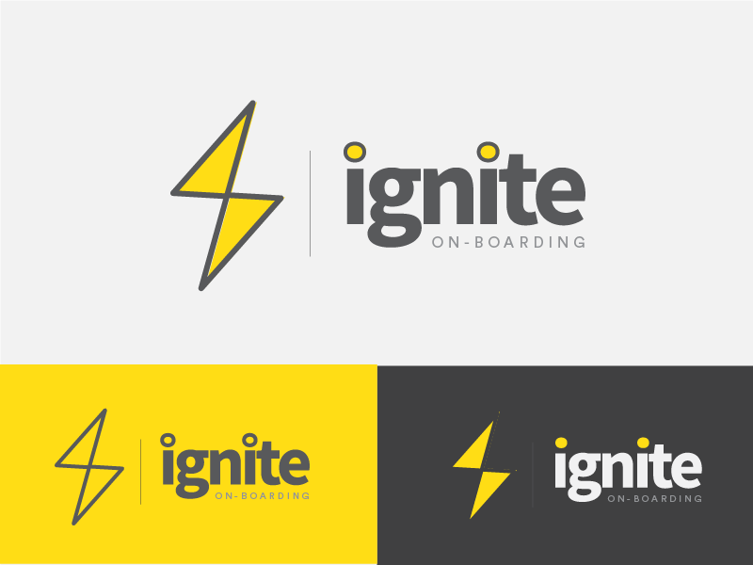
Using the basic logo above;
- Replace “ON-BOARDING” with “KART RACING” and add CHALLENGE” on the line below.
- Experiment with inserting a British Union Jack in the dots of the I in ignite, or;
- Experiment with replacing the yellow in the lightning graphic with a British Union Jack.
- Provide a version with a ™ and a version with a® to the right side of the logo.
- Leave the logo ‘as is’ and incorporate the union jack in some other way.
- Experiment with changing the entire colour scheme to reflect a red, black, and white logo below.
- Provide a version with the addition of the following text and logo underneath;
Powered by
