Original Sketch
Has three basic flows off of Messages Time Cards (today, history), Shift Notes (change of condition, activities, notes) and Messages
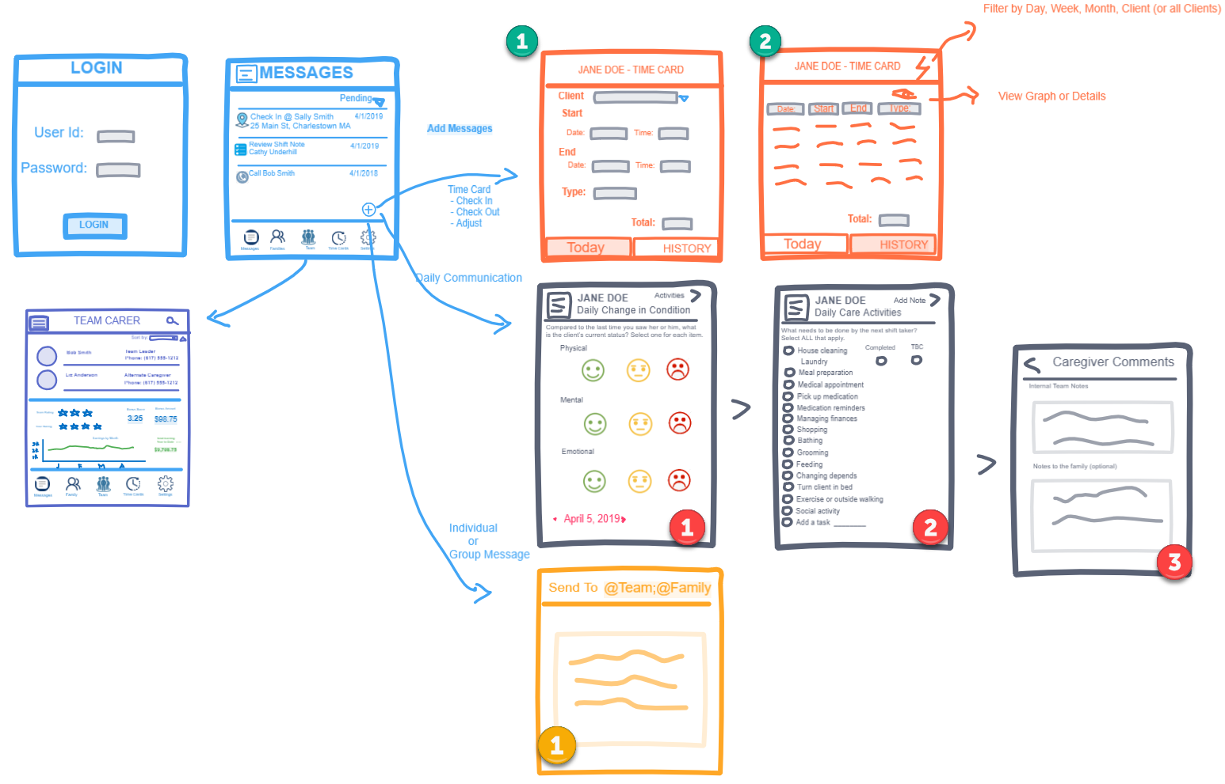

Time Cards

#1 Today Time Card current version and requested changes
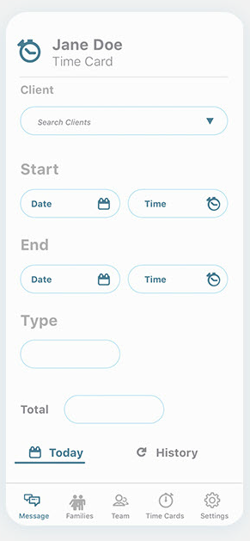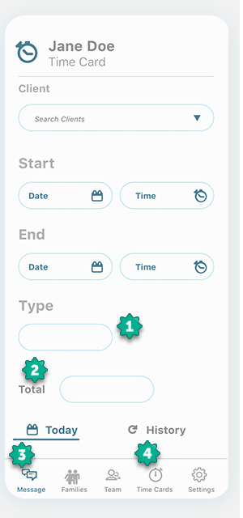

- This should be a drop-down field
- This is not a entry field, but rather a calculated value (= end – start). So if the blue board for the field is used to indicate entry, we need to represent an un-editable field in a different way
- Bottom navigation - Message icon should be gray
- Bottom navigation - Time Card icon should be blue

#2 Time Card History current version and requested changes
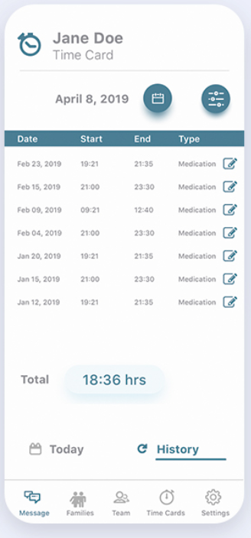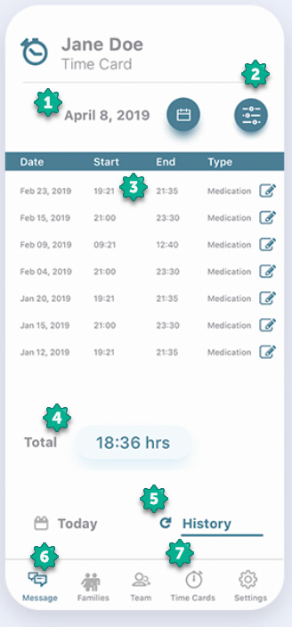

- Lets make the date and date picker right justified to be consist with how it appears on other pages
- Can we put the filter button in the page header, above the moved date picker?
- The line is missing some information,
  - Add Client Name – you can make this a multi-row line, it will probably be easier to read and select a distinct row (similar to the messages page).
  - Add total time
  - Change the date format to mm/dd/yy
- Right justify the total calculation
- The History icon used is very common for un-delete, can you change this
- Bottom navigation - Message icon should be gray
- Bottom navigation - Time Card icon should be blue

Shift Notes

#1 Current Version and requested changes
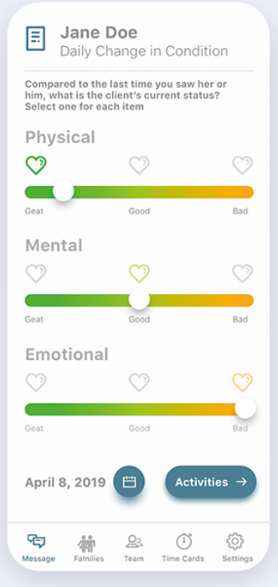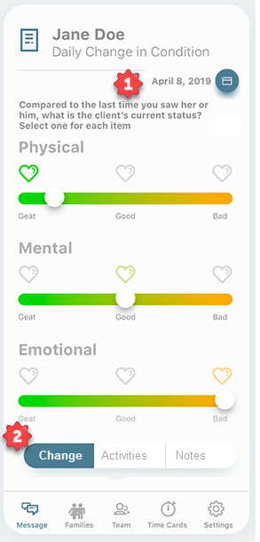

- Move the date and date picker from the bottom to the top
- Add a navigation bar to toggle between change, activities, and notes. Make Change selected and get ride of the Activities button

#2 Edits to current version

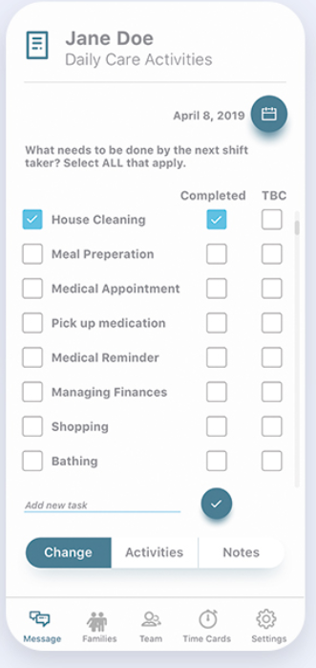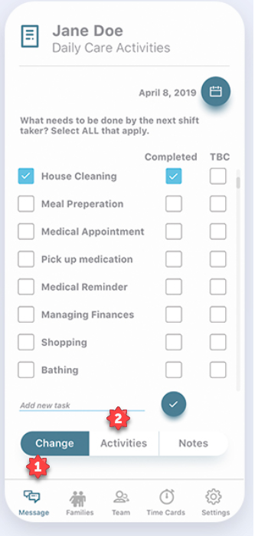

- The Change Navigation background should be white with gray lettering
- Activities Navigation background should be Blue with white lettering

#3 Edits to current version
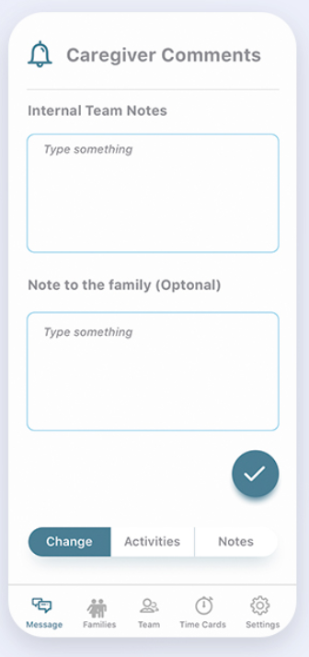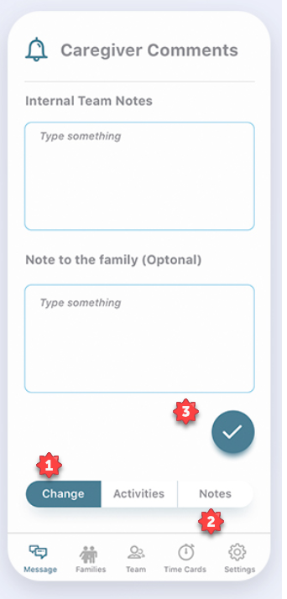

- The Change Navigation background should be white with gray lettering
- Notes Navigation background should be Blue with white lettering
- Change checkbox to Submit button – should have two states grey version (for not unfinished shift note) and blue version for finished shift note)

Message
The design for the message page is missing

Other Pages

Requested changes
#1 Client List
The original drawing had a section for Client List – this was missing from previous designs. I noticed that you had 2 designs for Team and so marked up one

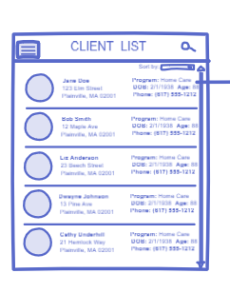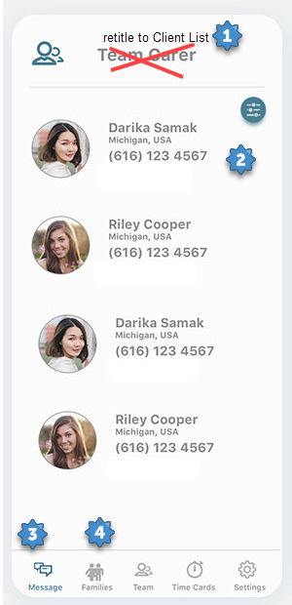

- Make the header read Client List
- Section should contain the following fields
  - Client Name, Address, City, State, Age and Phone
- Bottom navigation - Message icon should be gray
- Bottom navigation - Family icon should be blue

#2 Team Carer

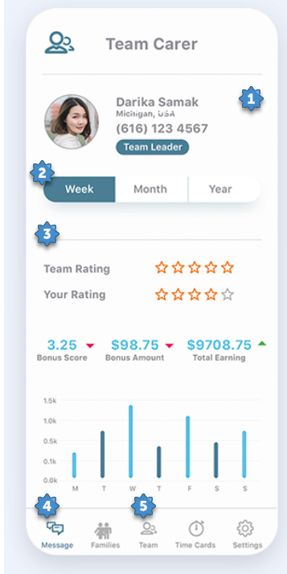

- The Team is made up of 2-12 people. We will need to add a scroll bar for the people section, and we should tighten up the size of the section (small picture, and view lines per person
- The week, month, year navigation should be below the #3 line and above the Team Ratings
- Move this lower as needed
- Bottom navigation - Message icon should be gray
- Bottom navigation - Team icon should be blue

#3 Message Page
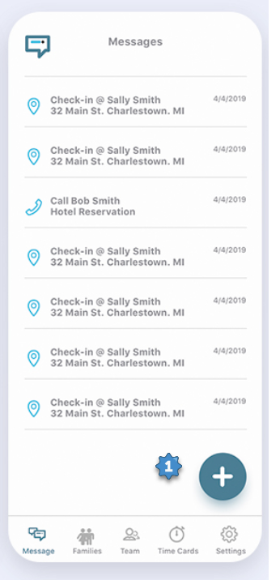

The Add button on messages needs a popup or menu selector – for type , Check-In, Check Out, Shift Note, and Message

