Sheridan Park Family Church – Design Brief

Date Written: May 01, 2019

Infographic for our Discipleship Pathway:

Design Needs:
A simple infographic that clearly communicates our discipleship pathway without requiring additional explanation.

Discipleship Process:
- In order for someone in our church to be completely discipled they must “connect in every direction”. They must connect …
  - Up to God
  - In to the Church
  - Out to the World

Tone and Manner:
- The main objective is that someone new to the church could look at the infographic and understand that our church wants to help them connect up to God, in to the church, and out to the world and that’s what they are supposed to do.
- Intuitive and obvious to understand.
- Simple and clear.
- Same color as our logo and values (if possible).
- Our church’s mission is “Connecting Young Families to Christ” so our focus is to reach out to families while not being exclusive to others.
- Our church’s core values are: Equipping, Serving, Belonging, Missional Living, Spirit-living
- Our target audience is families with school-aged kids.
- Our website is www.spfamilychurch.ca
- Our church is an evangelical Christian church about 50 years old, located in Mississauga, Canada, and recently went through a church relaunch where we came up with a new mission, vision, and values, and now our discipleship pathway.
- I would like the infographic to have a real quality to it which reflects the amount of effort and care we put into crafting our discipleship pathway and how important it is going forward.

Further Requests:
- I intend to place this infographic on a wall in the main auditorium (5 feet x 5 feet) and be able to place it on documents, posters, website, etc.
- Needs to be quality enough to scale way up and resize.
- Will need the graphic completed by May 14th.

Please contact Lead Pastor, Keith Piquette keith@spfamilychurch.ca
Name Logo
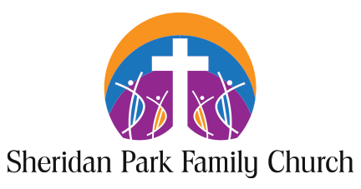

Our Core Values

