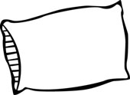

Phone: (702) 463-8062 • Fax: (702) 463-8368
1661 E. Flamingo Road Ste. 4-B • Las Vegas, NV 89119
“Everyone Deserves Restful Sleep”

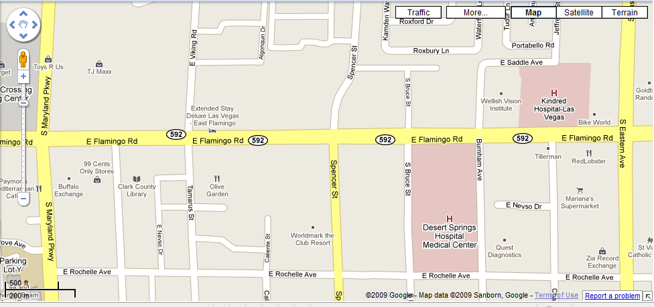
At Home
Sleep Studies
We are located on the south side of Flamingo Road inside Cambridge Quail Property (Blue & White Sign) between Spencer and Maryland Parkway.
This is a one story red brick building with a lot of trees. Our suite is located on the left side of the complex.

