To whom it concerns.

I need a design for a website, preferably written in Bootstrap. It’s a website where it should be easy to book a cleaner. I have included some images to make it a bit more understandable. These images are of course just examples, it’s the functionality I’m after. For reference, check this website https://www.helpling.co.uk/

- multilingual, a dropdown where I can change language, would like to have flags and name of language. See image.

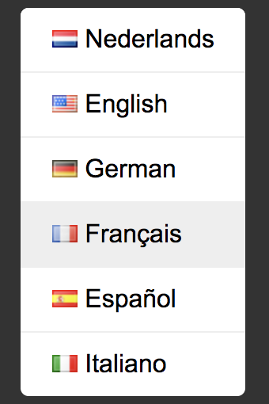

- A login with error handling and a link if you have forgotten a password. This link should create a modal window with an email input textbox with a cancel button and a submit button. See images.

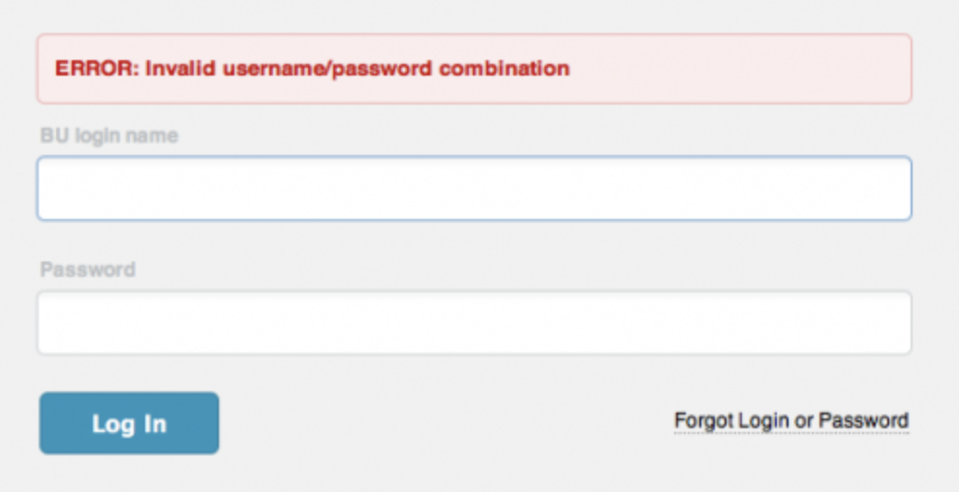

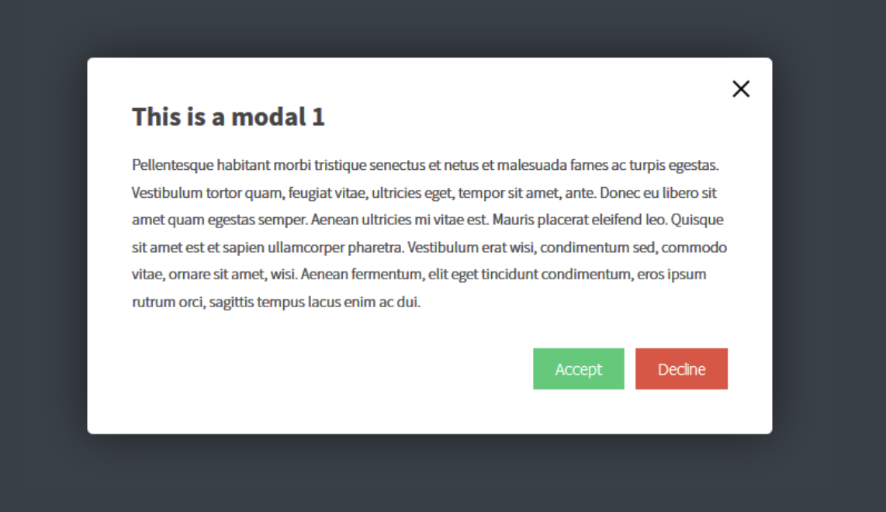

- A big push/selling surface to book a cleaner. By selecting area, date and time and square meters the user should get a search result with cleaners and time slots to book. The timeslot and cleaner should be presented with an image, price and a star-rating with a number attached (very much like Uber). And a direct book button and/or make a request for booking button.

3.23 rating

- A push area where you sign up as a user. The form needs to contain the following input fields: name, address, door code, square meters, number of rooms.

- A step-by-step guide how to book a cleaner. Step 1 search for cleaner, step 2 book cleaner, step 3 pay. We are using Swish for company payment option. No money will be transferred to the cleaner unless you are happy with the result.



- A checklist what you need to have at home once you booked a cleaner

- What we offer: safe payments, 100% satisfaction guarantee, well experienced cleaners

- A happy comment section with quotes from customers.

- In the footer: contact us, a link to a legal text, cookie link

- need a cookie consent solution

Admin GUI for a cleaner

Once you log in as a cleaner you should be able to see:

- Your username
- Price per square meters textbox
- How many years in the cleaning business textbox
- A checkbox (can book me directly)
- A date and time interface where it shows booked clients and available time slots. Every booked timeslot should be clickable and show clients name, address and other relevant info.
- An area where incoming booking requests are shown. Requests should show name, address, date and time, price. Every booking request should have accept/decline buttons.
- A booking history listing all booked clients

Admin GUI for a client

Once you log in as a client you should be able to see:

- Your username
- Address
- Door code and other relevant info
- Number of square meters textbox
- Pending bookings
- Future bookings
- Past bookings

