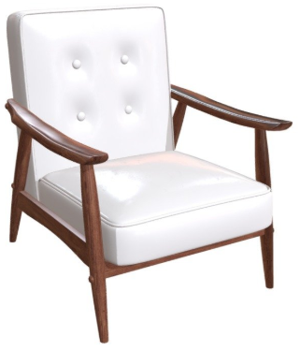
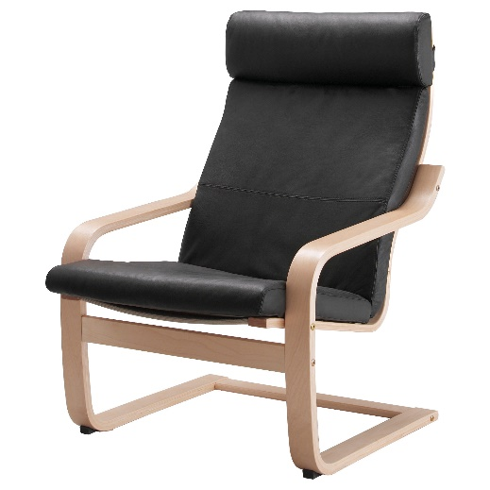
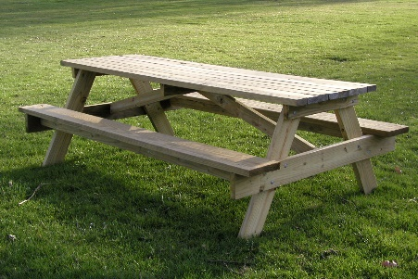
SH
AR
BR
SD
AC
SA
CO
FC

SEAT HEIGHT (SH)

ARMRESTS (AR)

BACK REST (BR)

ACCESSIBILITY (AC)

SEAT DEPTH (SD)

SEAT ANGLE (SA)
Estimate the seat angle. Does the seat slope backwards more than 15°?
COMPRESSIBILITY (CO)

FOOT CLEARANCE (FC)
Is there space under the seat for your feet?

