Mystic Opal (by Excites, out of Bovespa)
Lot number: 1414
Stable: QC 6
Sale date: 30 May 2019
Sale: 2019 Gold Coast National Broodmare Sale
Race record: 7 wins, 2 seconds, 2 thirds (27-7:2:2), $205,400 prizemoney
In foal to Deep Field, sire of: Cosmic Force (winner of the Group 3 Pago Pago Stakes by 7.5L), Dig Deep (winner of the Group 2 Karrakatta Plate), Hawker Hurricane (winner of the Magic Millions Clockwise Classic), Bullet Fly, Chevy Nova plus more…
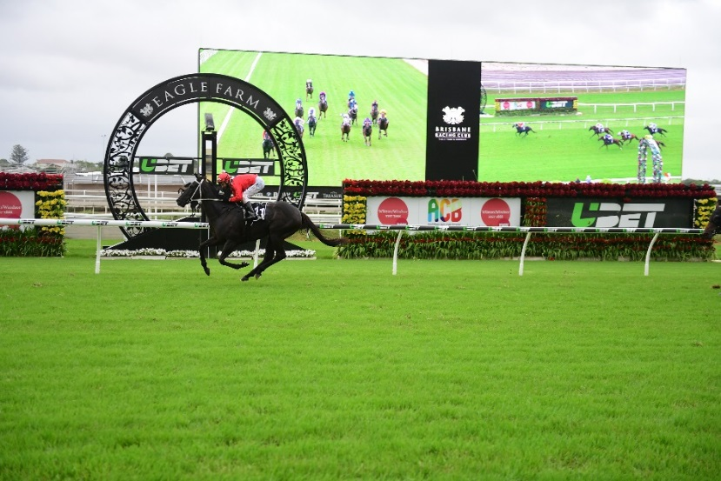
Mystic Opal wins by 3.5L
Class 6 Handicap – 1400m
Brisbane Racing Club (Eagle Farm), 21 January 2017
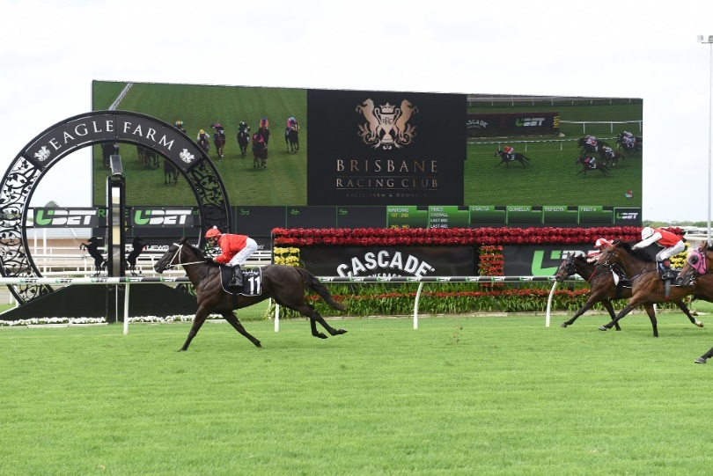
Mystic Opal wins by 2.8L
No More Than One Metro Win Handicap – 1400m
Brisbane Racing Club (Eagle Farm), 10 December 2016

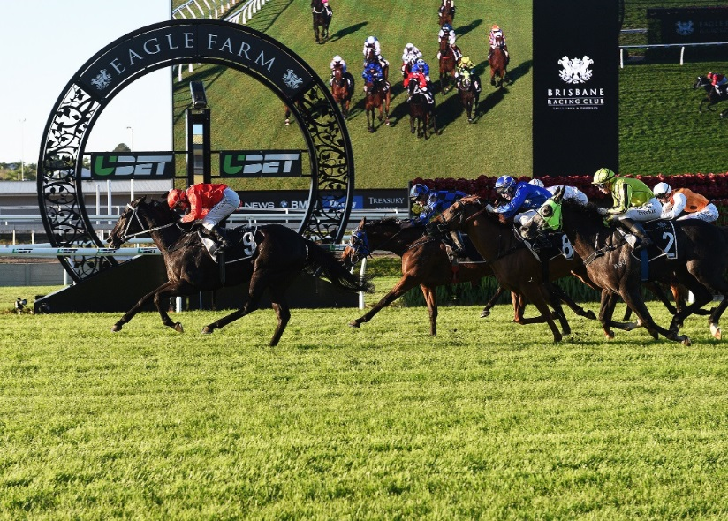
Mystic Opal beats Privlaka by 1.3L
Class 6 Plate – 1300m
Brisbane Racing Club (Eagle Farm), 29 April 2017

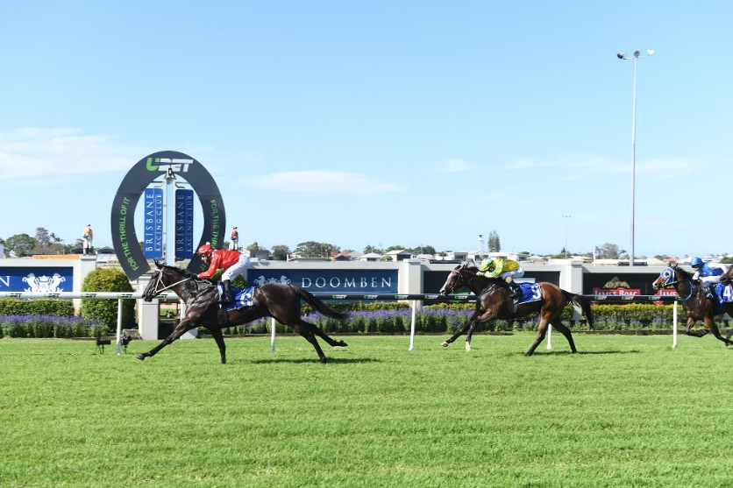
Mystic Opal wins by 2.3L
Class 4 Handicap – 1400m
Brisbane Racing Club (Doomben), 23 November 2016

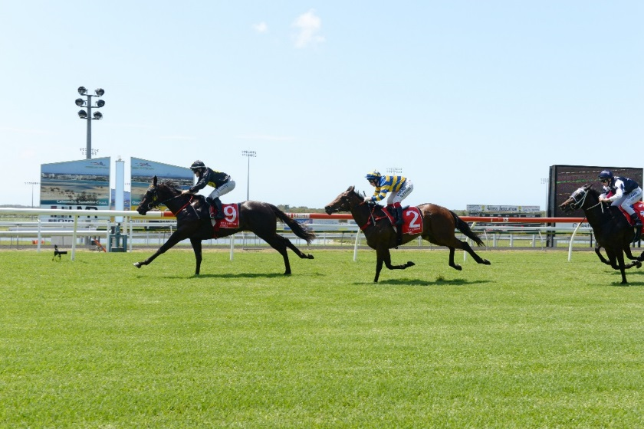
Mystic Opal wins on debut at the Sunshine Coast!
Maiden – 1000m
Sunshine Coast Turf Club, 23 October 2015

