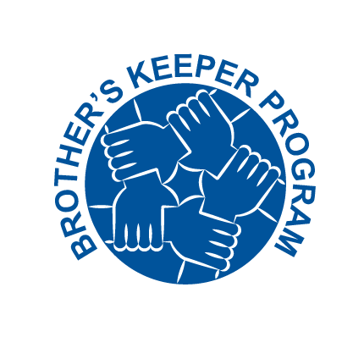



I commit to be an active participant in the Brother’s Keeper Program.

I personally commit to:

- Have a positive attitude toward safety and hold myself accountable.
- To intervene and stop work whenever I observe an unsafe act or condition.
- Immediately tell a co-worker if I identify any inappropriate or missing personal protective equipment.
- Do my part to keep the job site clean so it is safe for everyone.
- Actively share ideas with my co-workers to improve safety.
- Look for ways to coach others on safe work practices.
- Make sure my co-workers and I are using the right tool for the job.
- Consistently demonstrate my commitment to safety through my actions.
- Engage and participate in the behavioral-based safety program and make sure my co-workers are participating.
- Use Safety Task Assessments (STA’s) and Self Assessment Checklists (SAC’s) for each activity.
- Be an active participant in toolbox talks, safety meetings and the STA process.
- Show my appreciation to any co-worker who identifies an unsafe behavior and thank them for caring.

Signature: _________________________________ Date: ____________________

Printed Name: _________________________________________

Jobsite/location: _____________________ Shirt Size (S-5x) ____________

