Home page
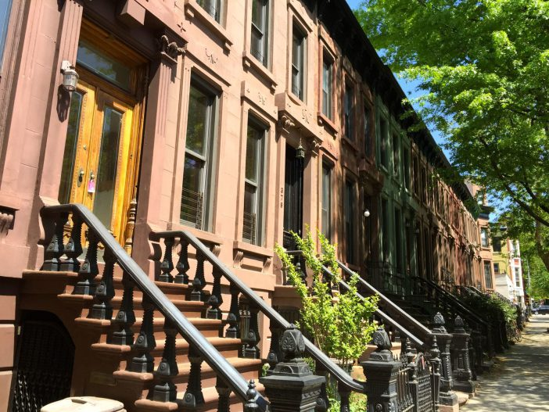
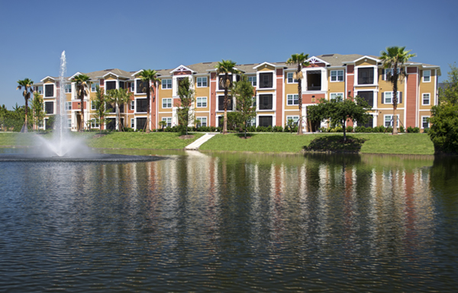

Maybe combine these pics or have on a slide

1 Liner:
Assisting landlords increase profits while decreasing the stress.

How we can help


Multi-Family Leasing

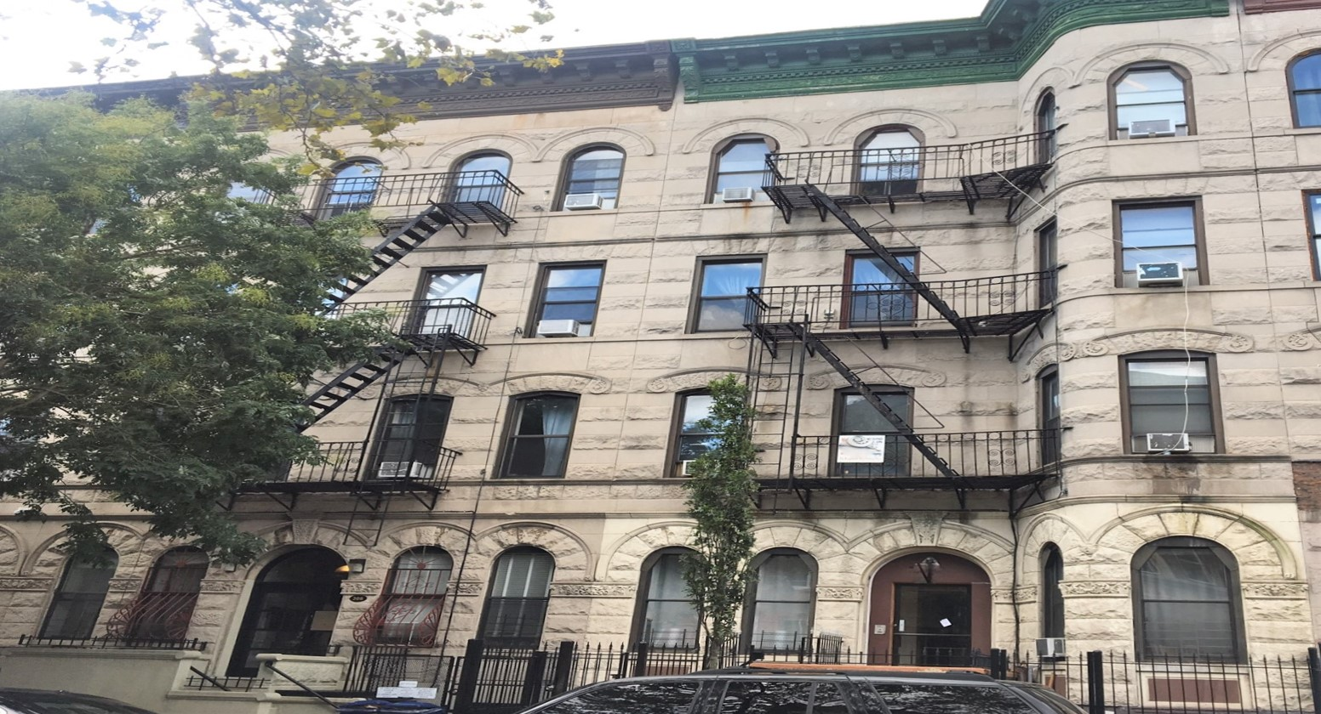

Multi-Family Sales

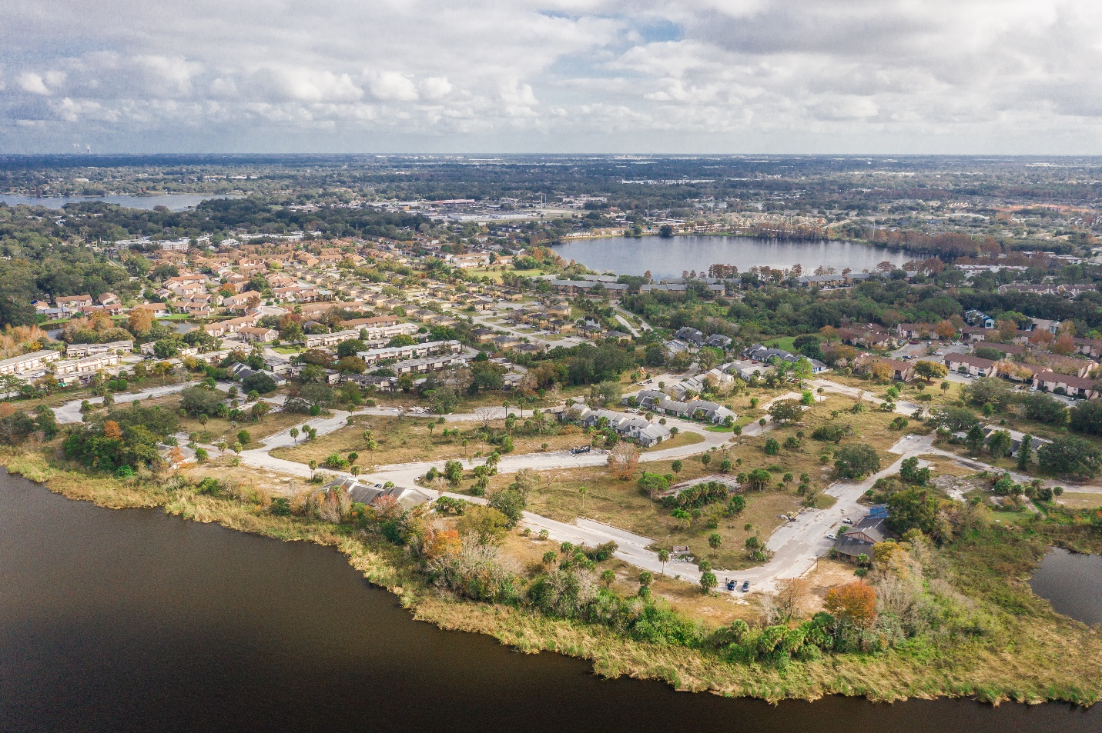
Site Selection Advisory

About page
Smiling client pic
Cover Realty NYC•PB is a full-service real estate brokerage firm with offices located in Brooklyn, New York and West Palm Beach, Florida. Our firm focuses on multifamily leasing, sales and Commercial Real Estate Site Selection Advisory.

Our clients are private and institutional multifamily real estate investors.

Our team differentiates ourselves by our ability to investigate the highest and best use for real estate assets as well as our high deal closing rate.
Services page
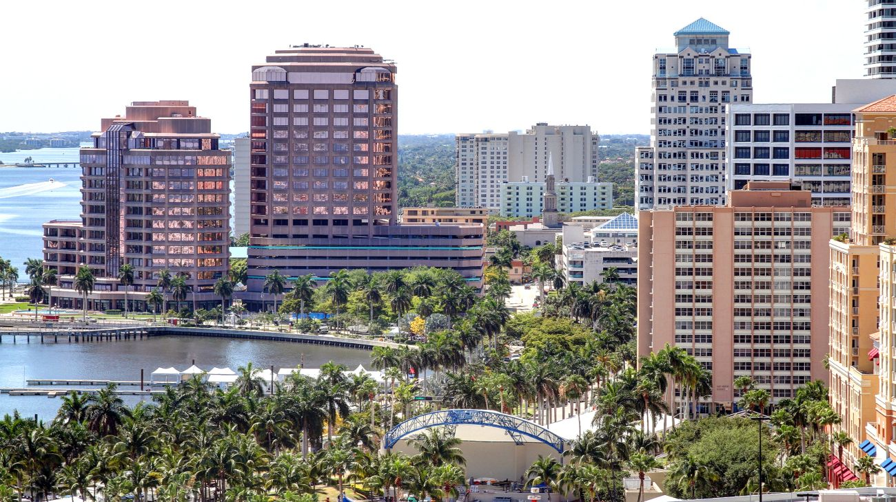

The services we specialize in are multifamily leasing, sales and Commercial Real Estate Site Selection Advisory.

Pic of the 3 services for them to select

Multi-Family Leasing
Pic of a lease signing with happy ppl

We specialize in sourcing quality tenants for landlords with high income, good credit and no evictions.

We believe in our tenant selection process so much that we offer a Landlord Guarantee. Landlord guarantee we guarantee we place a good tenant in your unit or we’ll refund our broker’s fee.

Multifamily Sales
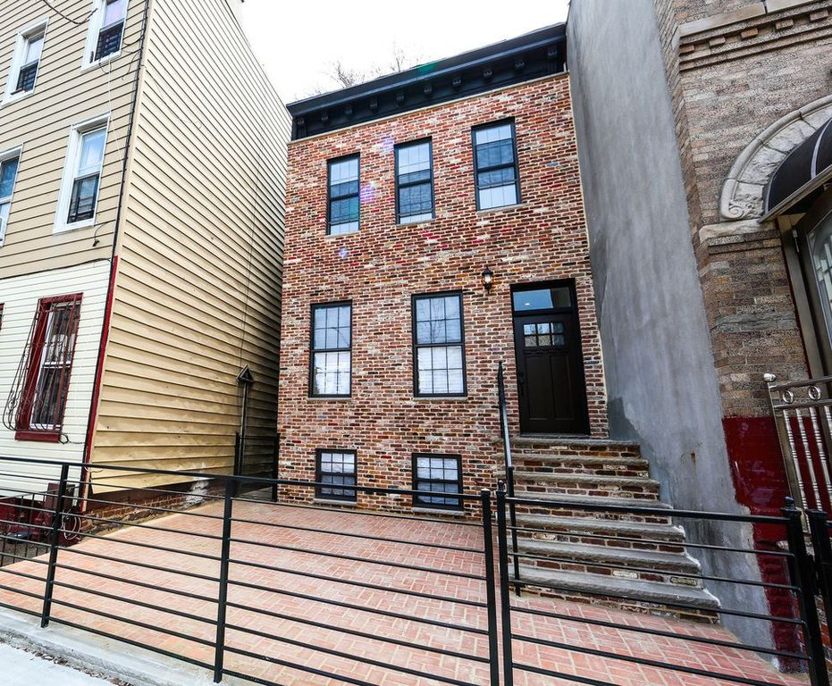
Cover Realty provides clients with reliable real estate research, advisory and transaction services. Our high sales closing rate is a result of our market knowledge, access to qualified investors and transaction expertise.

Site Selection Advisors

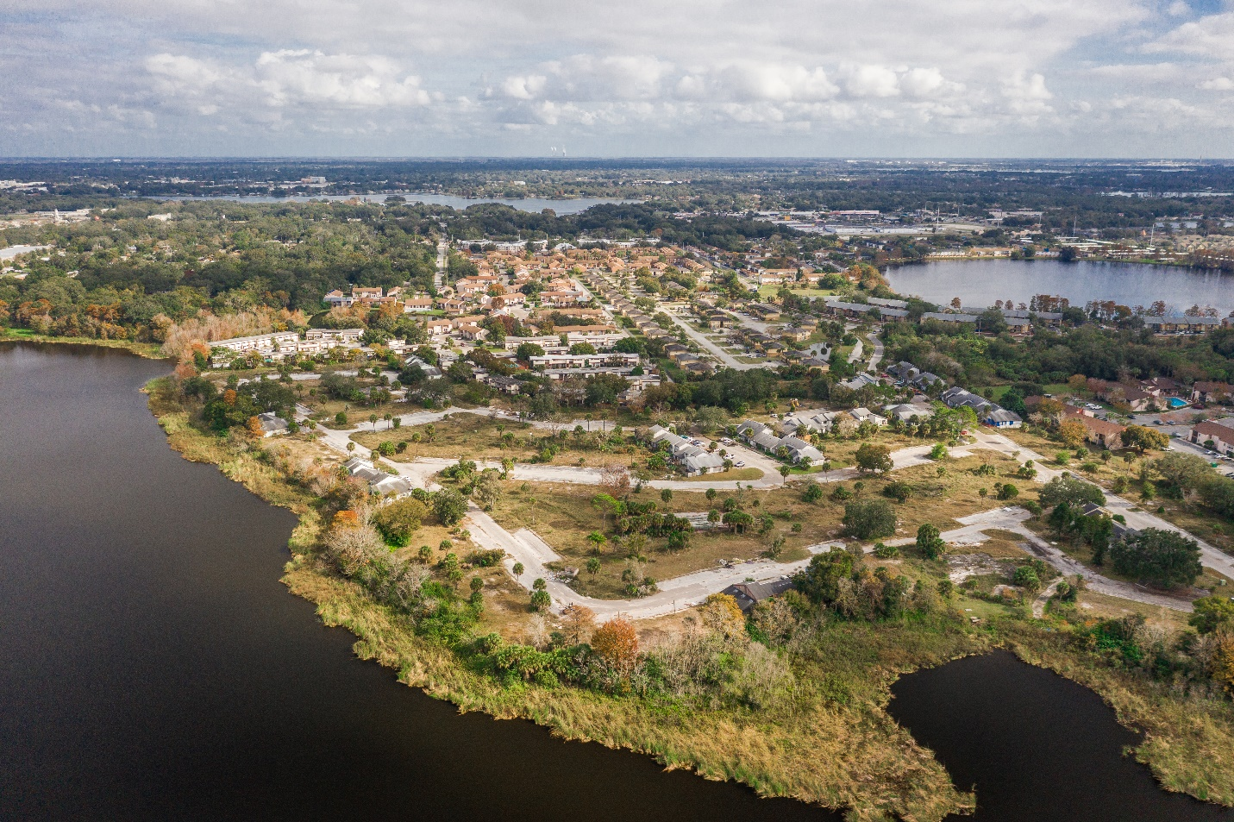

Our industry best Commercial Real Estate site selection services assists developers in narrow down the site that will work best for their investment needs. Our strategic approach to analyzing variables including price, feasibility and overall budget shows clients the highest and best use of selected properties. This ultimately means finding not just a good site for a future development, but the right site.

