FEEDBACK ON DESIGNS AND CHOICES

Overall comments

- We like the green leaves from logo as an accent in all pages like this:

- Try to have the logo as a fade watermark in the background whenever possible.
- After revised version is put together, then we will decide on background colors/texture.

Home page

- Choose a different picture (nature picture like below, no human figures).

Picture with creek, mountain, lakes, blue sky…

- Improve font size and placement of “Dr. Moussavand Tranquility Center” in home page
- Edit the text in home page as instructed in the original description word file.

About us

- Member pictures like:

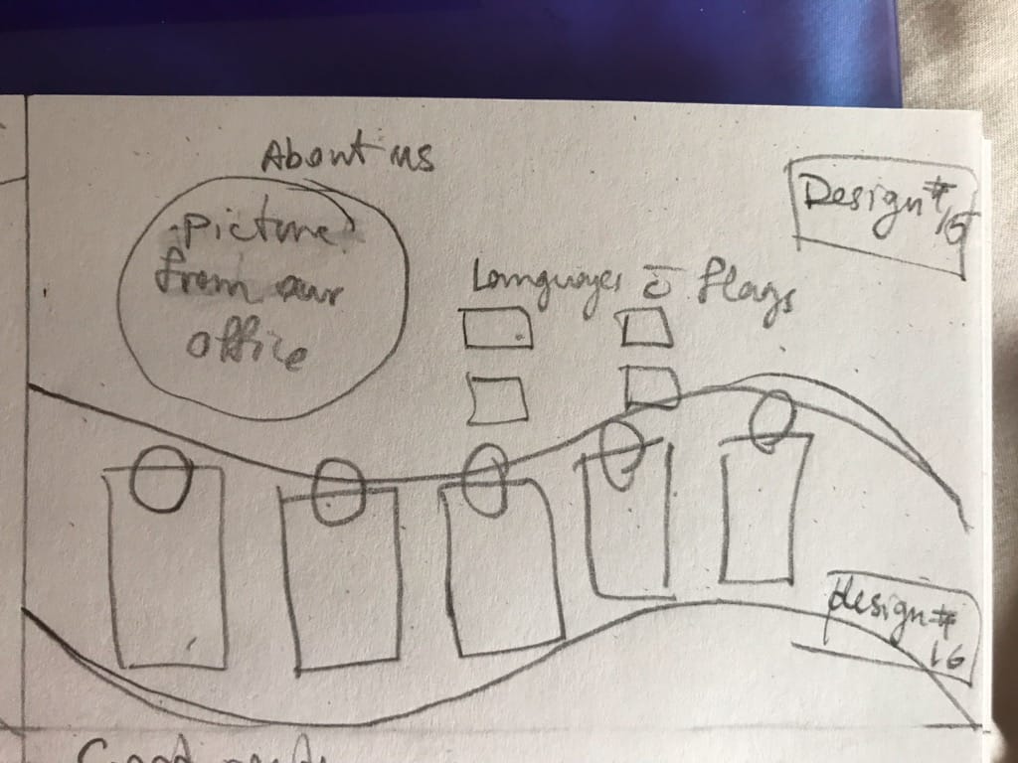

- In the big bubble on this page we would like a few pictures from our office/clinic.

Our services

- We like these:
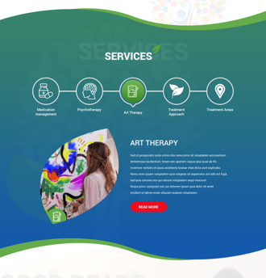

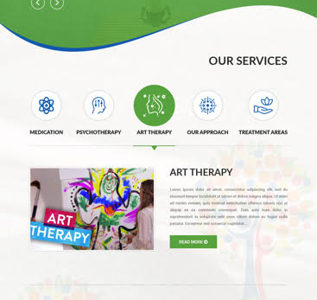

Good reads

- Please see pic below, we like the fade image of person reading; get rid of logo in the middle, keep faint logo in background` and “good reads” faded in background



