



- The company
Cendio pioneered the introduction and advocacy of Linux based solutions since the early nineties in Sweden. Today, Cendio’s customer base exist in more than 22 countries around the world, and the company’s focus is still yet Linux. Delete the word “yet”.
Cendio’s vision is that Linux should be available, easy to use and fulfil the everyday desktop computing needs of all users of all kinds. Cendio should develop products and services that work towards this future.
The company is committed to supporting the free and open source community, academic, and non-profit organizations generously, and nonetheless, individual users and small user groups. That can be noted through our contributions to open source software projects, free licenses for individuals and small user groups up to 5 concurrent users, and our discounted prices for academic and non-profit organizations. More details about these contributions can be found further in this document.

What is ThinLinc?
Thinlinc is a remote access software, tailored especially replace the word especially with the word specifically for Linux distributions. ThinLinc is used as an integral part of infrastructure solutions where there is a need for centralized computing resources and a reliable, secure remote access, whether the centralization was deployed using physical servers, or virtually in the cloud, the (The) Capital letter T last mile we take pride in, is a superb user experience that is equal to that of a decentralized computing infrastructure.

Thinlinc is constantly endorsed by our customers for:

- Linux-ability
By that we mean that:
- Cendio, the company that develops ThinLinc pioneered the introduction and advocacy of Linux based solutions since the early nineties in Sweden. Being exclusively focused on Linux for a long time helped us become experts in it.
- ThinLinc is built and optimized for those who are Linux enthusiasts and who choose Linux as an environment.
- ThinLinc works efficiently with various Linux distributions.
- The logic upon which ThinLinc was built makes its architecture, tools, and deployment very easy to understand, deploy, and manage for Linux administrators.

- Local experience
The hesitance to migrate to centralized, remotely accessed computing resources has been always related to reasonable concerns about the weak performance and the lack of quality of end user experience.
Thinlinc strives all the time Replace with constantly to make the end user experience when connected remotely, add coma after the word remotely, delete the word “is” is indistinguishable from that of a local workstation. Therefore, Thinlinc comes equipped with several tools to deliver the expected performance for a wide variety of demanding users, whether they are in high performance computing centers, or users who needs to run complex simulations and advanced mathematical calculations.

- Ease of use and administration

Thinlinc’s administration and end user interface are intuitive and efficient. ThinLinc is possible to install without specialized knowledge, and it does not require the user to input things it can determine on its own, and it is possible to use without reading its documentation.

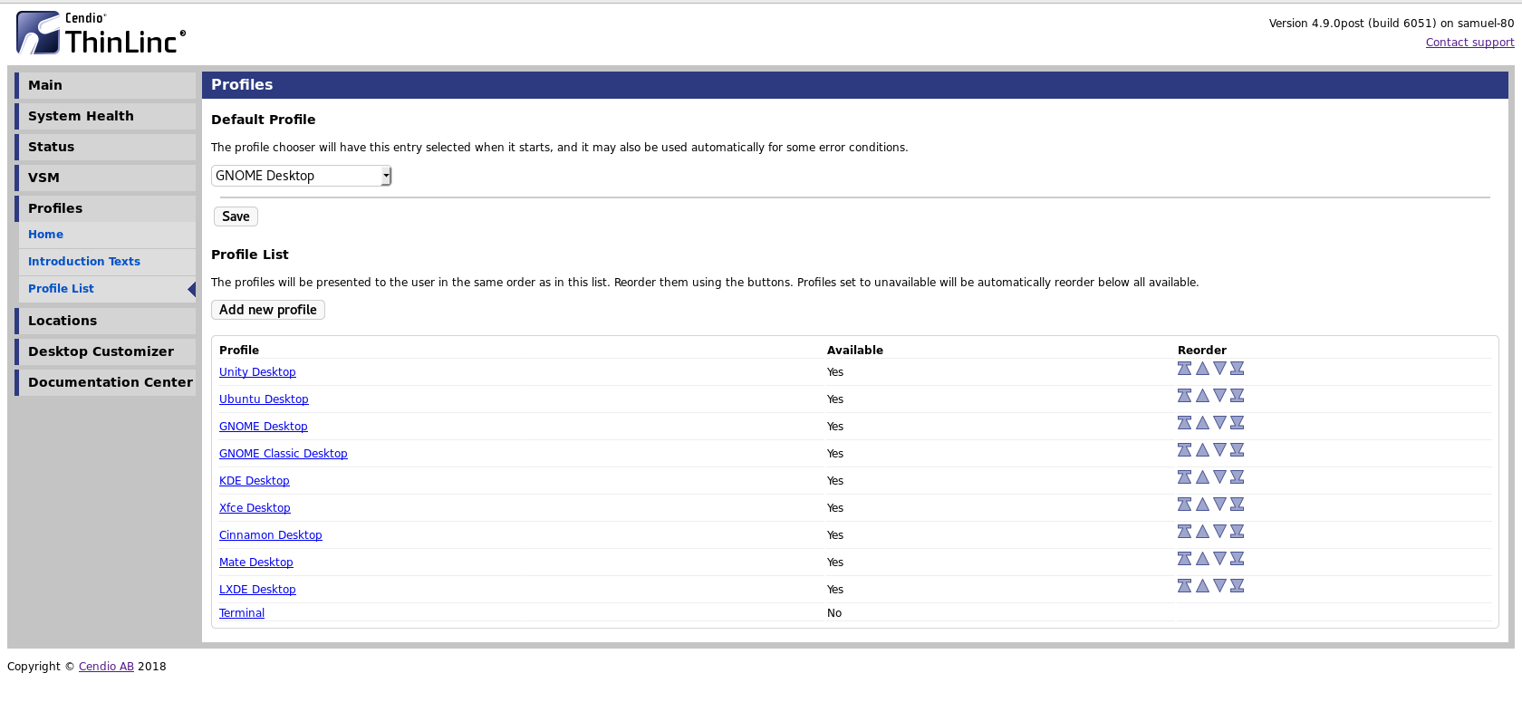

- Transparent information

Cendio works all the time to provide accurate, easy to understand, and honest information about ThinLinc, including information about flaws and limitations that ThinLinc has.
Cendio’s goal has been to maintain an ethical business practice through helping our customers and without any compromise replace with compromises to understand the following:

Understand if ThinLinc can solve their problem
Understand if ThinLinc can NOT solve their problem

Understand which parts are provided by ThinLinc, and which parts come from other vendors

Understand what our licensing allows and what it forbids and how much ThinLinc costs for their use case

- Cost of subscription and required investment
Thinlinc (L is capital here) out performs direct competitors in many aspects when it comes to the cost of subscription, these aspects include:
- The perpetual licensing:
The customers owns the licenses, and has an ultimate free will in choosing to change to between renewing or not renewing the subscription. ThinLinc subscriptions (Please add an S here to subscription) will continue to work for a lifetime. If the customer is willing to continue to get the updates and technical support, then it is completely up to the customer to renew the subscription agreement.
- Discounted prices for academic and non-profit institutes:
Cendio, being a company founded by academics in the first place, continue its commitment and support to the academic and non-profit organizations, by offering a generous discount of 20% on the subscription prices, regardless of which subscription type the organization choses please change to chooses, standard or premium.
- No need for expensive hardware on the client side:
Eliminating the need for a powerful and expensive hardware on the client side, the end users are able to enjoy the tremendous capabilities of servers, one of the perks of server based computing (SBC).

Cost of subscription - comparison between ThinLinc and two direct competitors *
Example Number of users | Competitor T | Competitor N  Standard | Competitor N Premium | ThinLinc Standard | ThinLinc premium
99 | 11,880 $ | 5,841 $ | 8,415 $ | 5,346 $ | 7,425 $
299 | 35,880 $ | 17,641 $ | 25,415 $ | 14,651 $ | 20,033 $
499 | 59,880 $ | 29,441 $ | 42,415 $ | 21,415 $ | 29,940 $
599 | 71,880 $ | 35,341 $ | 50,915 $ | 22,762 $ | 31,148 $

* Please note that the discount mentioned above of 20% will still apply to ThinLinc prices in the table above.

Reliable and robust

ThinLinc minimizes the consequences of external or internal errors and maintain as much functionality as possible.
Examples:

ThinLinc continues servicing new requests even if a single request encounters an unexpected error

ThinLinc informs the user about incorrect inputs and not act on them

ThinLinc informs the user about problems in a way that allows them to be easily fixed

Secure
ThinLinc is secure against eavesdropping and unwanted manipulation from all sources, local as well as remote.
Examples:

ThinLinc is secure against eavesdropping of network traffic between client and server
ThinLinc is able to detect and prevent connections PLEASE ADD an S here to the word connection to the wrong system
ThinLinc secures session information from anyone except the specific user or administrator

Any device or system
The ThinLinc server can be integrated into please change in to into any existing environment without modification, and any client device should be able to access the server.
Examples:

ThinLinc uses the system's existing user database and authentication methods

ThinLinc is usable from any laptop or workstation
ThinLinc is usable from the most popular thin terminals

Responsive support
Cendio takes pride in providing its technical support according to the highest industry standards, in order to do that, we focus on:



Shorter initial response time 2 days max complete The Result is that the customer please add The and that the to this knowing
Currently an hour or 2 response time. What to do next

System architecture and migrating to ThinLinc
ThinLinc is a product for enabling remote access to Linux desktops, by that, it is used for managing server based computing. The system is partly based on open source software, which has led to an expansion of the product to encompass solutions for authentication, availability systems, emulation and conversion between different computer systems. ThinLinc can be used as a gateway between different types of clients and a large number of base systems.
The system architecture allows for an existing infrastructure to be maintained while the new architecture is gradually introduced to replace to with in the organization. The system can be launched alongside the delete the word the existing systems for a gradual migration to a new platform, and at the same time it acts as a link or gateway between the existing systems.
The architecture is designed to be flexible in order to handle larger organizations with autonomous office applications or functions, whilst maintaining management and security. The system can be supplemented with an automated system for installation, configuration and administration of the client hardware, such as through the use of PXE. It's also possible to create different user groups. In this way departments with special needs are easily administered in the case of adaptations or user-driven application development.

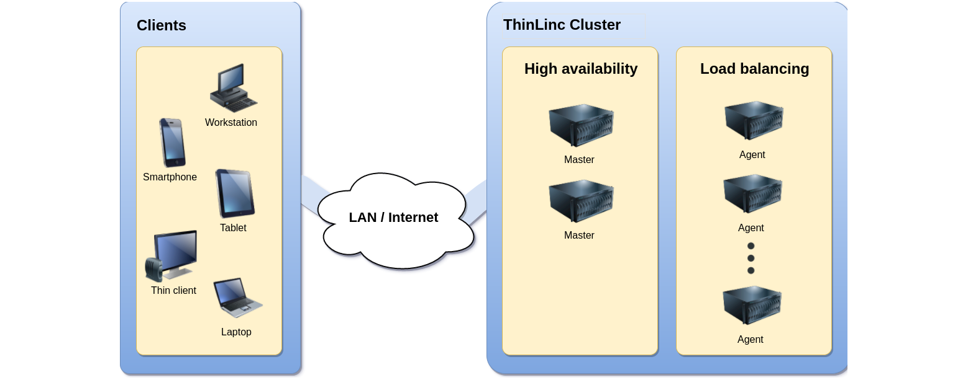
The ease of migration has allowed plenty of organizations to move to ThinLinc in the most efficient way, . Instead of coma an An instead of an example of a popular migration movement to ThinLinc from other solutions is moving from Oracle Sunray after Oracle announced the discontinuation of Sunray, please check our table of comparison, to see in detail how ThinLinc compares to Oracle Sunray, customer cases, and information on the migration process and how ThinLinc successfully replaced Sunray here:

 →

https://www.cendio.com/campaigns/replace
https://insights.oetiker.ch/linux/sunray2thinlinc/

Example of use cases for ThinLinc
Universities
No hassle deployment of University applications to students this shall be on a line alone ThinLinc provides a connection to a full, graphical desktop environment on a remote computer, including audio, local resource sharing (drives/printers/etc.), and smart card authentication. For programming from home. Over the years, it has proven to be difficult for students to install compilers add s here and text editor on
their own computer. An add An here alternative is ThinLinc where students can connect to university system who replace with which provides them with all the add the necessary tools.

Example of our university customers
Organization name | Location | Use
University of Kiel | Germany | Linux remote desktop access
Max Planck Institute | Germany | Linux remote desktop access
Stuttgart Universität | Germany | Linux remote desktop access
Universität Bielefeld | Germany | Linux remote desktop access
Stanford University | USA | Linux remote desktop access
Indiana University | USA | Linux remote desktop access
Lund University | Sweden | Linux remote desktop access

Click here to find out how Indiana University and Denmark Technical University DTU are using ThinLinc. https://www.cendio.com/casestudies/dtu_indiana_en.pdf

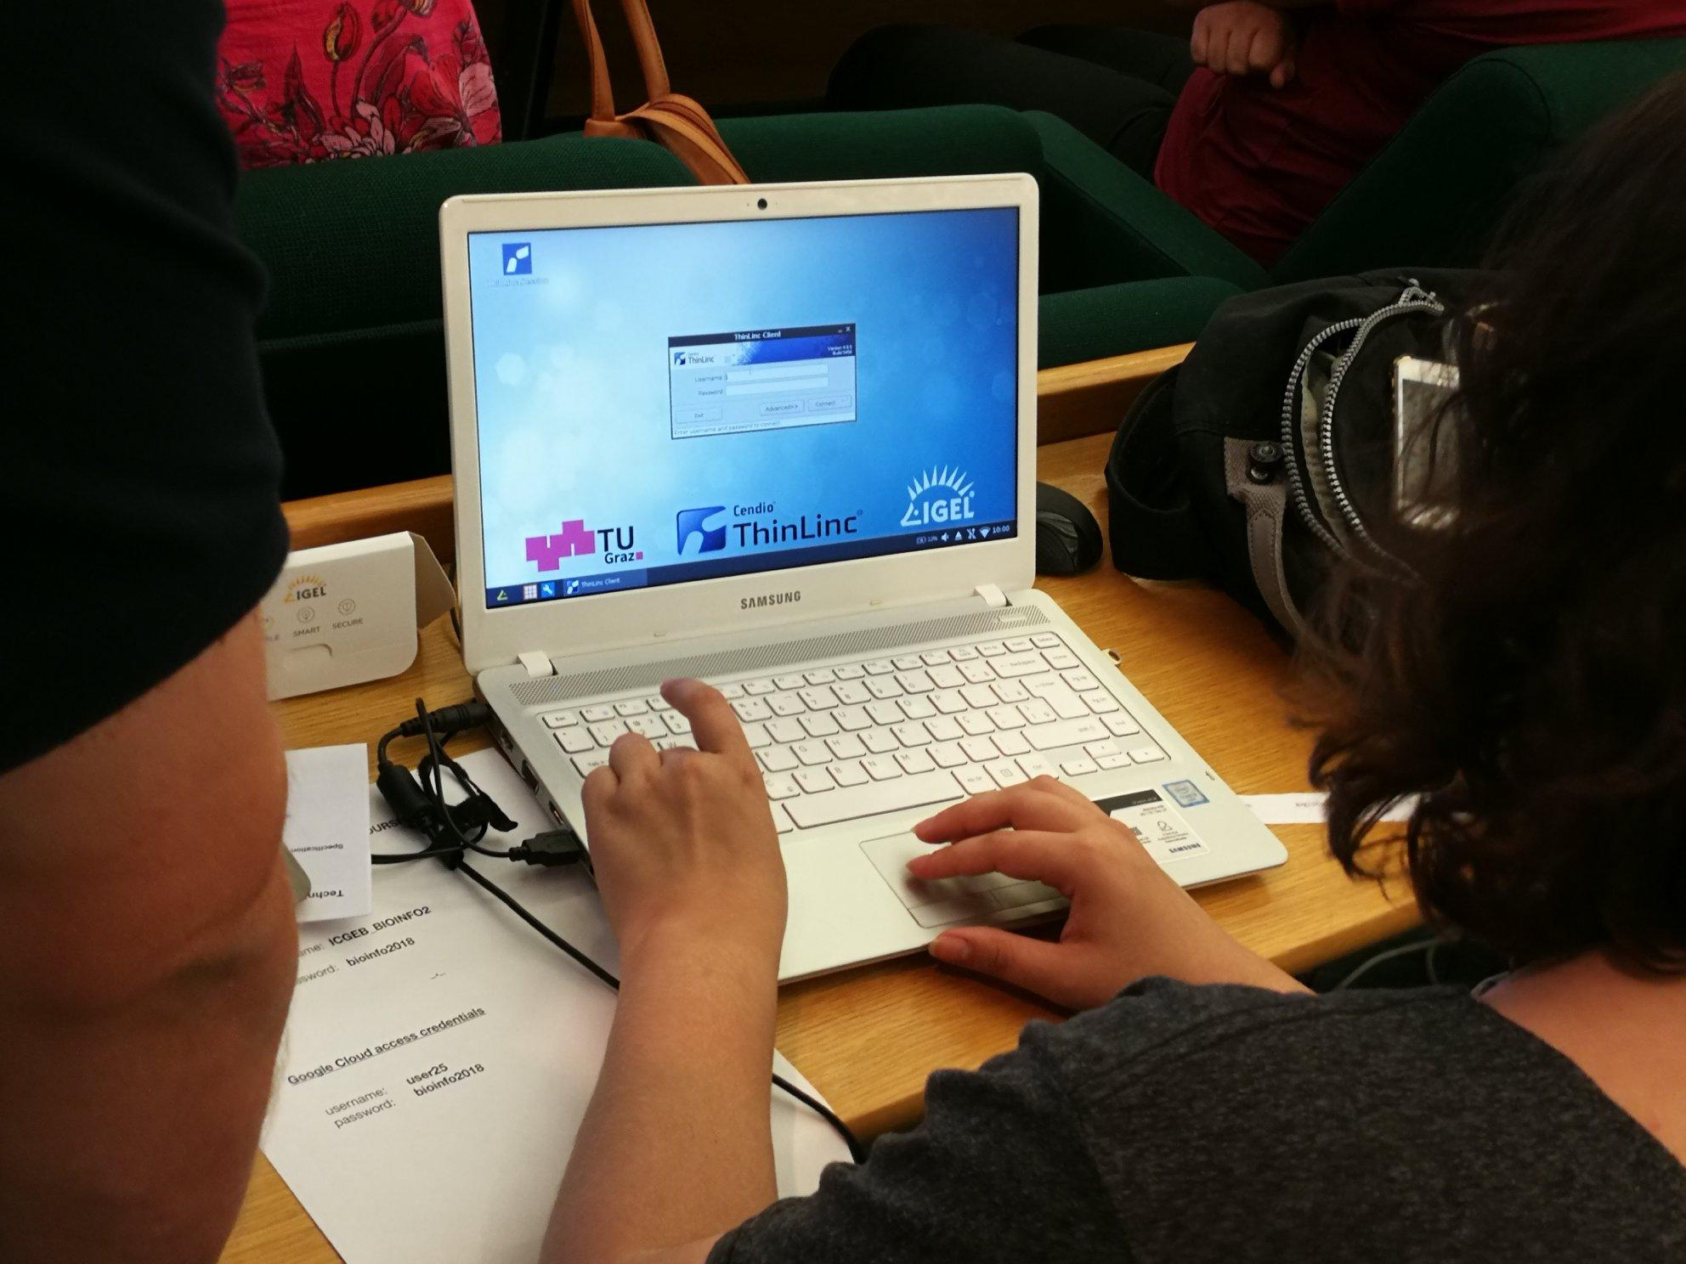

Hosting Linux applications
Legacy applications that need to be accessed.

Animation Studios
External access to sensitive data: This shall be on a line alone
ThinLinc can provide you with a way to reduce the risks of allowing external parties access to your sensitive data. The data remains securely stored on your servers with ThinLinc still providing a way to see and interact with that data. Copying the data out of the system can be made very difficult by disabling data transfer features of ThinLinc and the underlying Linux system. This setup has proven popular with companies in the content industry where contractors and other third party need easy access to the content as it is being produced.


Example of our customers:
Disney animation studios https://www.disneyanimation.com/
MPC https://www.moving-picture.com/
Themill http://www.themill.com/

Linux on Windows add ows to win Computer
Linux applications with any client device:
If your organization needs to access specific Linux applications or entire Linux environments add s to environment on Windows computer than then instead of than is delete is ThinLinc a great solution. ThinLinc gives users local desktop experience, freedom and flexibility to work from anywhere and they don’t need to care about their data and security because everything is stored in a central server. Please swap the location of the penguin ad Microsoft here under



High Performing Computing

Easy, efficient access to computing clusters from any device: this shall be on one line alone
By running the X server on a server in the cluster (i.e closer to your application) and using an efficient method for delivering the image to your local computer (VNC-based), most graphical applications will run significantly better than when using X-forwarding tunneled through SSH. ThinLinc can also make use of a graphics card in the ThinLinc server to provide hardware acceleration to OpenGL applications (e.g VMD, Maestro, Gaussview).

Here are some use cases:
- Modern GUIs that do not run well using X-forwarding
Certain graphical user interfaces are implemented with no regard for performance when tunnelled through SSH on a connection with high latency, and will be more or less unusable. Since ThinLinc presents a local X server to the application (with almost zero latency) and handles the transportation of the graphics data invisible to the application, it can perform much better for these types of applications.
Here you have copied the text in the upper paragraph twice please change this to the green text in this paragraph, thanks.
- Using accelerated OpenGL applications

Perhaps you want to run a graphical user interface (GUI) that is using OpenGL (e.g VMD) to visualize data that is located at a please add a server? Please add a question mark Rather than moving a large amount of data to your local computer and visualize it there, you can run the GUI directly on a server system and display the window on your computer with much better results (higher frame rate etc) than using traditional X-windows tunneled through SSH.

Example of our high performance computing customers:

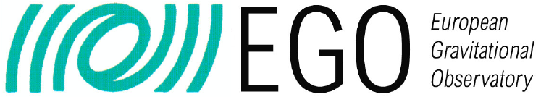

Red Network
Internet browsing from secure networks
In some scenarios it is necessary to create a network that is isolated from the outside world. Commonly this is because of very sensitive or secret data being stored on this network. However, access to the internet is still often required for users to be able to perform their work effectively. ThinLinc has allowed companies this possibility without having to set up multiple computers and multiple networks for each user.
The basic principle is that a ThinLinc system is set up on an intermediate network between the secure network and the public internet. The system is heavily locked down to prevent accidental data leaks and firewalls are configured so that this bridge can only be used
for ThinLinc. Whilst not as secure as a fully air-gapped network, this setup can provide a very high level of security whilst still allowing users to have a flexible work environment with the tools they need.


Commitment and contribution to FOSS


In addition to our commitment and support to universities, academic institutions, and non-profit organizations, Cendio’s contributions to the open source community can be clearly noted in the following areas:

TigerVNC

Cendio has a long history of working with the open source community, and participating in the VNC development has been a high priority for us.

Between 2002 and 2009, we worked with the TightVNC project. We contributed with patches to the TightVNC 1.2 series, which was based on the original VNC code base. In 2004, we started porting the "Tight" protocol to the fourth generation of VNC. The result was the TightVNC 1.5 series, which included an Xserver which could be used with Xorg 6.8. This was a huge improvement compared to the old releases, and allowed us to ship a server with features such as font anti-aliasing, OpenGL, and much more, making Xvnc suitable for modern desktop environments and applications.

Cendio is a leading developer of TigerVNC
The 1.5 series of TightVNC was never released. Instead, in 2009, we teamed up with Red Hat and the VirtualGL project. The result was the TigerVNC project. It was based on TightVNC 1.5. One of our first contributions was an integration of "SIMD" accelerated JPEG compression and decompression. Given a reasonable reasonably instead of reasonable fast server, client, and network, this makes it possible to play back motion graphics in full screen mode remotely. This can be done without any client side video decoder software or specialized handling of video. These performance enhancements also made TigerVNC suitable for VirtualGL setups, which provides hardware accelerated OpenGL on the server side. This allows applications such as Google Earth to run with good performance. Other enhancements include: Please make the following paragraph an itemized list

- Development of the ExtendedDesktopSize extension, making it possible to implement the RandR extension on thep the instead of thep server
- CMake based-build system. Windows components can be built with MinGW
- A new FLTK-based vncviewer which supports UNIX, Windows, and macOS

In addition to combining our efforts of creating a superior VNC implementation, we are also continuously working on documenting the RFB protocol and its extensions.

How to evaluate ThinLinc?
The process of evaluating ThinLinc is easy

Download ThinLinc server bundle from our website www.cendio.com
Contact us during the evaluation, your technical questions will be answered by our experts in a clear and honest manner.
Large size deployments can get additional testing licenses and an evaluation account
1
3
2



Customer testimonials
Finally in this section, we thought to include some of our customers testimonials, voluntarily written by our customers, sharing their thoughts about ThinLinc and Cendio.

"One of the main reason for us to replace FreeNX with Cendio is a much better linux client integration, bidirectional audio, Centralized Web Interface, desktop web access, amongst other great features, but mainly support from you guys, which I been following for more than 3 years."

Rui Lapa
Tranquilade

"Thank you for this outstanding software!"
Dr.-Ing. Norbert Riefler
Leibniz-Institut fuer Werkstofforientierte Technolgien

"I tested Thinlic and it is awesome! The installation works out of the box. The feeling is way better than NX or other products I tested before!"

Matthias Jung
Technische Universität Kaiserslautern

"Many thanks for the excellent Cendio Support in investigating this tlclient issue on my Debian Buster desktop."

Zdenek Matej
MAX IV Laboratory

"ThinLinc is an elegant and efficient solution that we chose to provide the clients with a remote access to the HPC environment."

Vincent Vu
Shared Services Canada

"I am currently doing research for a NASA customer who is faced with kicking their SunRays to the curb and having to find a reasonable replacement. So far, ThinLinc seems to fit the bill especially when it comes to OpenGL and graphics capabilities at the client side of the equation."

Mike Williams
Dynamic Systems Inc.

Contact us

Cendio AB
Teknikringen 8, 583 30 Linköping
Sweden
Email: contact@cendio.com
Phone: +46 (0)13 21 46 00

