Le Grand Plan
Premium Olive Oil Producer from Provence – Bottle Label

Project
Design front and back labels for the bottles of our olive oil. The bottle colour is black matte. Front label is oval (70mm wide, 105mm tall). Back label is rectangular (50mm wide, 150mm tall)
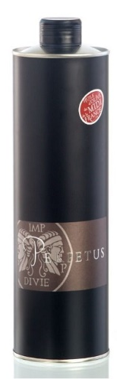

Our brand
Le Grand Plan is both the historical name of the estate and the name of our brand. It represents the rugged beauty of nature, the value of craftsmanship, and the respect of hard work. It’s bold and premium without being superfluous. It’s a young brand that represents timeless values for men and women alike.

Logo elements supplied
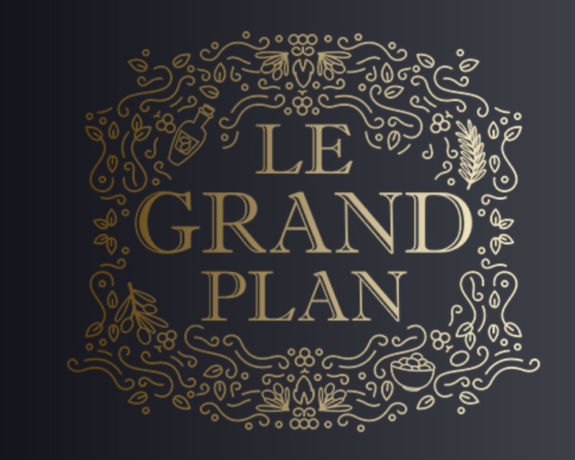
From this option, we’d like to retain the ornament around the logo. This needs to extend across of the label and provide background of the design (see the example of Naughty & Nice below)
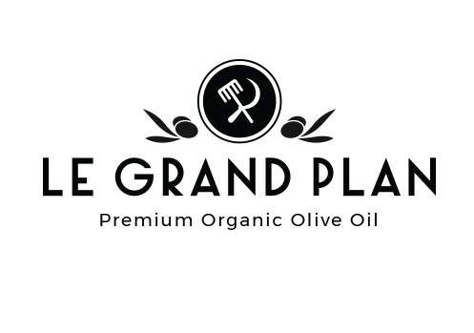
From this option, we’d like to retain the ‘masculine’ typography of Le Grand Plan and the ‘stamp’ of the logo above it. These elements need to be integrated into the design.

Inspiration

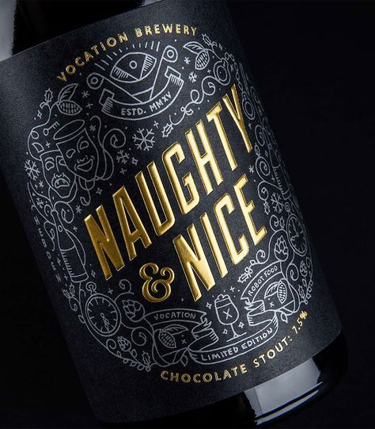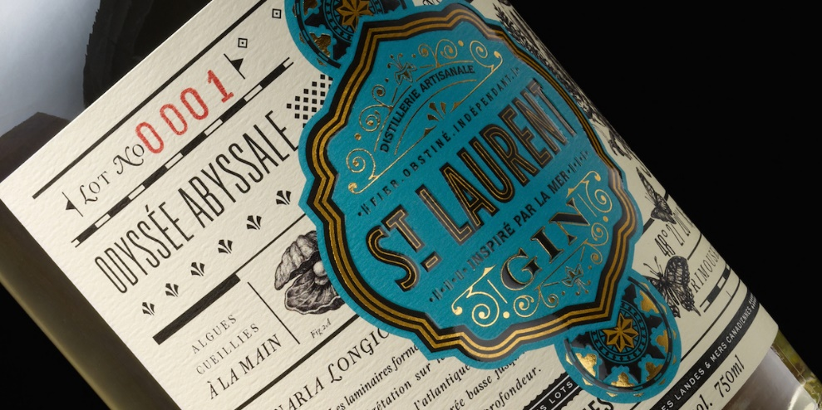

Elements to integrate
Front label:
- Name: Le Grand Plan logo (as per above)
- Descriptor: Huile d’Olive Vierge Extra
- Call-outs:
- AOC Haute-Provence
- From Provence
- Organic
- Hand-picked
- Artisanal
- Single cold-press
- Unfiltered
- Late harvest
- November 2018
- Limited production
- Made in France
- Vol. 500ml
- Bottle No: (leave space for the number)
Back label:
- The story of this bottle
- Nested in the hills of Provence, Le Grand Plan is a wild and magical place where forest opens up to vineyards and olive groves. We fell in love with it, and you would too! It’s in these hills that Aglandau olives were grown since Roman times, and we were happy to bring them back. Our production is entirely organic, we pick our olives by hand and only at the point of maturity. We don’t harvest our Aglandaus until very late in the autumn, and use a single mechanical cold-press extraction. The reward? A very special extra virgin oil with its full-on bold taste, hints of artichokes and fresh-cut grass, and remarkably low acidity. Best enjoyed before August 2020. Do let us know how you liked it at info@legrandplan.com! L+M

