Fleetmaxx Solutions Logo Brief

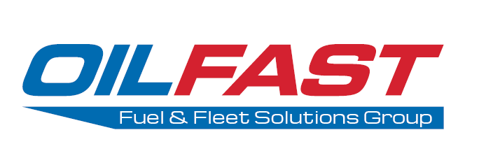
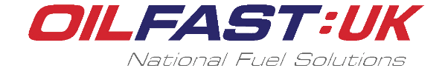

Above is an idea of how the company is structured. The company is Oilfast Limited and has previously been made up of Oilfast and Oilfast UK. We have recently purchased VTS Group and are setting up Fleetmaxx Solutions as a new trading name.
Oilfast Group
Oilfast Group logo was created by our in-house digital marketing assistant who has experience at design. It was created to merge the Oilfast and Oilfast UK logos into one group instead of sitting as separate unconnected brands.

Oilfast
This is our main brand and is made up of 7 Scottish fuel depots. These supply kerosene heating oil to domestic homes, and Gas Oil Red Diesel and DERV Road Diesel to businesses across the majority of Scotland. We also offer fuel related products such as fuel tanks, accessories, Adblue and LPG gas bottles.
Oilfast also offer Fuelcards to commercial fleets but this part of the business will merge into Fleetmaxx Solutions

Oilfast UK
Oilfast UK are a national fuel solutions provider for the whole of the UK. The brand focuses on being a one stop shop for all commercial fuel requirements. Many large commercials require either large quantity deliveries or have hundreds of sites across the UK which require fuel. Oilfast UK allows these commercial clients to have one point of contact for all their fuel needs rather than calling local distributors in each area they operate.
Under the Oilfast UK brand, we have also bought a small fuel distributor in Raglan, Wales. We are making efforts to move this away from the Oilfast UK brand and onto the Oilfast Group.

VTS Group
We recently purchased VTS Group which specialises in fleet telematics which allow companies to GPS track their fleet, see a range of statistics from mileage & fuel consumption to live diagnostics, as well as dashcam tracking which record and send reports back to head office.

Fleetmaxx Solutions
This brand is being setup to merge the Fuelcards with the telemetry of VTS Group.
The intention being that we can offer complete fleet solutions from fuel to telemetry to eventually selling fleet insurance and in-cab communications. The sales staff will be making outbound calls to a range of commercial clients so it makes sense for them to cross sell other products they may be interested in.
Fleetmaxx will be predominantly fuelcards and will sit separately from VTS Group.
VTS Group will simply pass on a commission for any sales Fleetmaxx makes on its behalf.
The product range is geared around the needs of fleet operators from ‘man and van,’ to more substantial operations that might have a mix of vehicles, cars and vans to HGVs.
The major products that will be offered include telematics, fuel cards, insurance and communications.

Some words that may describe our operation at Fleetmaxx Solutions:

Serious Professional Consultative National
Client-led Simplicity Convenient Security
Economical Service-led Ease of use Safe
Adaptable Diligent Inventive Reliable
Creative Honest Receptive Savings

Possible slogans:

‘Driven by customers’ ‘Driven by you’ “Complete Fleet Solutions”

Possible colours and their psychological suggestion:

Green - balance and growth, self-reliance.
Turquoise - communication and clarity of mind.
Blue - trust, peace, loyalty and integrity.
Brown - friendly, yet serious. Security and protection.
Gold - success, achievement and triumph.

Don’t want:

Cartoons
Exclamations
More than three colours
Old-fashioned fonts

Brief
For Fleetmaxx Solutions, we would like a logo that sits close to VTS Group as they will be selling VTS products but with enough of a difference to know they were two separate companies. The logo should reflect Oilfast Group if at all possible to show a link back to the main brand.

