CREATIVE BRIEF DESIGN CROWD

LOGO DESIGN

Who are we ?
RD Producten is our company name and we own webshop https://hondenkussen.nl/. We sell dog pillows (in Dutch translated as ‘hondenkussen’) and bench cushions on which dogs (or cats) can relax or sleep.

What are we looking for ?
We presently only have a logo of our company name (see below), but we would like to get a combination of our company name and the name of our website/webshop.
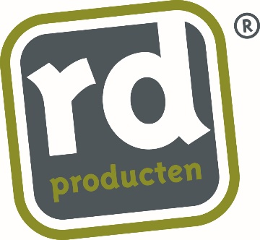

Desired name of the logo ?
RD Hondenkussen

Target market ?
Our pillows are made of high quality fabrics & virgin EPS granules. We aim for the higher end of the market, meaning consumers that are willing to pay a relatively high price for a chic dog pillow

Project details ?
The new logo
- should preferably show a link to our present company logo
- must include a silhouette of a dog
- must
- stand for Quality
- stand for Reliability
- stand for Exclusivity
- give a Chic impression

