Young CEO Squad Brand ID Development

The company will have an online platform and product line to encourage kids age 12-18 to start their own businesses. The students will use their personal cell phones to login to their account where they will learn from videos the skills they need to be successful as entrepreneurs. We want this to be young and fresh but not child-like. We are ok completely changing the current logo and color scheme. We want the brand to be bold and innovative. We want to attract kids who are motivated to make money but the real buyer is going to be their parents.

The YCS brand should express vivid colors palettes, bold fonts, and futuristic patterns to communicate our young, rule-breaking vibe for our young customers. We want an explosion of futuristic influences to stand out from the noise created by other brands.

Target Audience

Kids age 12-18 who are motivated to be successful entrepreneurs will subscribe to our app and be a part of an online ecosystem with like minded kids. The brand is young and fresh but not child-like. We're focused on middle school and high school, US only, and all economic backgrounds. We'll have a scholarship component as well. We want to attract kids who are motivated to make money but the real buyer is going to be their parents so it does need to convey a solid reputation, trustworthy and look established.

Common elements of our futuristic design

Bright color palettes

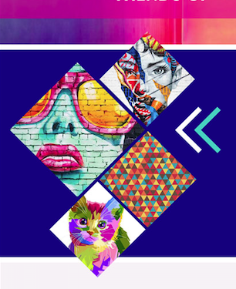

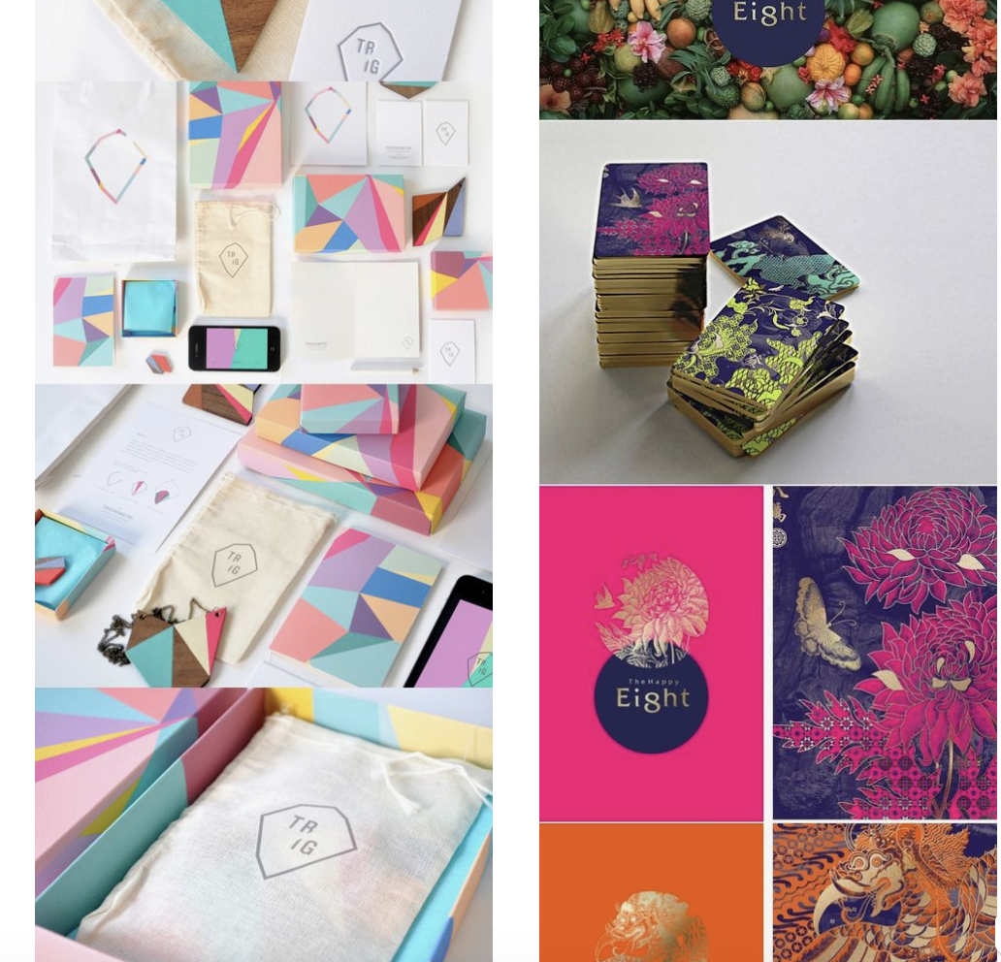

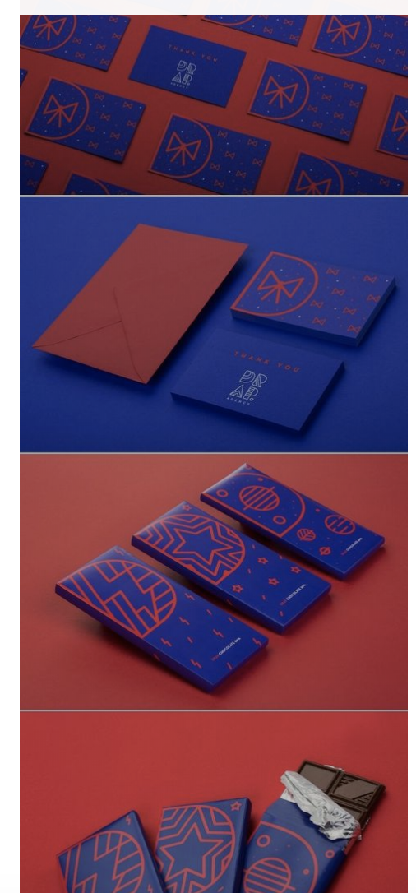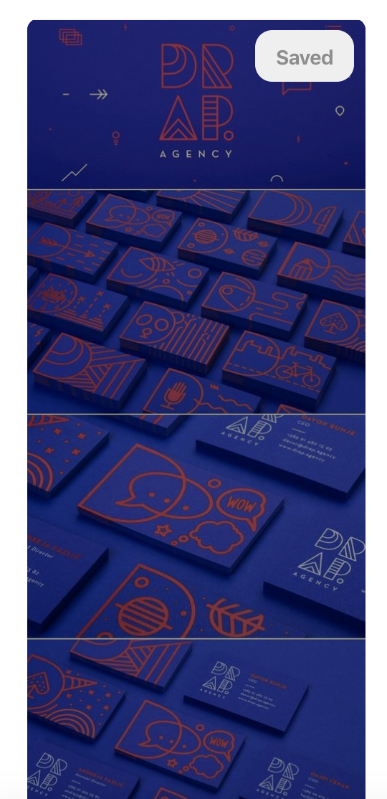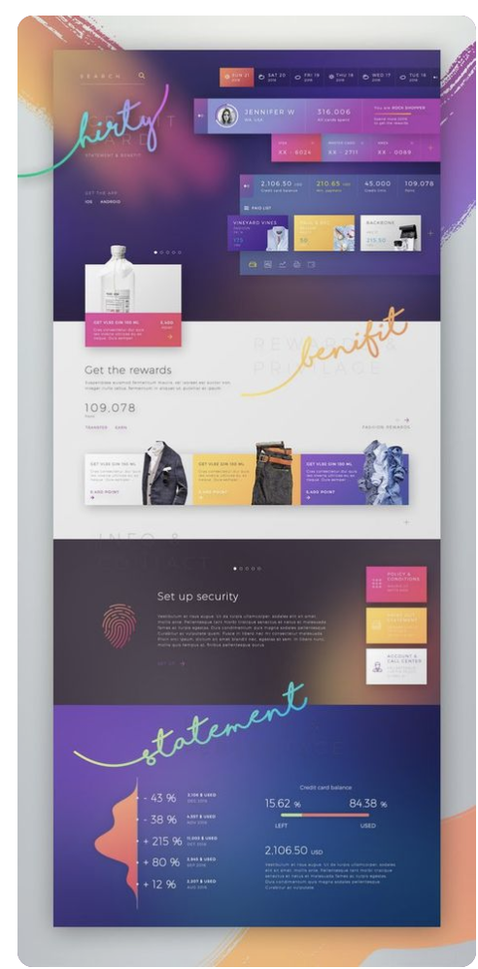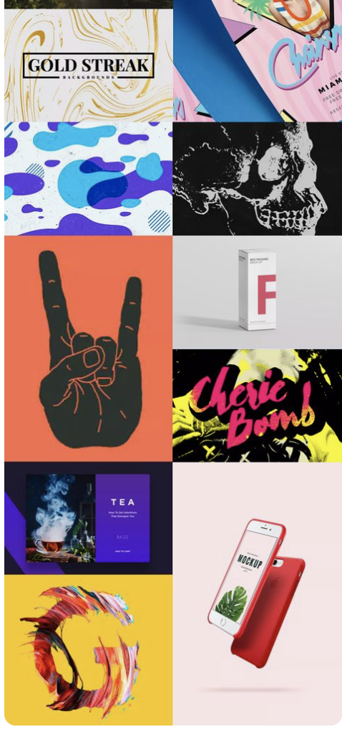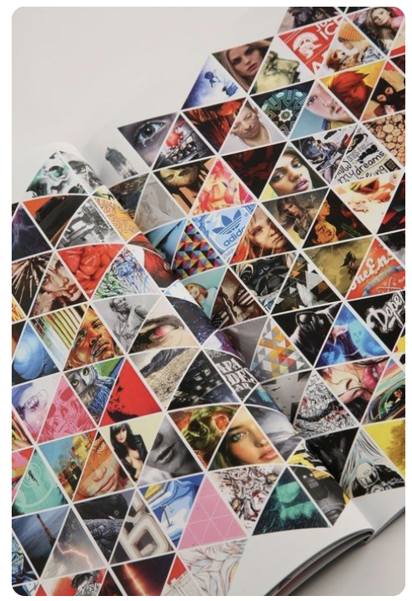

Strong Bold Fonts

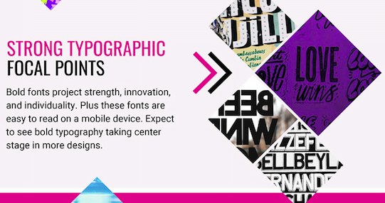
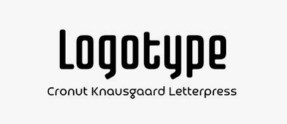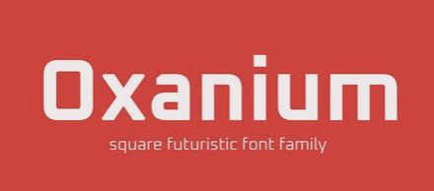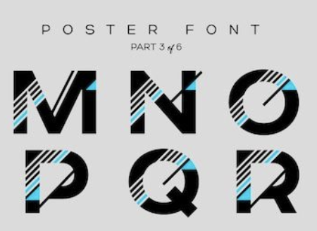
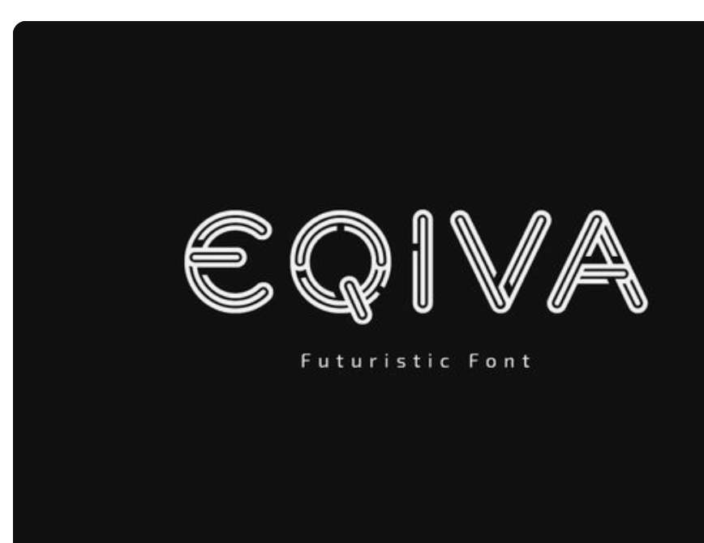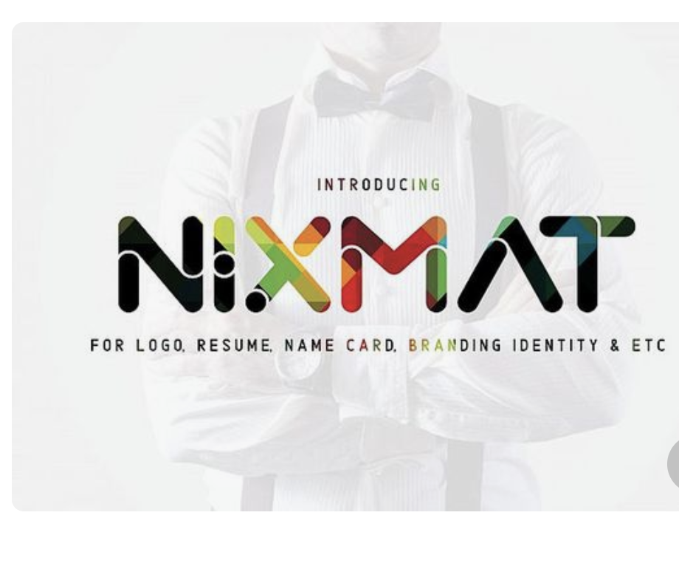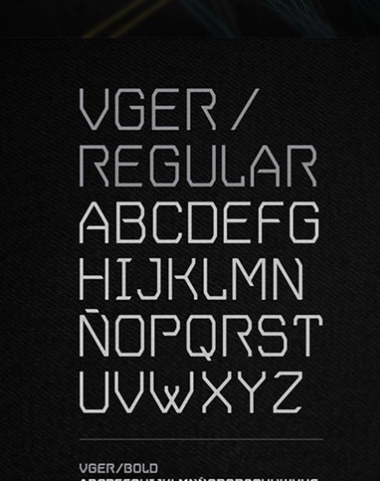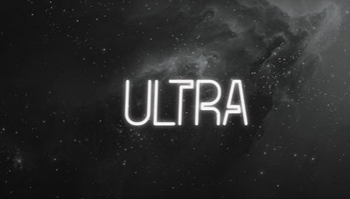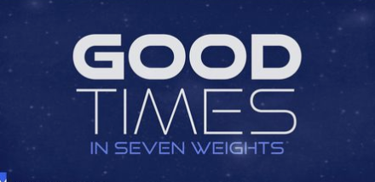

Gradients and other color transitions/ Patterns with geometric influences

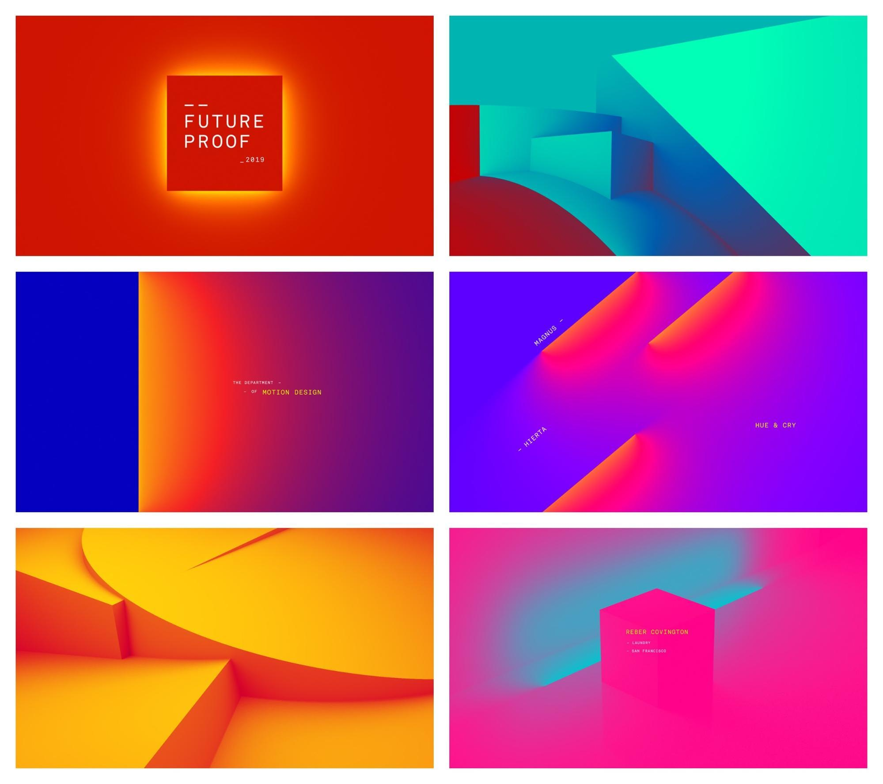

Holographic and reflective elements

Gradient grows up and is used in more ways than just a simple background This simple overlay can instantly upgrade even the blandest stock photo. Also, this visual strategy can become part of their brand, making it easier for readers to spot their content.

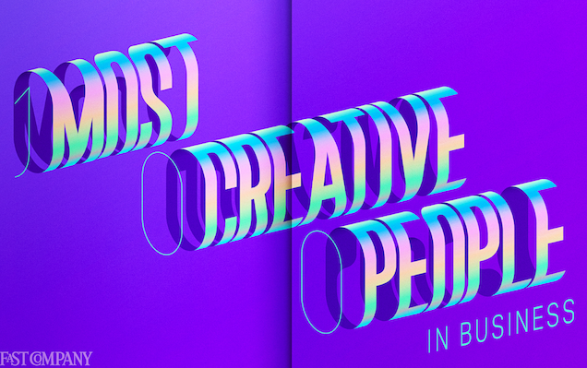


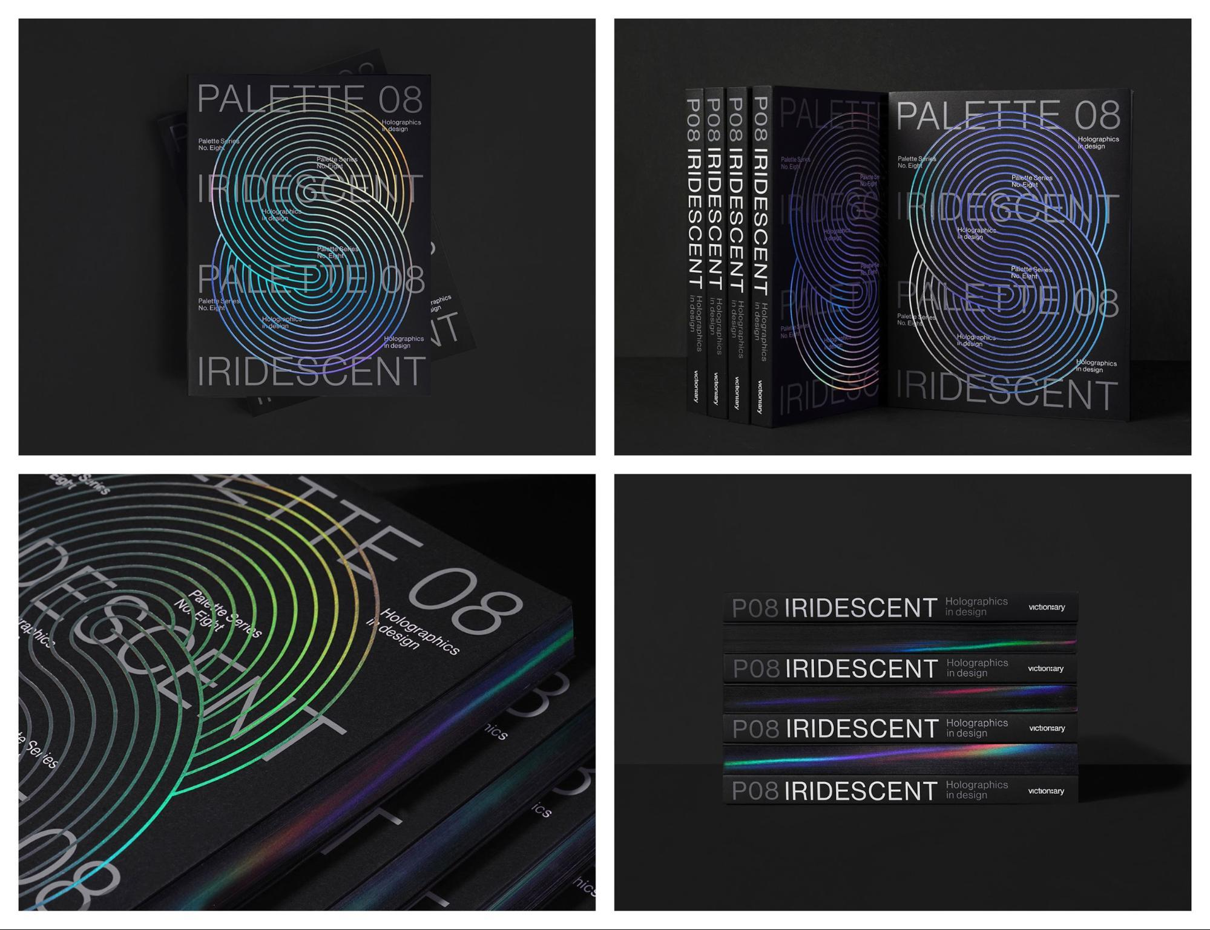

Custom or hand-drawn illustrations

Custom or hand-drawn illustrations are an excellent way to make your visual content stand out. Reject the overly polished company image that they see online every day.

I like that these illustrations look like they were all created by the same designer, which is very difficult sometimes. Especially when they have a whole team of designers working on one project. This method makes each share or email from them look like it came from a single voice, that their readers can easily recognize.

