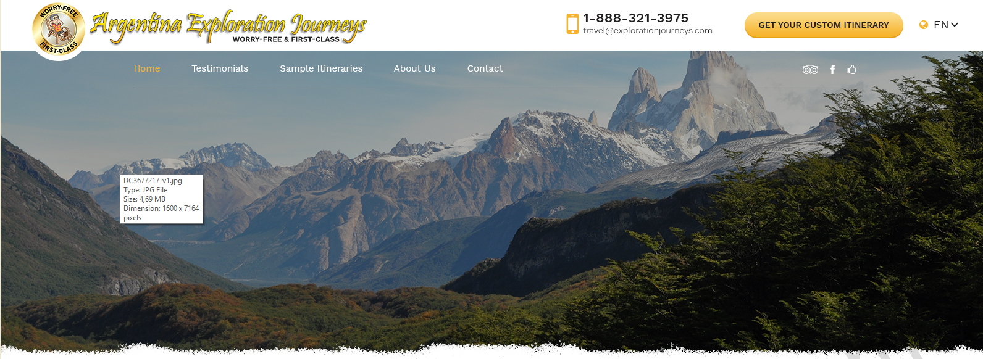

PALLETTE:
The chosen color pallette is this or similar is the one of the header below, with this colors for buttons. But rounded corners. And maybe 3d.


HEADER:

Our favorite header:
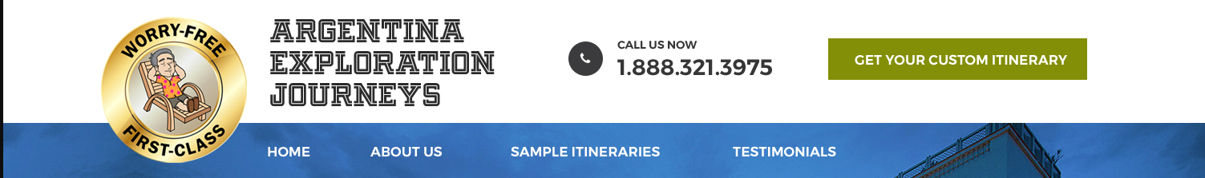
But:
- make menu fonts larger.
- Add the tripadvisor, facebook and our testimonial page icons to the right
- Rounded corners on “Get... “ button
- Place the language bar on the upper right:
- Logo font: please find a rounded font.
- Font ideas:
  - KG Red hands font, green interior (the green in the “Get...” button”. Black outline. 2 pt drop shadow. 4pt blur. This is an example, but not well done:
  - Another font we like: Poppins Thin
  - Of course you can place one word below the other, as above.

- Try the “Get...” button inside the blue ribbon, to the right of testimonials, and the logo with the 3 words on the same line. So the header will be less tall.

GET YOUR QUOTE SECTION - Version 1:

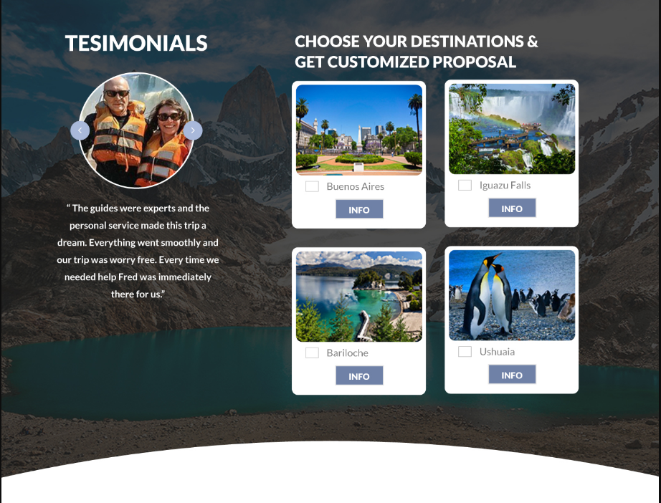

Comments & changes:
- We love the curve below
- The texts above have to be these:
- Make the round photo MUCH larger, to occupy almost the entire width. The caption much larger, everything has to be readable by 60+ year olds. It can go a bit over the photo if needed.
- Add 4 more destinations at the bottom
- Make buttons yellow as above. Everything with rounded corners.
- For the layout of the destinations, we prefer the button above:
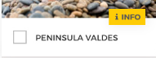
But the button in this shape: 

GET YOUR QUOTE SECTION - Version 2:

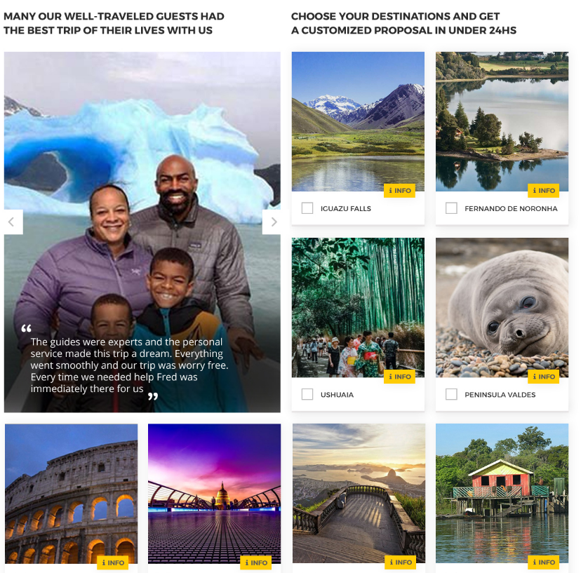

Comments & changes:
- All rounded corners.
- Larger destination name font
- Info button in the same location but in the shape as above. No “i” in the text.

AFTER THE DESTINATION PICKER

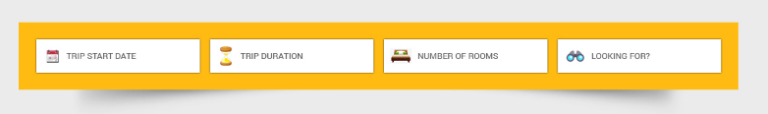

BELOW THIS
A big, nice, rounded, green “GET YOUR CUSTOM ITINERARY IN UNDER 24 HOURS” button.

UP TO HERE, IT IS NOT MANDATORY BUT IT’S MUCH DESIRABLE TO KEEP EVERYTHING ABOVE THE FOLD.

NEXT: TRUST SECTION. we like these graphics more than anything else. Make all fonts dark over light, not yellos.
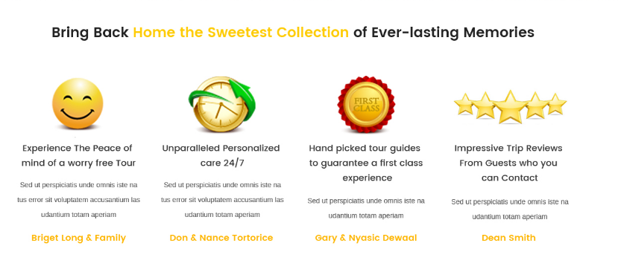

NEXT SECTION: TESTIMONIALS

We like this:

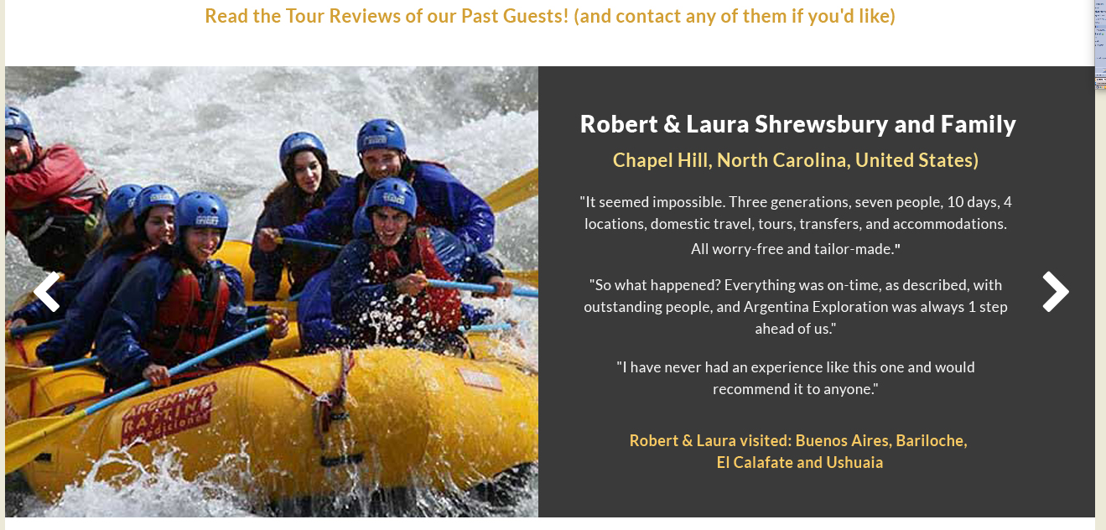

ANOTHER SECTION: CONTACT GUESTS

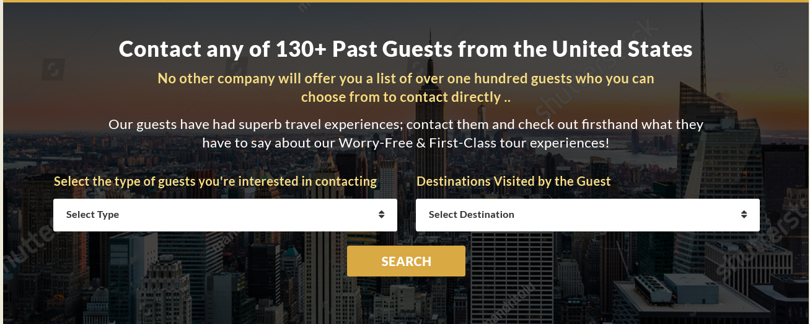

NEXT SECTION: FEATURED DESTINATION

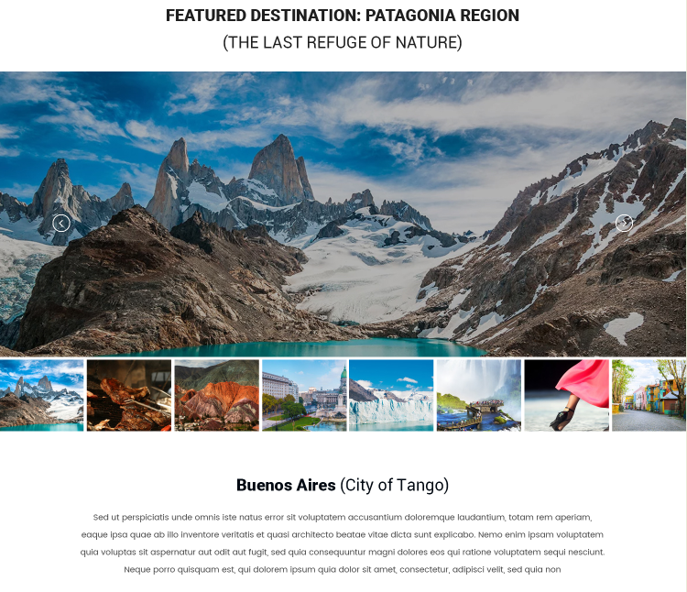

THEN THIS, BUT:
- We need a “info” button for each destination.
- Larger font
- Larger photos.
- Make the rings in the colors of the pallete. Maybe drop shadow.
- Call them all ‘fernando de noronha’
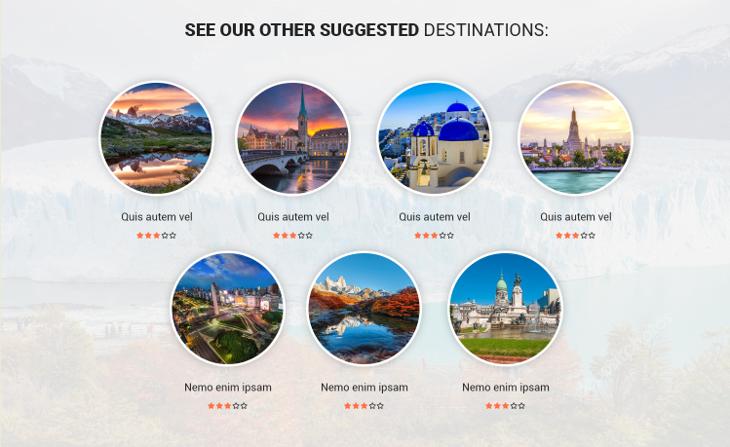

THEN: SAMPLE ITINERARIES

Title: See our sample itineraries

Place on on the right and one on the left. The one on the right has a “gold” badge and on hte left “silver” badge. https://www.brazilexplorationjourneys.com/newejincludes/webquote/images/interface/gold_trip.png
https://www.brazilexplorationjourneys.com/newejincludes/webquote/images/interface/silver_trip.png

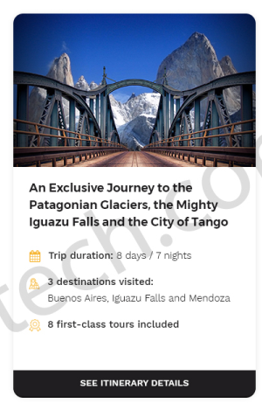
We like this design, but:
- Apply the color pallette
- Use these icons:
- Trip duration:

- Destinations visited:
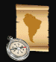
- First class tours included

You can get the icons here:
https://www.brazilexplorationjourneys.com/newejincludes/website/images/interface/EJ-home-sprites.png

WE LOVE THESE CURVES, PLEASE USE THEM ABOVE SOMEWHERE.

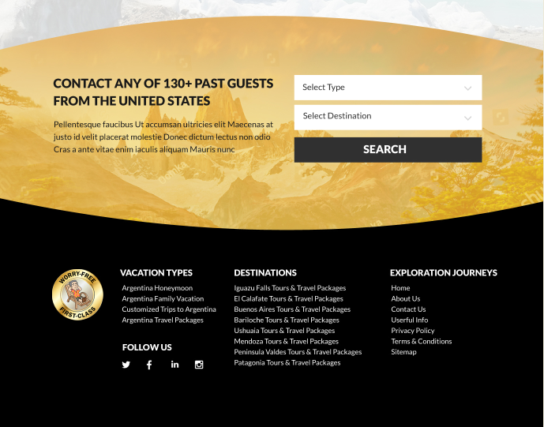
THIS FOOTER IS OK

See below:
Just a comment: nice curves!
