Many thanks for your many proposals and effort!
Here goes feedback for a second round. For now, let’s focus only on the above the fold content. As soon as we have feedback for the rest, we’ll let you know.

- Font size: everything has to be readable by 60+ year olds. Big readable fonts.

- Font contrast: always use high contrast font over background. Never yellow over white, etc.

- Color pallettes: please use one of these in one version and the other in another version



- Header: we like this with the coin in the middle
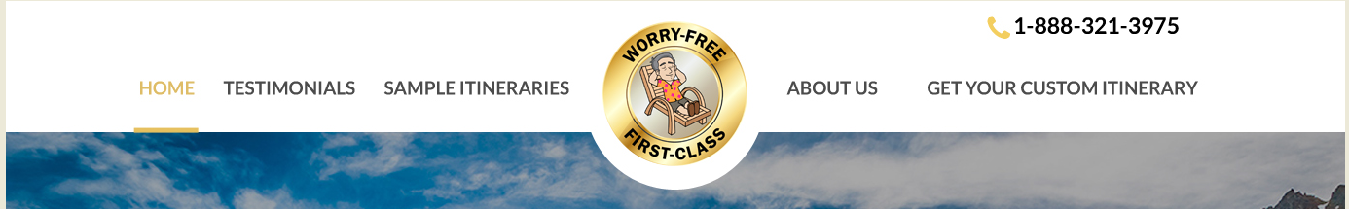

Let’s redo the items, from left to right:
- Left margin: Logo “Argentina Exploration Journeys”. All on the same line if possible. Use an outline font, like these below. We love the Columbia font:
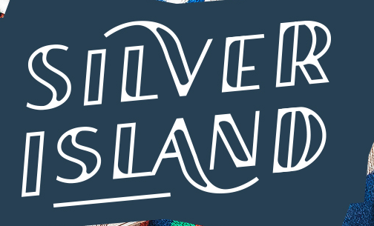
- To the right of the logo: About us
- Then: Sample itineraries
- Then, more or less in the middle: the worry free golden coin
- Then: Testimonials
- Then: The telephone number, aligned to the right margin of the screen. Like this:
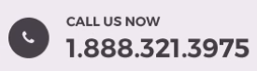

Another version of the header: with the Gold coin, the logo, the telephone and the “get your custom itinerary” button on the top line. And on the line below, the 4 menu items: About us, Sample itineraries, Testimonials.
More or less like this (don’t pay attention to the fonts and graphic design of elements, you can do it any way you prefer,a ccording to the guidelines above):

- Below the header:
To the left: a testimonial photo with a quote. Enlarge or deform the photo if needed we can make them any size.
To the right, destination picker. Please make one of the names “Fernando de Noronha” instead of “Nemo Enim”. We want to make sure it fits.
See the following page for a rough layout idea of this. Make the destination photos flatter and much wider, so we use better the horizontal space. The testimonial photo make it any size necessary, we’ll adapt.
Many our well-traveled guests had Choose your destinations and get
the best trip of their lives with us a customized proposal in under 24hs
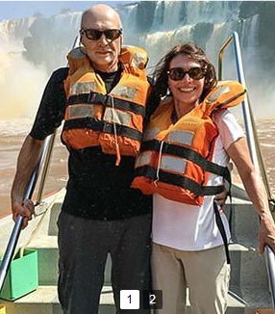
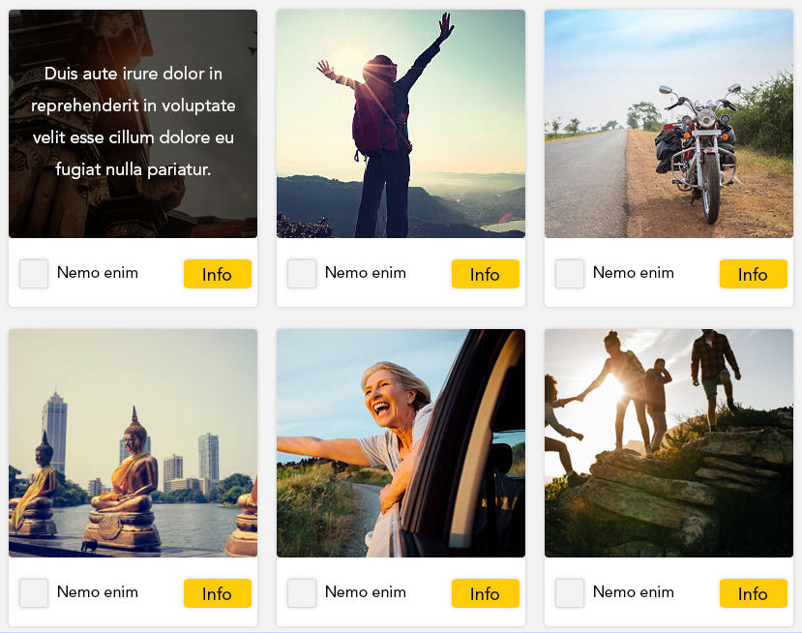
"The guides were experts and the personal service made this trip a dream. Everything went smoothly and our trip was worry free. Every time we needed help Fred was immediately there for us."


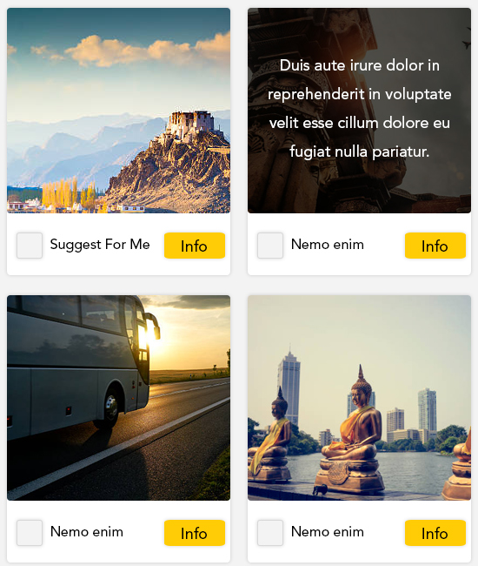
Put these quotes wherever you prefer

