Froggy's Party Pad
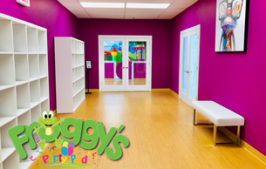
Froggy's Party Pad offers Private Parties for children under 6 years of age. Each event ranges from 2 to 4 hours and are all PRIVATE.

Indoor Play Space
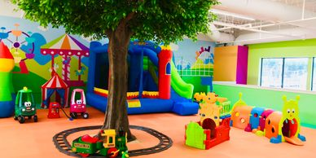
At Froggy's your child will have a great time exploring our facility! From Bouncy Houses to Climbers to many interactive toys. Lots of fun with music and dancing!!! Our main play space is set up with colorful foam flooring for your child’s safety.
(No shoes allowed in this area.)

Parent Seating Area
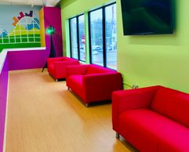
Welcome to the Parent’s Lounge! With our open floor plan, parents can relax and still be able to watch their children as they party, play and have an all-around fantastic time!

Snack Area
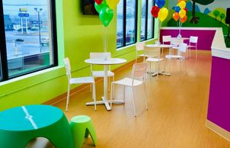
Our inviting and well-lit, Snack Area is equipped with a Vending Machine and plenty of seating!

Media Room
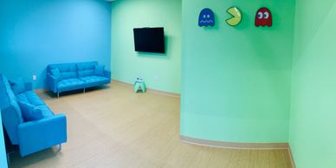
Older siblings or guests? No problem! Froggy’s Media Room is set up with comfortable seating, TV and Wii system to help entertain everyone!

Private Cake Rooms
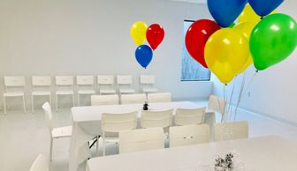
Enjoy our spacious, all white, Cake Rooms that help bring out the colors in every theme to create a vibrant celebration!

