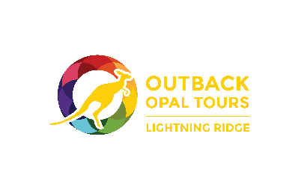



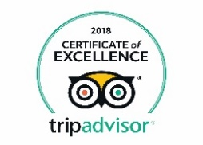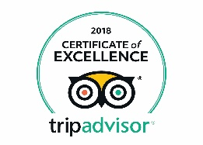(please use vector files if possible for Certifacte of Exc 2017 and 2018
Real tours by locals for the real experience – You’ll be glad you did!!!
Let OUTBACK OPAL TOURS take you on the dirt roads. and give your car a break

Daily TOWN TOURS See the best there is to see of the Ridge
9am & 2pm from $55

FULL DAY TOUR to the Grawin, Glengarry, Sheepyard Opal Fields and three bush pubs
The real deal outback opal mining experience from $120

OTHER TOURS
EVENING TOUR, COACH TOURS, GROUP TOUR and PRIVATE TOUR - please enquire

BOOKINGS  (02) 6829 4110

www.outbackopaltours.com.au






Package deals available - See more and pay less if you book multi-tours

BOOK NOW (02) 6829 4110
Let us show you what we do and how we live in THE RIDGE

TOWN TOUR 9am & 2pm – 7 days a week
See the best there is to see of the RIDGE with us – REAL TOURS by locals

Highlights: Guided underground tour at WALK IN-MINE (easy access), refreshing morning/afternoon tea, famous AMIGO’S CASTLE, historical miners’ camp GEMSEEKERS PARADISE, opal cutting demonstration by expert cutter, opportunities to purchase local opal, Lunatic Hill, tips for fossicking, commentary & colourful stories from our local tour guide and so much more
Available: 9am & 2pm daily with pickup / drop-off from your accommodation
Duration: 3 hours + Minimum guest number per tour: 2
Price: Senior $55 - Adult $60 - Children $20 (5 - 15 years) - Family (two adults & two children) $140
Included: Entry fees Walk-In Mine, Amigo’s Castle and morning / afternoon tea

FULL DAY TOUR to Grawin, Glengarry and Sheepyard Opal Fields including all 3 bush pubs
The real deal outback opal mining experience

Highlights: View working mines and machinery, get inside into the daily grind of an opal miner, visit the War Memorial, fossicking under expert guidance, talk to the locals at the Club in the Scrub with its unique golf course, quench your thirst at Glengarry Hilton and Sheepyard Inn.
This trip feels like travelling back in time a few decades - an absolute must see while in Lightning Ridge

Available: 9am daily with pickup / drop-off from your accommodation
Duration: 7 hours + Minimum guest number per tour: 6
Price: Senior $120 - Adult $125 - Children (5 - 15 years) $75
Included: Devonshire morning tea (coffee / tea) and lunch (drinks at own expense)

OTHER TOURS - EVENING TOUR, COACH TOUR, GROUP TOUR and PRIVATE TOUR - please enquire about
further details and about tailored tours

We have two air-conditioned buses and for your convenience pickup from your accommodation and the Visitor Information Centre. All tours are subject to change without prior notice due to weather or road conditions. For terms and conditions please visit www.outbackopaltours.com.au. Prices 1/4/2019

TOUR BOOKINGS Phone (02) 6829 4110
www.outbackopaltours.com.au


