Equine Training, Performance and Welfare
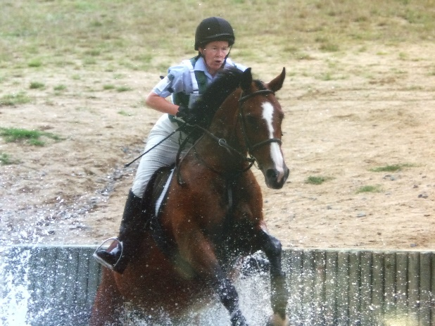

The Animal Behaviour Clinic was established in 1994 by Orla Doherty
as an animal behaviour referral, consultancy and education provider dedicated to improving understanding
of animal behaviour and welfare and investigating and resolving problem behaviours in a range of animal species.
Dr Orla Doherty, Drumcrowie, Malin, Co Donegal.
Email: equinecognition@gmail.com
Telephone (To be confirmed)

Orla Doherty grew up on the beautiful Inishowen peninsula in north Donegal, where the family nickname is Saddler- derived from a family history of saddlery. Orla immersed herself in local horse activities as a child, riding her own and other ponies at gymkhanas and shows, riding out racehorses, and as an adult, competed in dressage, showjumping and eventing.
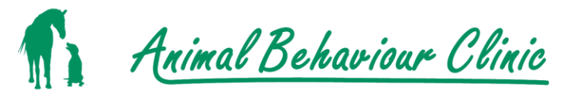
Orla qualified as a veterinary surgeon from UCD in 1992. She completed a Masters degree at Edinburgh University in Applied Animal Behaviour and Animal Welfare in 1993. Orla completed a doctorate at the University of Limerick in 2016, studying pressures used on the ridden horse, and finished her diploma in Equitation Science in September 2017. In addition to her doctoral research at the University of Limerick, Orla has worked in research on horses in different universities around the world (Auburn University, Alabama, Cornell University, New York, Edinburgh University).
Currently junior vice president of the International Society for Equitation Science, Orla’s publications include scientific papers on transport of horses, tack use by riders, pressures exerted by nosebands, welfare of horses and the importance of an understanding of learning theory for the veterinary surgeon.
Orla has lectured in the veterinary faculty at UCD since 1995, on animal behaviour and welfare, and on equine behaviour and welfare at the University of Limerick (1997 - 2016). Orla teaches and demonstrates the use of learning theory and horses to students of equine assisted learning and therapeutic riding at Festina Lente, and lectures on animal behaviour and behaviour problems to veterinary surgeons at clinical society meetings throughout the country.
Internationally, Orla has presented her work to advisory groups for the British Horse society, the Equine Behaviour Forum (UK), the Swiss Society of Veterinary Behaviourists (Switzerland), the Progressive equine behaviour and training forum (USA) and been a participant of the Havermeyer Horse Welfare Workshop (Canada).
Orla acts as an expert witness in legal cases involving horse behaviour, and has presented her research at conferences internationally (UK, USA, France). Her research has been the topic of articles in Horse and Hound magazine, HorseTalk (New Zealand), the Veterinary Record (UK). She has worked with owners and riders at clinics in Ireland, Northern Ireland and Canada, and has organised equine behaviour and performance workshops and clinics in Ireland with visiting international experts for the past 10 years.
Orla is a member of the RDS sub-committee on Ethical Training and Welfare, and has acted in an advisory capacity to the FEI, The International Dressage Trainers Club, The British Horse Society welfare advisory group and Dressage New Zealand. She has taken part in numerous RTE television and radio shows including the Afternoon Show, Live at Three, the Gerry Ryan Show, Beastly Behaviour.
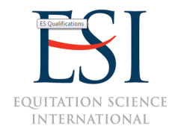

What we offer
1. Behaviour consultations.
During a behaviour consultation, an individual assessment of the horse is carried out, incorporating information regarding the horses health, management, past training and competition history, current training methods and outcomes, behaviour patterns displayed, problem behaviours or simply poor performance. Recommendations are made at the end of each consultation regarding management, training etc, required to achieve the desired outcome.
Duration: 2 hours. Cost €280
2. Training sessions: individual training sessions with horse and rider, designed to address training problems, the performance of problem behaviours or general poor performance. Each training session will focus on equipping the rider with a good understanding of learning theory, and how to apply it to achieve optimal results with their horse. An initial behaviour consultation (above) is recommended before individual training sessions are arranged.
Duration: 45 minutes. Cost €100
3. Training your horse - theory and practice
This course incorporates both classroom sessions and practical sessions in the arena, developing the rider skills in training, both in hand and under saddle. The course will be run for groups of four or more, allowing riders, or participants without a horse, but interested in learning, to work in a safe environment to deepen their understanding and skill in working with and training their horse.
Duration: 1 day.
Cost: Cost will be determined by the location, number of participants, cost of facility hire, etc.
4. Training, performance and welfare
During this course, run for groups of 8 to 12, students will greatly deepen their understanding of the horse, through attending lectures, workshops, demonstrations and individual training sessions. The course will address a range of areas including training methods, welfare, the horses physiology, neurology, effects of management and diet on performance. Training sessions will address riders individual handling and training issues, both during group and one-to-one sessions.
Duration: 4 days. Cost: As for 3 above
Behaviour assessments and training sessions will take place either at the facility at which the horse is stabled or an alternative venue, to be arranged, depending on the location of the horse. In addition to the costs quoted, there may be additional costs to cover travel and facility/ arena hire.

‘Dr Orla Doherty is an outstanding practitioner of Equitation Science and I am very enthusiastic to support her in establishing Equitation Science in Ireland. Aside from her credentials and noteworthy academic publications in Equitation Science, Orla also has the distinct advantage of being a qualified veterinary behaviourist with an established practice at University College Dublin and also as a behavioural consultant to Dublin Zoo. In that regard, from a multi-species and multidisciplinary standpoint, Orla has a highly accomplished and unique background that is complemented by her lifetime experience with horses in training and competition horse trials’.
Dr Andrew Mc Lean, Equitation Science International, Australia.
“Orla has been coaching learners on the principles of equitation science as part of Festina Lente’s Therapeutic Riding Coaching Programme and the Equine Assisted Learning Facilitator Training Programme since 2012. Her lectures continuously inspire and motivate learners to reconsider their approach to managing equines. Additionally, Orla’s approach provides a safe and non-judgemental environment in which learners can consider new ways of equine welfare and management”

Dr Jill Carey – Chief Executive Officer – Festina Lente
Student quotes
‘Orla, Thank you so much for this course. I’ve had a wonderful time and learned so much’
‘This course really allowed me to bring theory and hands-on experience together’
‘Amazing research and knowledge shared! New techniques in the basic foundation training of horses are ones that I will definitely use in the future’.
‘Trainer had huge depth of knowledge. Very easy to listen to’.
‘Orla is the most interesting person I have talked to about horses and I would love more time to talk to her’.

‘Highly useful information. Very interesting lady and also a lovely person. Very gentle, patient and precise’

‘Found I could listen to Orla forever. She is so passionate about her work. Very soft spoken and easy to listen to’
