PhoneCoil Logo Brief

Name Meaning
The name PhoneCoil is made from 2 unique words.
Phone – A mobile/Hand held device
Coil – Female Contraceptive

The Problem
Mobile devices are becoming a bigger part of our everyday lives, but the battery life often falls short of expectations. This has led many people to see an open charging port as an oasis in the desert.

- Have you ever plugged your phone into a strange USB port because you really needed a charge and thought: "Gee who could be stealing my data?". We all have needs and sometimes you just need to charge your phone

- Have you ever plugged your phone into a friends computer USB port and acciently conducted a data exchange?

Solution
Introducing PhoneCoil. A "USB Condoms" that prevents accidental data exchange when your device is plugged in to another device with a USB cable. This is achieved by cutting off the data pins in the USB cable and allowing only the power pins to connect through.

PhoneCoil is used to:
- Charge your phone on your work computer without worrying.
- Use charging stations in public without worrying.
- Turn a normal USB cable into a "charge only" cable

PhoneCoil use cases:

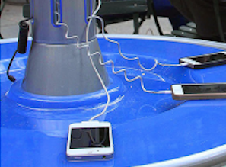 |  |  | 
Charging Stations | Airports, Airlines & Hotels | At The Office | Firneds Laptop’s

Keeping your smartphone safe while you juice it in public!

