Here are some examples of logos that I like.
I do want the name “Nobis Grain LLC” to appear in the logo.
I also like the idea of the ear of corn in the logo.
It may be nice to include the names of my farm locations—
St. Johns, Michigan and Chelsea, Michigan

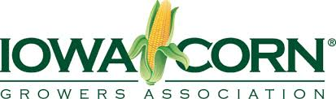

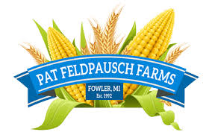
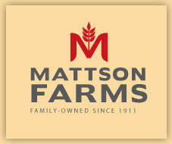

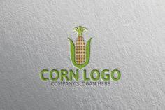

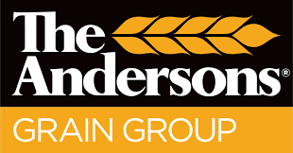



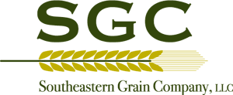

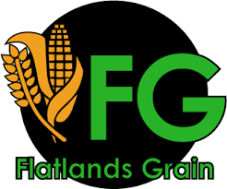

Nobis
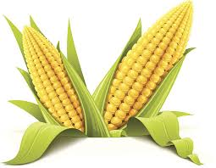
Grain LLC
St. Johns MI – Chelsea MI
NGF Nobis Grain Farms LLC
St. Johns MI – Chelsea MI

