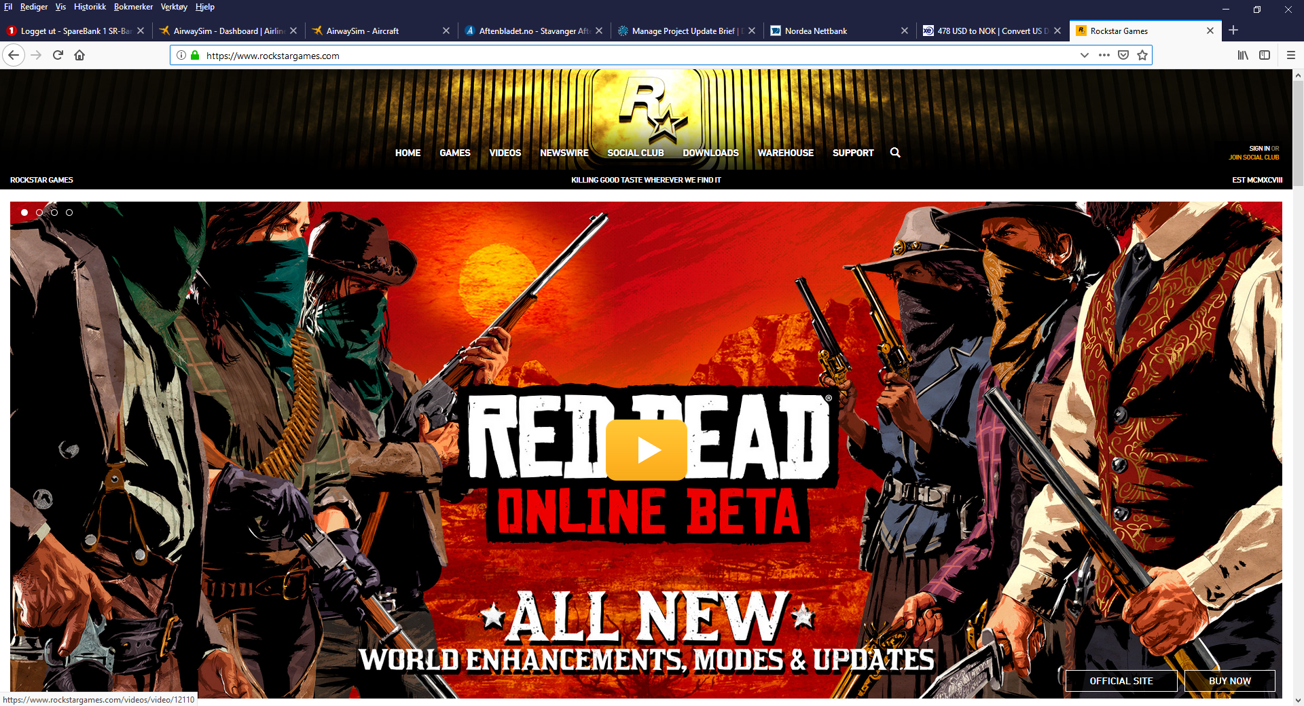

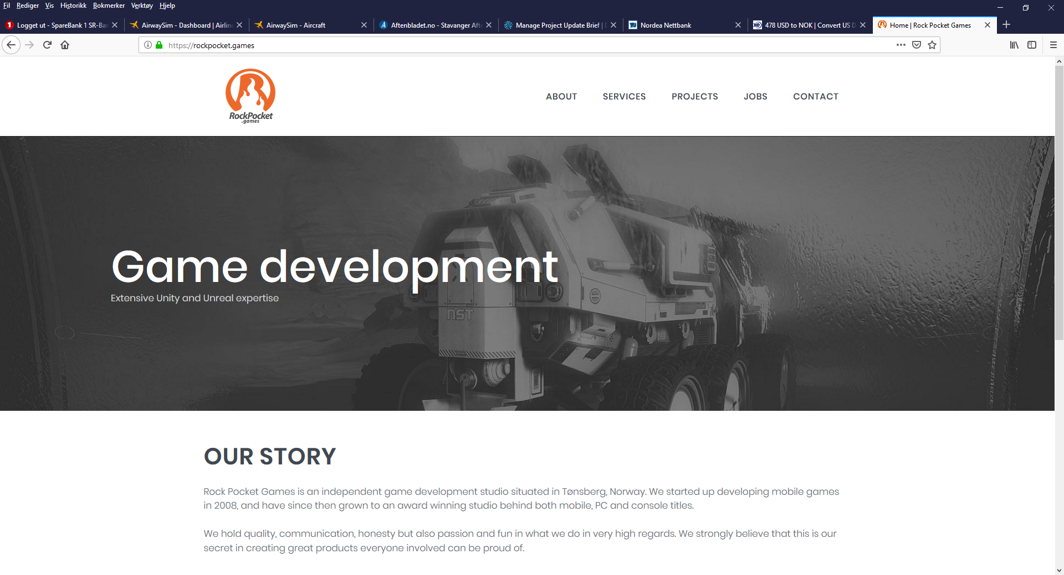

Make a more professional looking webpage, where we can showcase our games, about us, contact and media coverage.
Here is our current webpage: www.miscgames.no
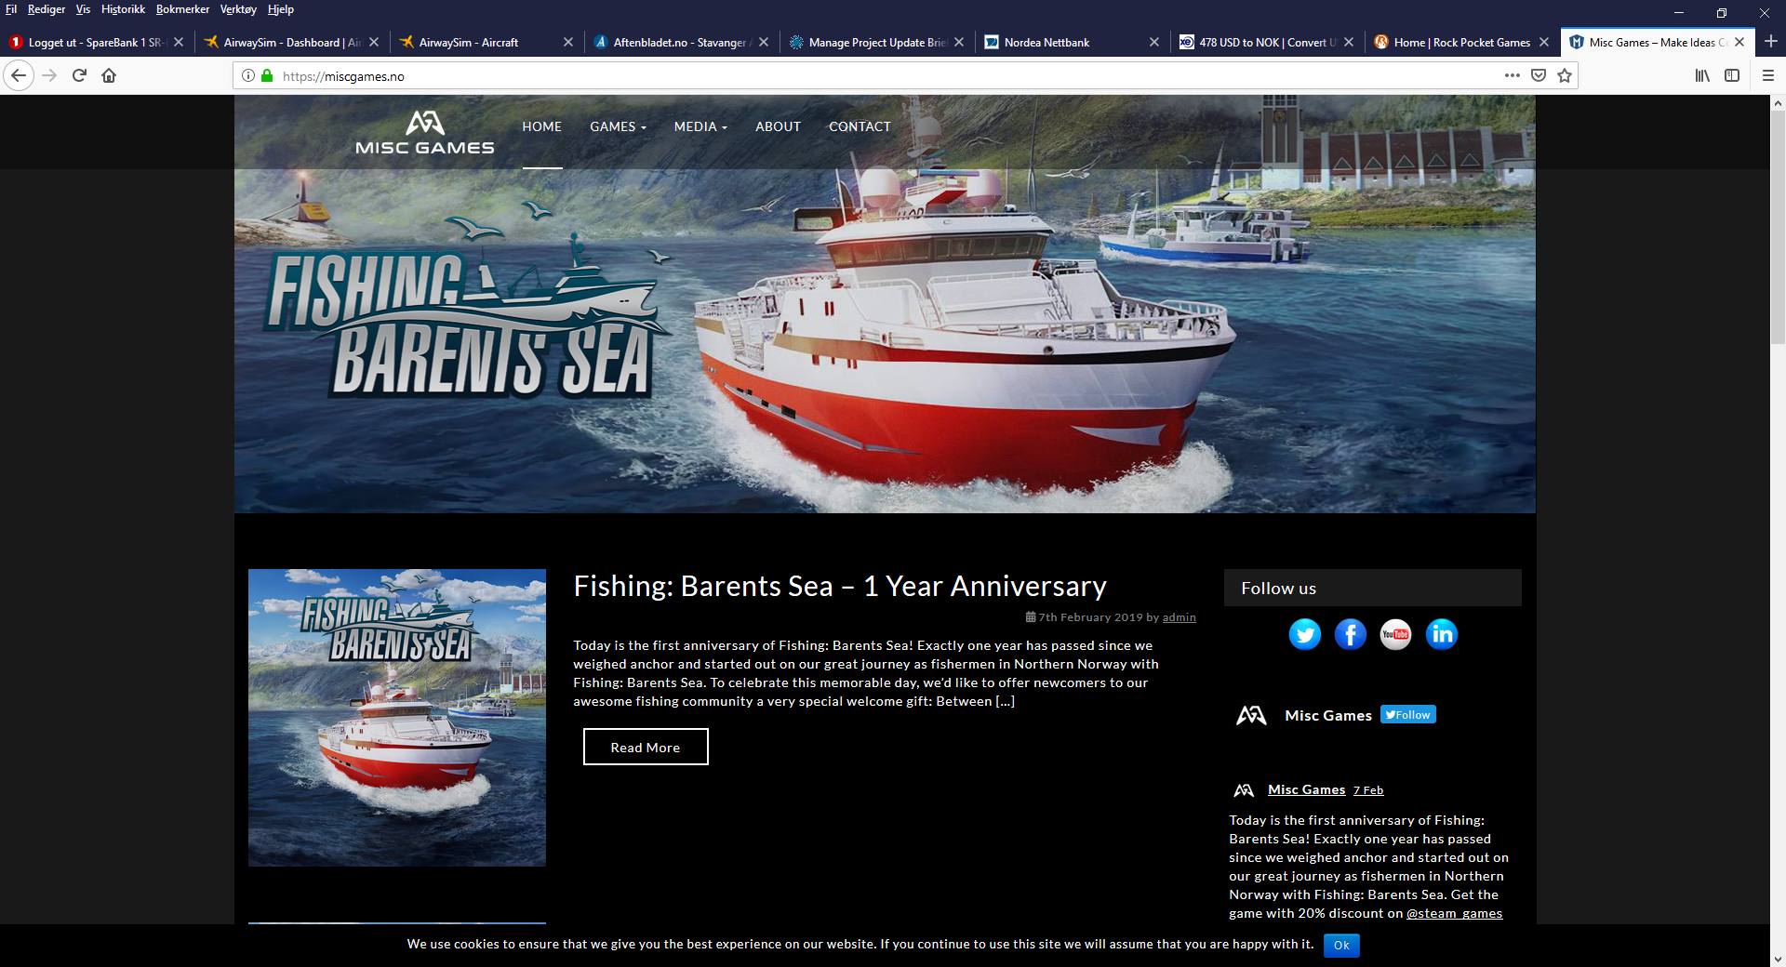
Need to support Wordspress!

