Sheridan Park Family Church – Design Brief

Date Written: March 27, 2019

Sermon Series Graphic:

Design Needs:
A graphic for our upcoming sermon series

Tone and Manner:
- Sermon series is called “Messy”
- The subtitle will be “Joining God in the Mess”
- Our name logo should be on the graphic as well.
- The subject matter will revolve around how this world and those in it are messy. Jesus came into this messy world as one of us and gets messy helping us. The church and Christians are to follow in Jesus’ example to help the poor, sick, hurting, sinful, etc.
- Our church’s mission is “Connecting Young Families to Christ” so our focus is to reach out to families while not being exclusive to others.
- Our church’s core values are: Equipping, Serving, Belonging, Missional Living, Spirit-living
- Our target audience is families with school-aged kids.
- This series is an invitational focus so we want it to be appealing to non-church goers.
- It should be attention grabbing while not being too ‘edgy’

Request:
- An image for our sermon power point that can also be formatted for a 14cm x 11cm invitation card, and could also be used for things like FB and e-blasts.
- A front-page web-banner that is 1140 x 350 pixels. This is normally just a section of the front of the ad.
- An announcement image that is 1920 x 1080 pixels or another 16:9 resolution. This can also just be the back of the ad resized.
- Will need the graphic completed by April 14th.

Invitation Advertisement Cards:

Design Needs:
An advertisement for an invitation card to be given or mailed out, advertising our church, Sunday service, and new sermon series.

Tone and Manner:
- The front of the card will most likely consist the Sermon Series Graphic, title & subtitle of the series, and perhaps our name logo somewhere on it.
- The back of the card will invite and give the basic information for the church, Sunday service, and series so that the people will be encouraged to save the date(s) and come to one or all of the services.
- Here are some things that could be included on the back:
  - The time of the services: Sundays @ 10:30
  - Names & Dates of the sermons:
    - April 28th: “We Made This Mess”
    - May 5th: “Bless in the Mess”
    - May 12th: “Born into the Mess”
    - May 19th: “Messy Work”
    - May 26th: “Messy Church”
    - June 2nd: “Messy Hospitality”
    - June 9th: TBD
    - June 16th: “Messy within Boundaries”
  - Features of the service:
    - Staffed nursery & children’s program every Sunday
    - Coffee & snacks
    - Everyone welcome
  - Information about the church: our website and address, etc
- The rest of the tone and manner are the same as the sermon series graphic.

Request:
- An advertisement that can be formatted for a double-sided 14cm x 11cm invitation card, and could also be used for things like FB, e-blasts, Power Point, website, etc.
- An announcement image that is 1920 x 1080 pixels or another 16:9 resolution. This can also just be the back of the ad resized.
- Will need the advertisement completed by April 14th.

Please contact Heather Cushing worship@spfamilychurch.ca

Name Logo
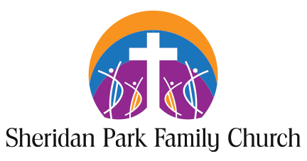
Sample from Previous series:



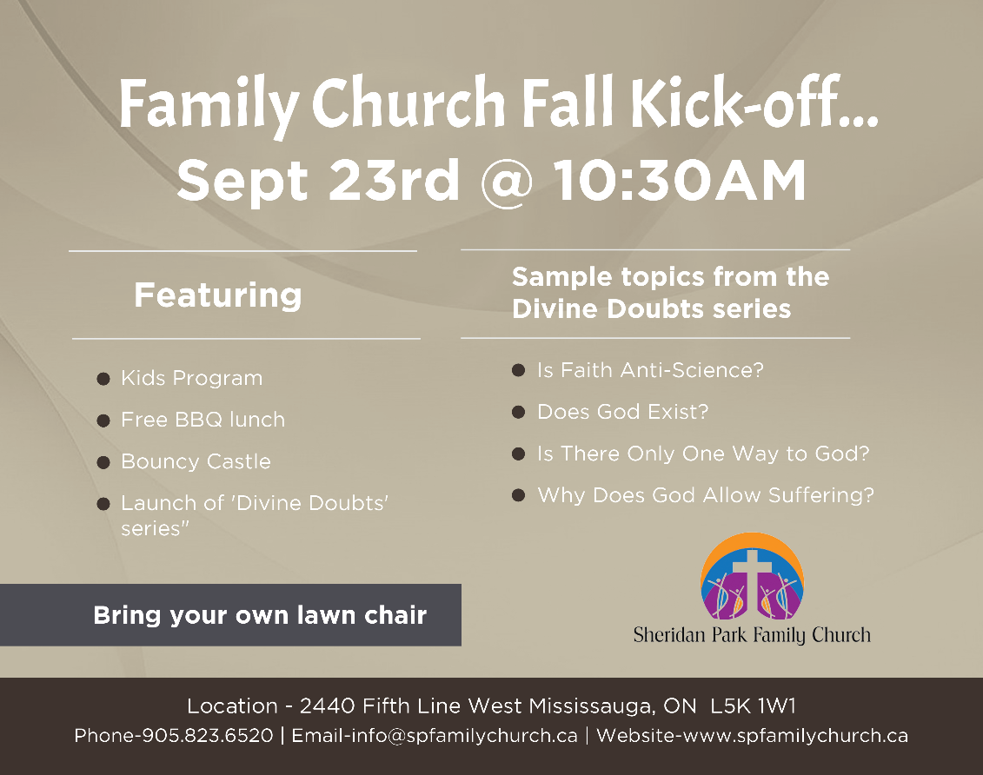
Our Core Values

