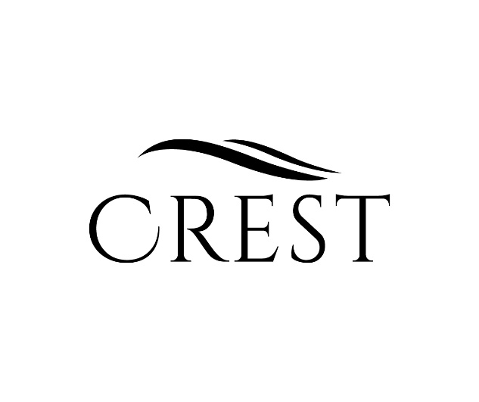
Crest water’s origins lie in the heart of Australia’s pristine Southeastern Alps. Natural springs at the foot of the Snowy Mountain range enrich the water with a premium, balanced minerality. Bottled at its source, Crest water stands alone for its exceptional purity, freshness and unaltered quality.
Typical analysis
Chlorire
Biiccarbontae
Sodium
Magnesium
Calcium
Potassium
BAR
CODE
BEST BEFORE
21/11/2202
2628
Lightly Sparking
750 ml
PREMIUM AUSTRLIAN WATER

