Page 1
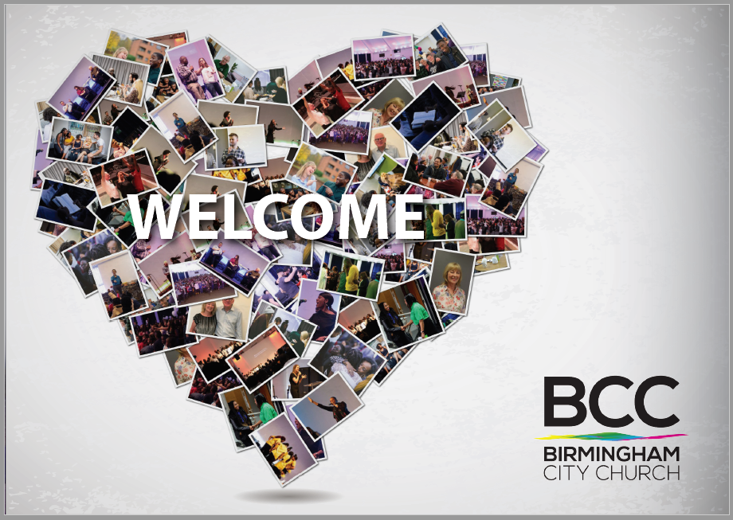
We would like the size of the booklet to be 21cm x 19.12cm
And all the writing for each page needs to be in Calibri size 11 unless is a heading.
I like the heart shape as it is – but the team thought people will wonder why we’ve used photos more than once. Please can we use all different photos? I have uploaded more photos for you to use and also can you bring the heart shape more to the centre and make the heart shape a bit wide like the sample pic I uploaded. That way the ‘WELCOME’ can be bigger and wider.
Is the background shaded, or is it pure white? I think it would look cleaner and more professional pure white that gray colour – but that is just my own taste.

Page 2
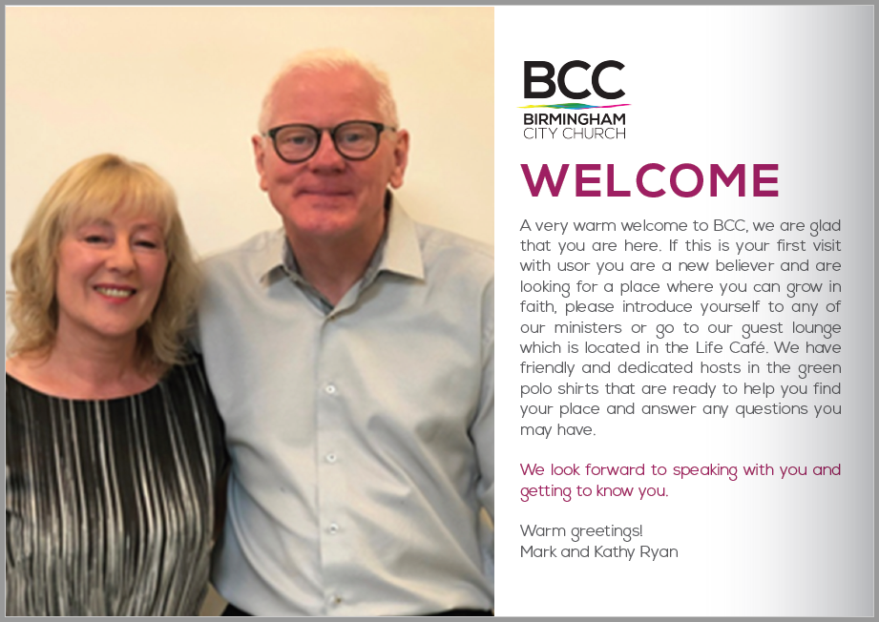
This picture of Mark and Kathy – it is much too fuzzy, and needs to be made really crisp and sharp. I think if it is enlarge it doesn’t have a good quality maybe if you redesign the page make it smaller it might look good and great quality? Just my thoughts
The word WELCOME is not using any of our ribbon colours – and we might want to insist on that (my preference, not an absolute requirement). The RGB colour codes from our ribbon are:
- Green: 120, 171, 53
- Pink: 216, 61, 150
- Blue: 0, 160, 220
- Yellow: 230, 224, 9
- Purple: 152, 121, 183
Here are 2 text corrections from this page:
- A very warm welcome to BCC. We are glad that you are here. (i.e. make this two sentences – currently it is trying to be one sentence that is not grammatically correct)
- We have friendly and dedicated hosts in green polo shirts (not in the green polo shirts i.e. take out the word the)

Page 3
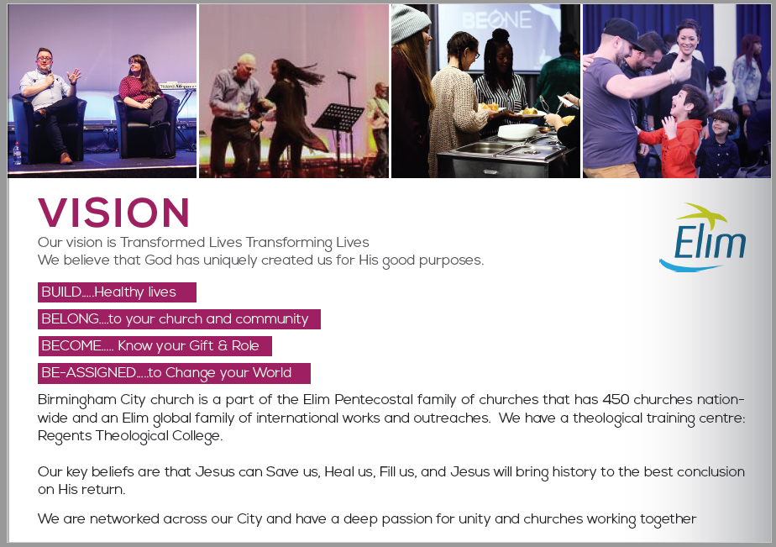
The picture of Kevin and Chloe (first pic) looks like it has a line down the left-hand side (not a massive deal, but it is noticeable. Please cropped it so it not showing.
Please keep the picture of Sheila and Mark (the second Pic), because it’s so great and sums up the life and joy we have here at BCC, but make it sharpen to have similar quality like the other pics if possible
Text updates for this page:
Each of the Build, Belong, Become and Be Assigned needs the same number of dots after it i.e. 3
Our vision is Transformed Lives… Transforming Lives Please have this in bold and on a separate line
Healthy Lives (i.e. this needs a capital L on Lives)
Church and Community (i.e. this needs a capital C on both Church and Community)
Know your Gifts (this is plural gifts, not one gift)
Be Assigned (does not have a dash in it)
Birmingham City Church needs a capital C on church
It’s 550 churches nationwide, not 450 churches nation-wide i.e. change the number and also remove the dash
Change family of “international works and outreaches” to “family of churches and ministries internationally”
Change “we have a theological training centre” to “we also have a theological training centre” i.e. add the word “also”
Please change the last sentence: “We are networked across our city” – the word City in the last sentence needs to be lower case i.e. city

Page 4
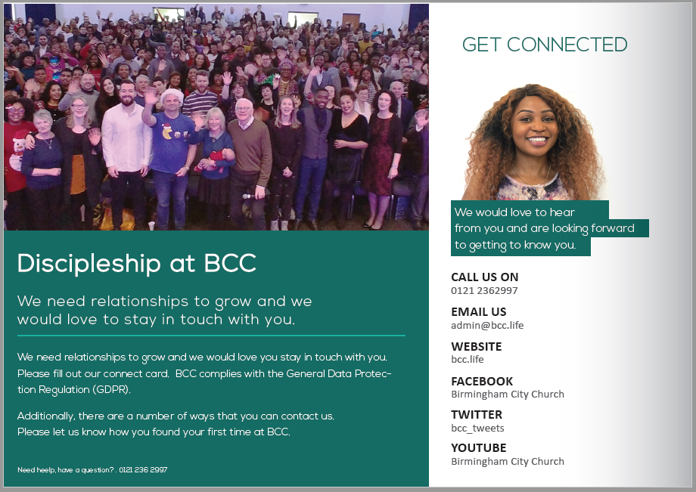
Please replace the top left-hand picture this is pic above Discipleship at BCC – but keep it being used on the back. I have uploaded a picture labelled it Replace this with the pic above Discipleship at BCC use that pic.
All the text below the main heading Discipleship at BCC needs to be changed. It’s currently an awkward mix up of discipleship and GDPR and getting in touch. Please remove all the text and make it just about discipleship, so write this text below as follows:
Discipleship is the lifelong process of following Jesus in order to achieve the character and destiny that He has in mind for us.
Our heart at BCC is to create as many ways as possible to copy Jesus, because it is our experience that effective discipleship has a powerful capacity to bring about remarkable transformation in ordinary people.
At BCC we encourage you to build your discipleship journey using multiple approaches and through a variety of opportunities, such as through Life Groups and serving opportunities.

The part where it say Get Connected is fine, just change the colour of the heading to have the same pink colour like page 1 and 2. Also at the bottom of the ‘Get Connected’ panel, put the sentence about GDPR i.e.
BCC complies with the General Data Protection Regulation (GDPR) by asking you for your consent to process your data.

Also the whole page needs to be white and the Headings to have the same pink colour like the Words welcome & vision in page 1 and 2. We want to look uniform not one page a different colour

Page 5
Update the ‘Join a Life Group’ section amend the words to say - ‘Our various Life Groups are located either on our Central Campus or in different parts of the city, and they typically meet once a week, once a fortnight or once a month. We run various series teaching in the year that will set you on a journey to discover faith and help you live in the will of God. There will be something that you will find enriching. As you connect to a group not only will you find enriching teaching but you will also build great friendships and grow as a person.’
Also Join a Life Group’ should be capital L and Capital G.

‘Attend one of our course’: Amend the text and let it read as follows:
For our new members, a great start would be for you to attend the BCC Life course. We would love to get to know you and help you settle into the BCC family. If you would like to join a Life Group, please come along to our Central Life Group which takes place here at the church on Wednesdays from 7:30 - 9:00pm
To find out more about our Life Groups, please visit bcc.life/life-groups and for more information about our courses, please visit bcc.life/courses
Have the website references in bold

‘Serve on a team’ - Amend the text and let it read as follows:
Sunday services, Foodbank, Children’s work, Youth teams, drama group, - our church could not happen without you!! Being part of a team is a great way to meet people and actually make a difference in the life of our church. You are literally making the vision of the church happen by serving with us.

Page 6
Change the picture where it’s says Sunday Celebration to one I have labelled - Sunday celebration new picture. Also words ‘SUNDAY CELEBRATION’ make it bolder bigger so it can be noticeable.

CHILDREN (0-11 years)
Change ‘childrenhave’ to ‘children have’
Change ‘fun filled’ to ‘fun-filled’
Change ‘Mother’s’ to ‘Mum’s’
Make all web links on this page bold

YOUNG PEOPLE (11-17 years)
Make leaders into leaders’ i.e. with an apostrophe
Change the CitYouth picture – the current one with them wearing the yellow tops is too fuzzy please use a picture I have labelled ‘page 6. YOUNG PEOPLE Exchange pic to this one’
GUEST LOUNGE
Change ‘Loungein’ to ‘Lounge in’
Change ‘Life Café, we would’ to ‘Life Café. We would’

Page 7
Change ‘Putting God First’ to ‘putting God first’
Change ‘where take’ to ‘where we take’
Change ‘listen to His direct’ to ‘listen to His direction’
Change ‘foodbank’ to ‘Foodbank’
Change ‘but hope; we always’ to ‘but hope. We always’

Page 8 Back Page
Change to: We would love to keep in touch, using your smartphone camera, simply scan the QR code and leave us your details to as follows:
‘We would love to keep in touch! Using your smartphone camera, simply scan the QR code and leave us your details.
Change ‘AnElim’ to ‘An Elim’

