Cover page – the line is still there, you havent removed the line.
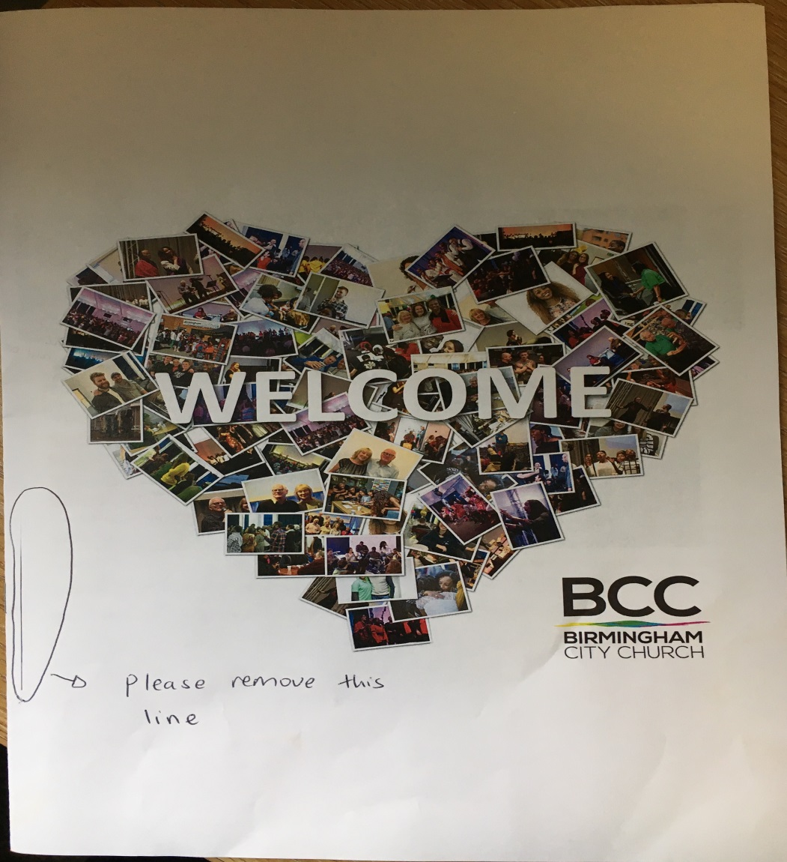

Page 1 - welcome page the word nationnalities is spelt wrongly. it should be nationalities and the part that says frienliness is spelt wrong, needs to be friendliness. After you do the work please can you double check spellings and that your work is correct. It doesn't seem like you are double checking.

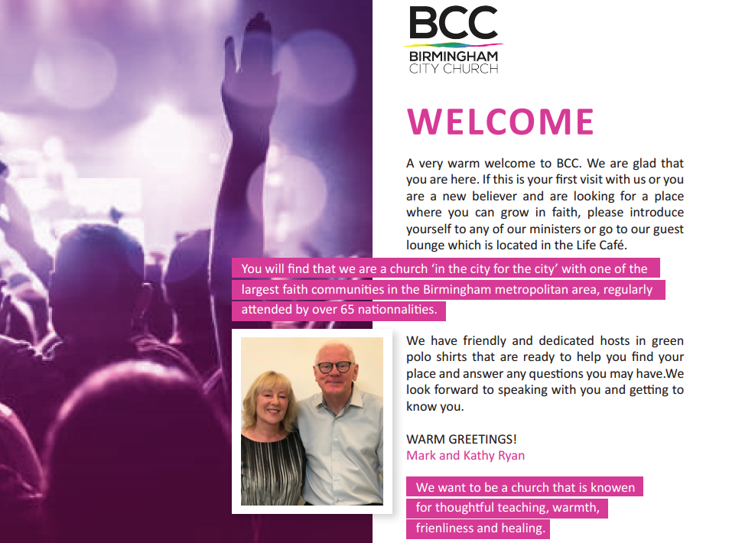
There needs to be a space after the full stop
Wrong spelling it should be known
Wrong spelling it should be nationalities

Wrong spelling it should be friendliness

Page 2- Transformed Lives ... Transforming Lives needs to be bigger size 14
The part that says BELONG… to your Church and Community – remove the And put &
It should be BELONG… to your Church & Community

Page 3 –

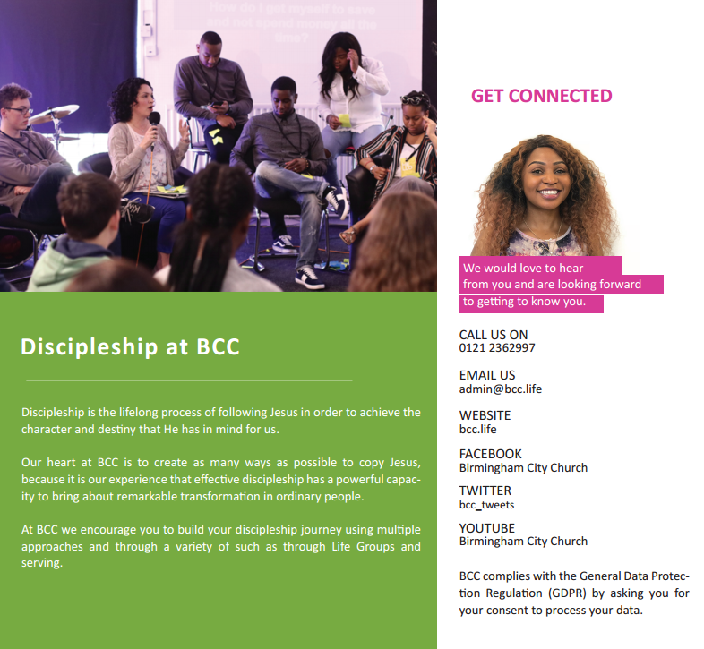
Bigger and needs to be pink like the word GET CONNECTED
You need to put the word opportunities back. You were supposed to take out only one opportunity.
It should be – a variety of opportunities such as
We do not want the green colour please. ALL THE TEXT Calibri size 11 and in black colour
In the previous revision I told you to make this page white but you haven’t done it. The whole page needs to be white and the Headings to have the same pink colour like the Words welcome & vision in page 1 and 2. We want to look uniform to all the other pages

PAGE 4
I have asked to make each heading to have the same pink colour like the word welcome, vision, get connected etc . WE DO NOT WANT THE GREEN
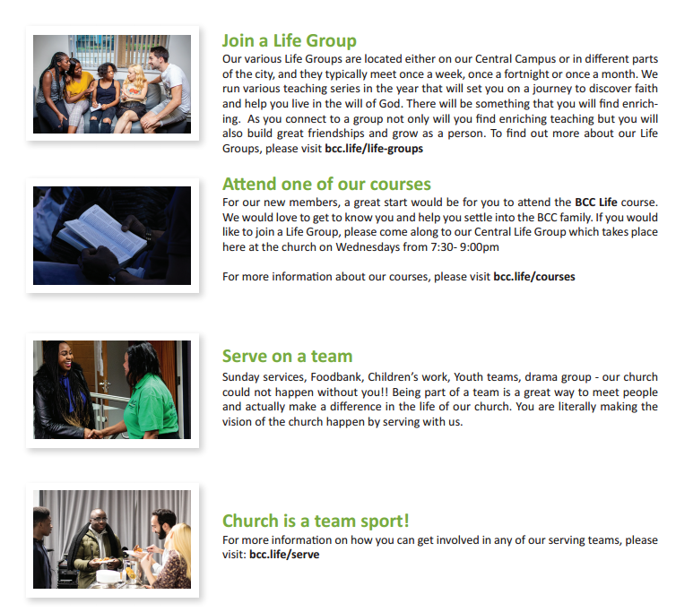
Put a space between the 7:30 and the dash and also put full stop after 9:00pm. It should look like this – Wednesday 7:30 – 9:00 pm.
Central Life Group needs to be bold

