And all the writing for each page needs to be in Calibri size 11 and in black colour unless is a heading. Some page the writing is in grey colour and not black
There needs to be space between the us and the or. I.e. it should look like this us or
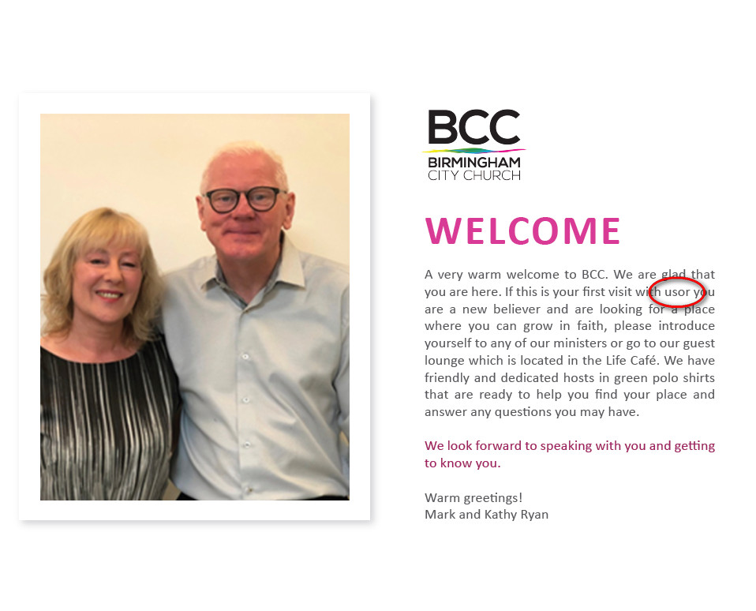
Also I have realised that there is a sentence missing in this page. I have taken a picture of our old welcome booklet. Please could you add that information please see below. I have uploaded the picture labelled Welcome page. It’s just an example you can redesign the welcome page and make it look better as long as it a nice professional contemporary design, it’s doesn’t have to look exactly the same like our old booklet. This pic of mark and Kathy still looks fuzzy.
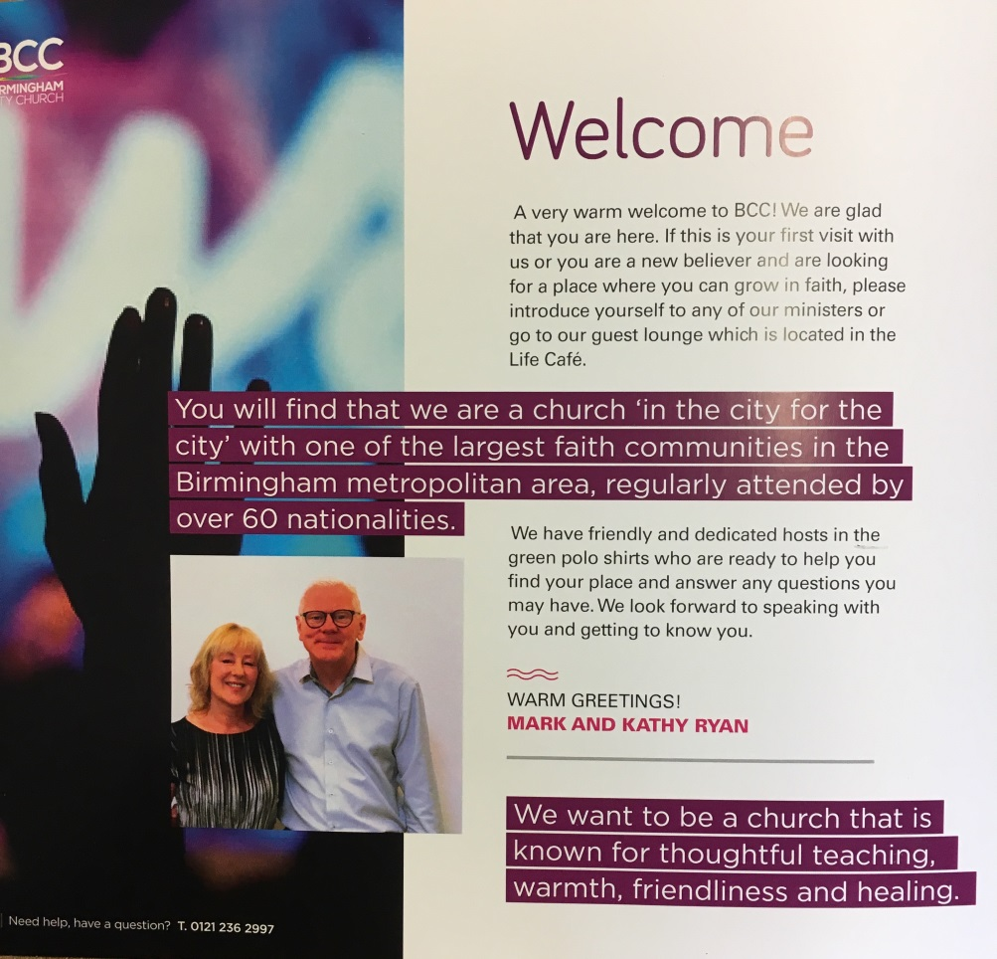
This is the other missing information that we want it to be on that page
This is the missing information and we would like you to add that information but where it says 60 nationalities. Change the number to 65
And all the writing for each page needs to be in Calibri size 11 and in black colour unless is a heading. Some page the writing is in grey colour and not black
Remove the word it’s. We only wanted you to change the number
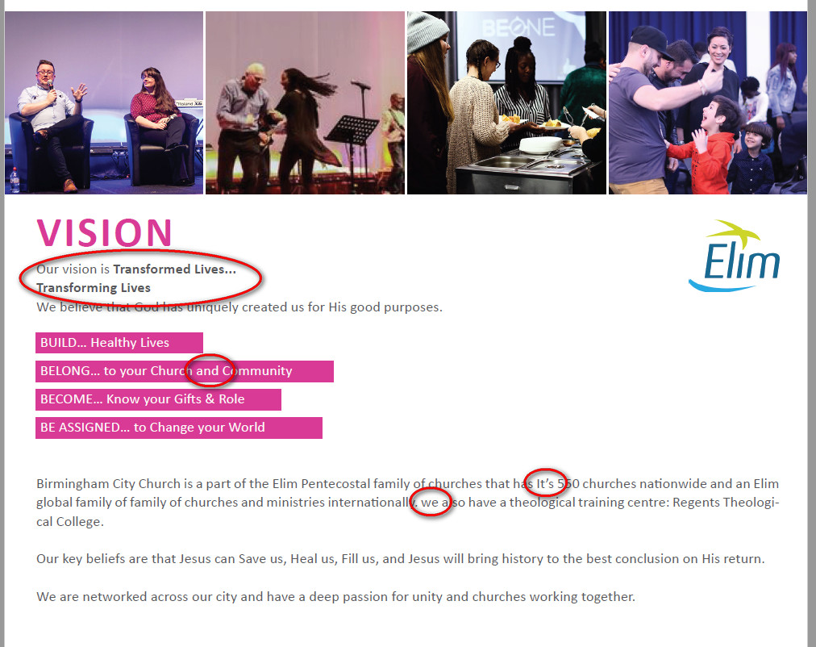
The words Transformed Lives.. Transforming Lives need to be bigger and bold and in one sentence i.e
Transformed Lives… Transforming Lives

The we needs to be capital W i.e. We
The words family of is repeated twice.

Page 3
You did not change everything we have asked you to change. Please make sure you are following our brief and revisions I have asked you to change. And all the writing for each page needs to be in Calibri size 11 and in black colour unless is a heading. Some page the writing is in grey colour and not black
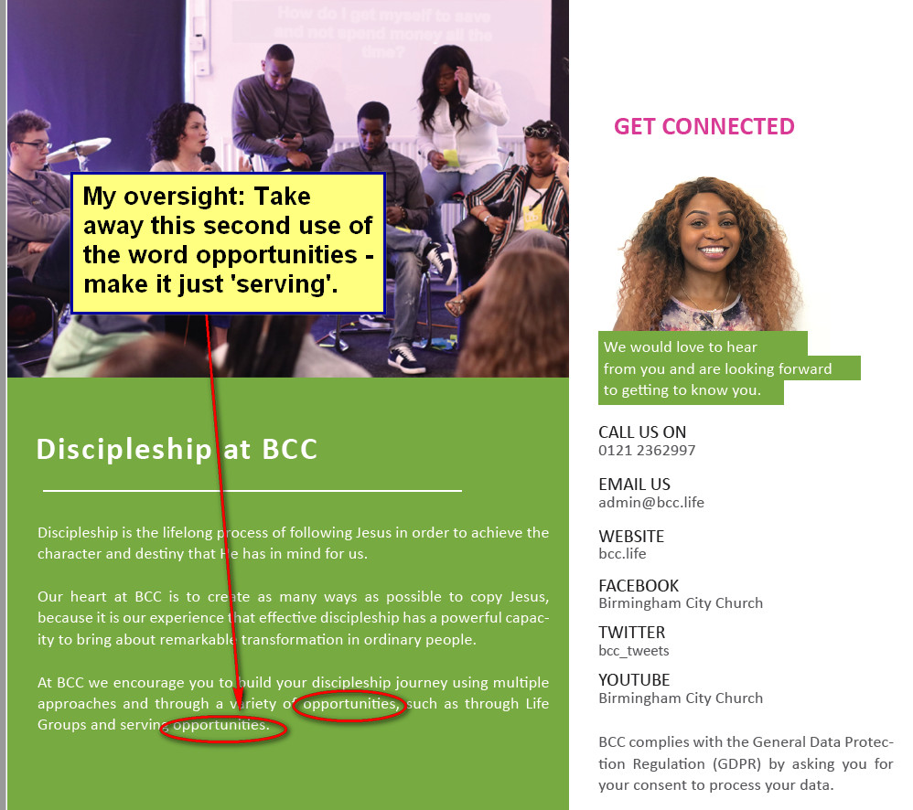
Make GET CONNECTED a bit bigger
The green colour needs to go. Use the pink colour and the writing in white like as you have done in page 2 where it says Build, Belong etc.
In the previous revision I told you to make this page white but you haven’t done it. The whole page needs to be white and the Headings to have the same pink colour like the Words welcome & vision in page 1 and 2. We want to look uniform to all the other pages

Take out the word opportunities

And all the writing for each page needs to be in Calibri size 11 and in black colour unless is a heading. Some page the writing is in grey colour, we want it black. All headings need to have the same pink colour like page 1 and 2.
Change series teaching to teaching series.

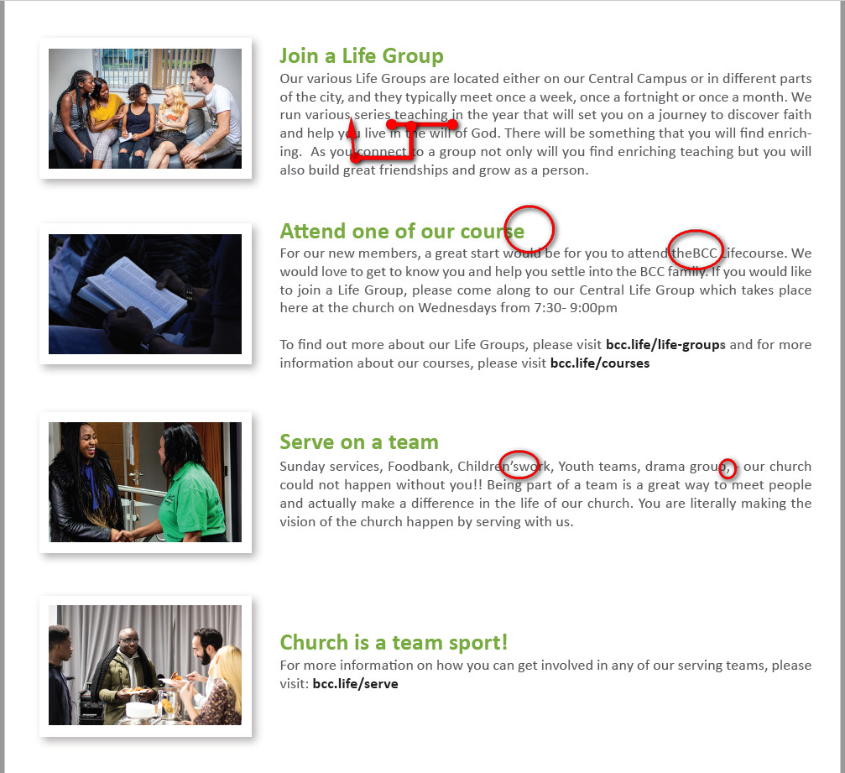
Remove the comma
There needs to space between children’s and work i.e Children’s work
Remove - To find out more about our Life Groups, please visit bcc.life/life-groups
But leave - for more information about our courses, please visit bcc.life/courses
S is missing it should be courses
There needs to a space between the and BCC i.e. ‘the BCC Life course. BCC life in bold’
Here put To find out more about our Life Groups, please visit bcc.life/life-groups
all

And all the writing for each page needs to be in Calibri size 11 and in black colour unless is a heading. Some page the writing is in grey colour and not black. We want it in black

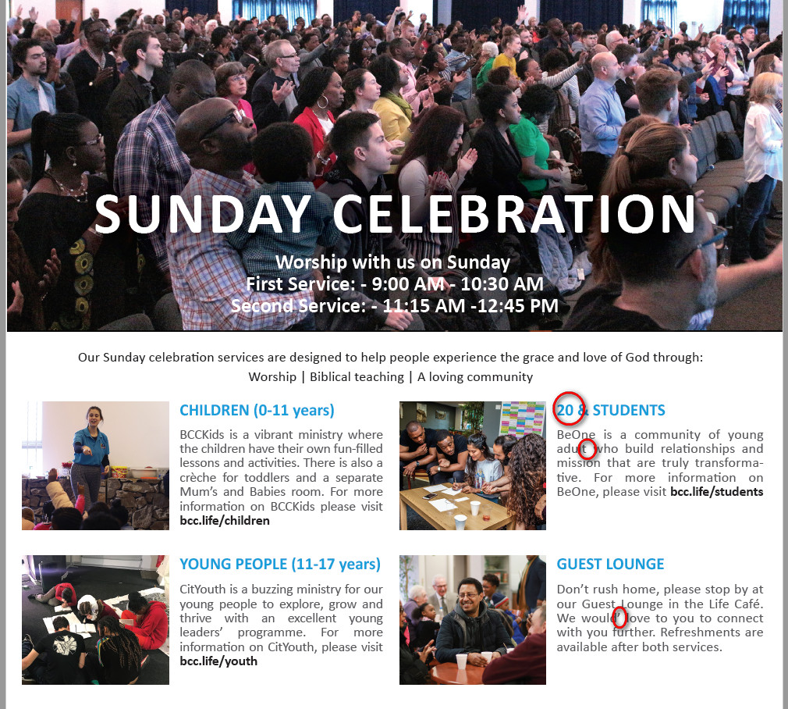
Please make that whole paragraph bold.
S is missing, it should be 20s
it should be young adults
Remove the apostrophe ‘ and the word you to
It should say – We would love to connect with you further
Make it bolder so it can be seen clearly

And all the writing for each page needs to be in Calibri size 11 and in black colour unless is a heading. Some page the writing is in grey colour and not black. We want it in black

Inside this box put
COME AND BE APART OF OUR FIRST CONFERENCE
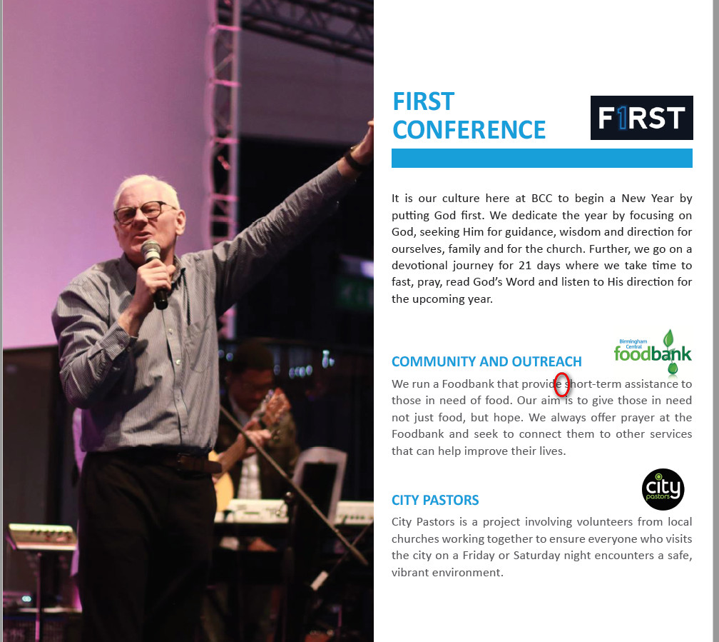
S is missing i.e. provides

Here a sentence is missing. Put
To know more about our first conference please visit bcc.life/firstconference
Putting God first need to be in bold

You still didn’t change this. It needs to be
An Elim not AnElim

