Cover page – the line is still there, you havent removed the line.
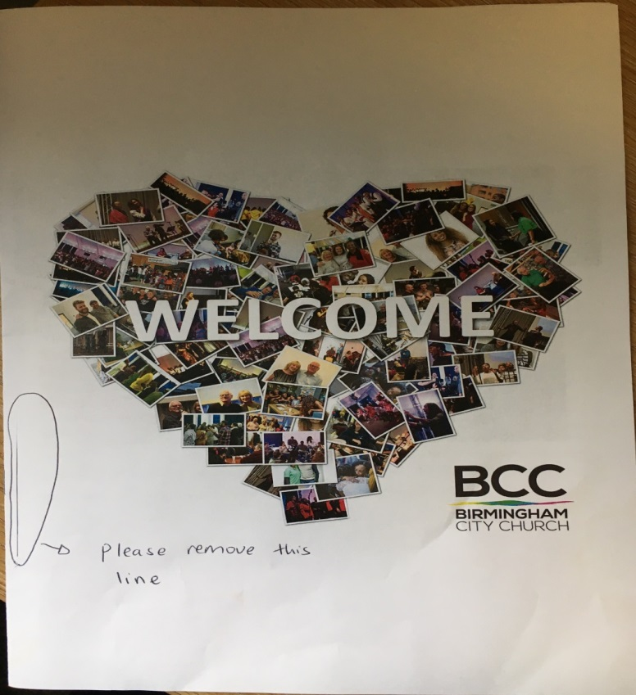

Whenever we print the pdf copy we keep seeing this line. Please can you remove it, not sure why that line is there? 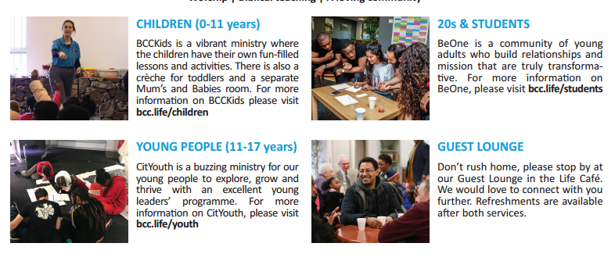
The 4 pictures, please can you put them in a white frame like the way you have done the picture in page 4 where it says Join a Life Group, Attend one of our courses etc.

