Design Brief: Mining Process Image
We want to get an illustration showing the copper mining process, from the mine (where the copper can be extracted from the ground) to the tailing dam (the storage place for the waste produced during the mining process).
Since the extraction of the mineral can be done through Open-Pit or Underground mining, we need 2 variations of the same process.
Illustration 1 will show the end-to-end process flow of Open-Pit mining:
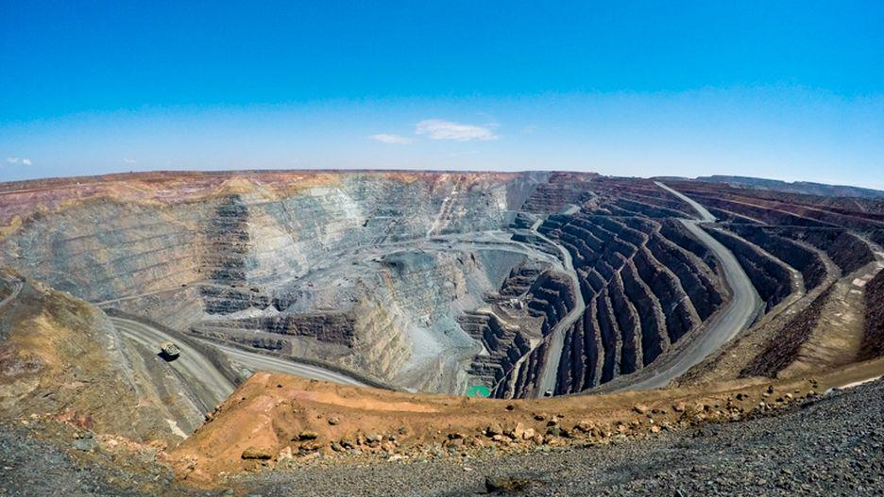
PROCESSES | TYPE OF EQUIPMENT (USE REPRESENTATIVE CHARACTERS) | EXAMPLE OF PICTURES FOR A BETTER UNDERSTANDING OF THE EQUIPMENT AND PROCESS
Drilling | Mining Drillers | Driller
Blasting | Blasting Equipment | Blasting
Loading Trucks | Wheel loaders | Wheel Loaders
Transportation | Trucks | Mining Trucks
Crushing | Crushers | Crusher scheme  Crusher
Process Plant (main output: concentrated copper) | Mill + Flotation | Mining mill  Flotation Tank  Flotation process
Tailings (Plant waste) | Tailings pipeline and channels.  Tailings dam. | Tailings pipeline  Tailings arriving to the dam  Tailings channel  Dam  Another Dam

A 2nd illustration should represent the flow of Underground mining where Drilling, Blasting, Loading Trucks, Transportation and Crushing are performed underground (see the following picture).
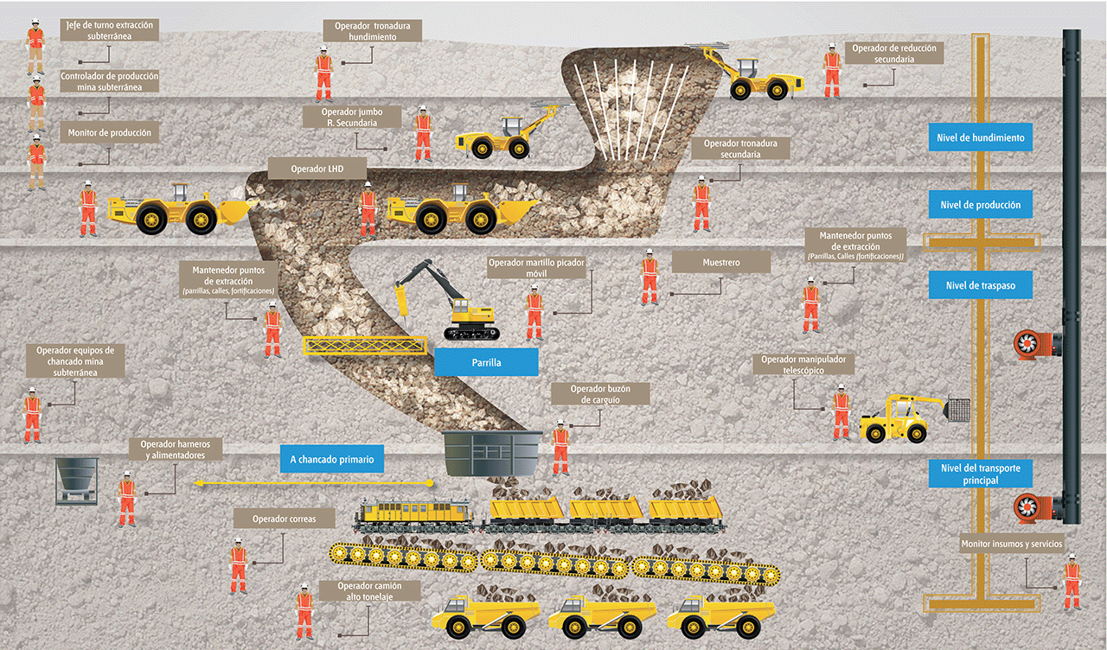

Sample illustrations similar to what we are looking for OPEN PIT
