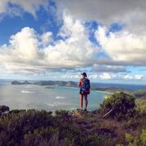
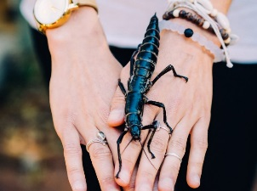
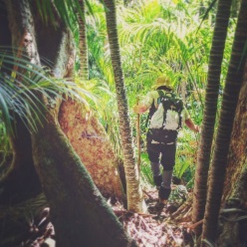
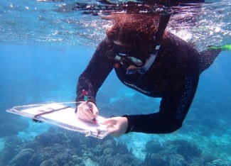
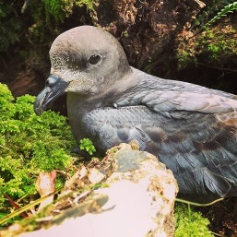
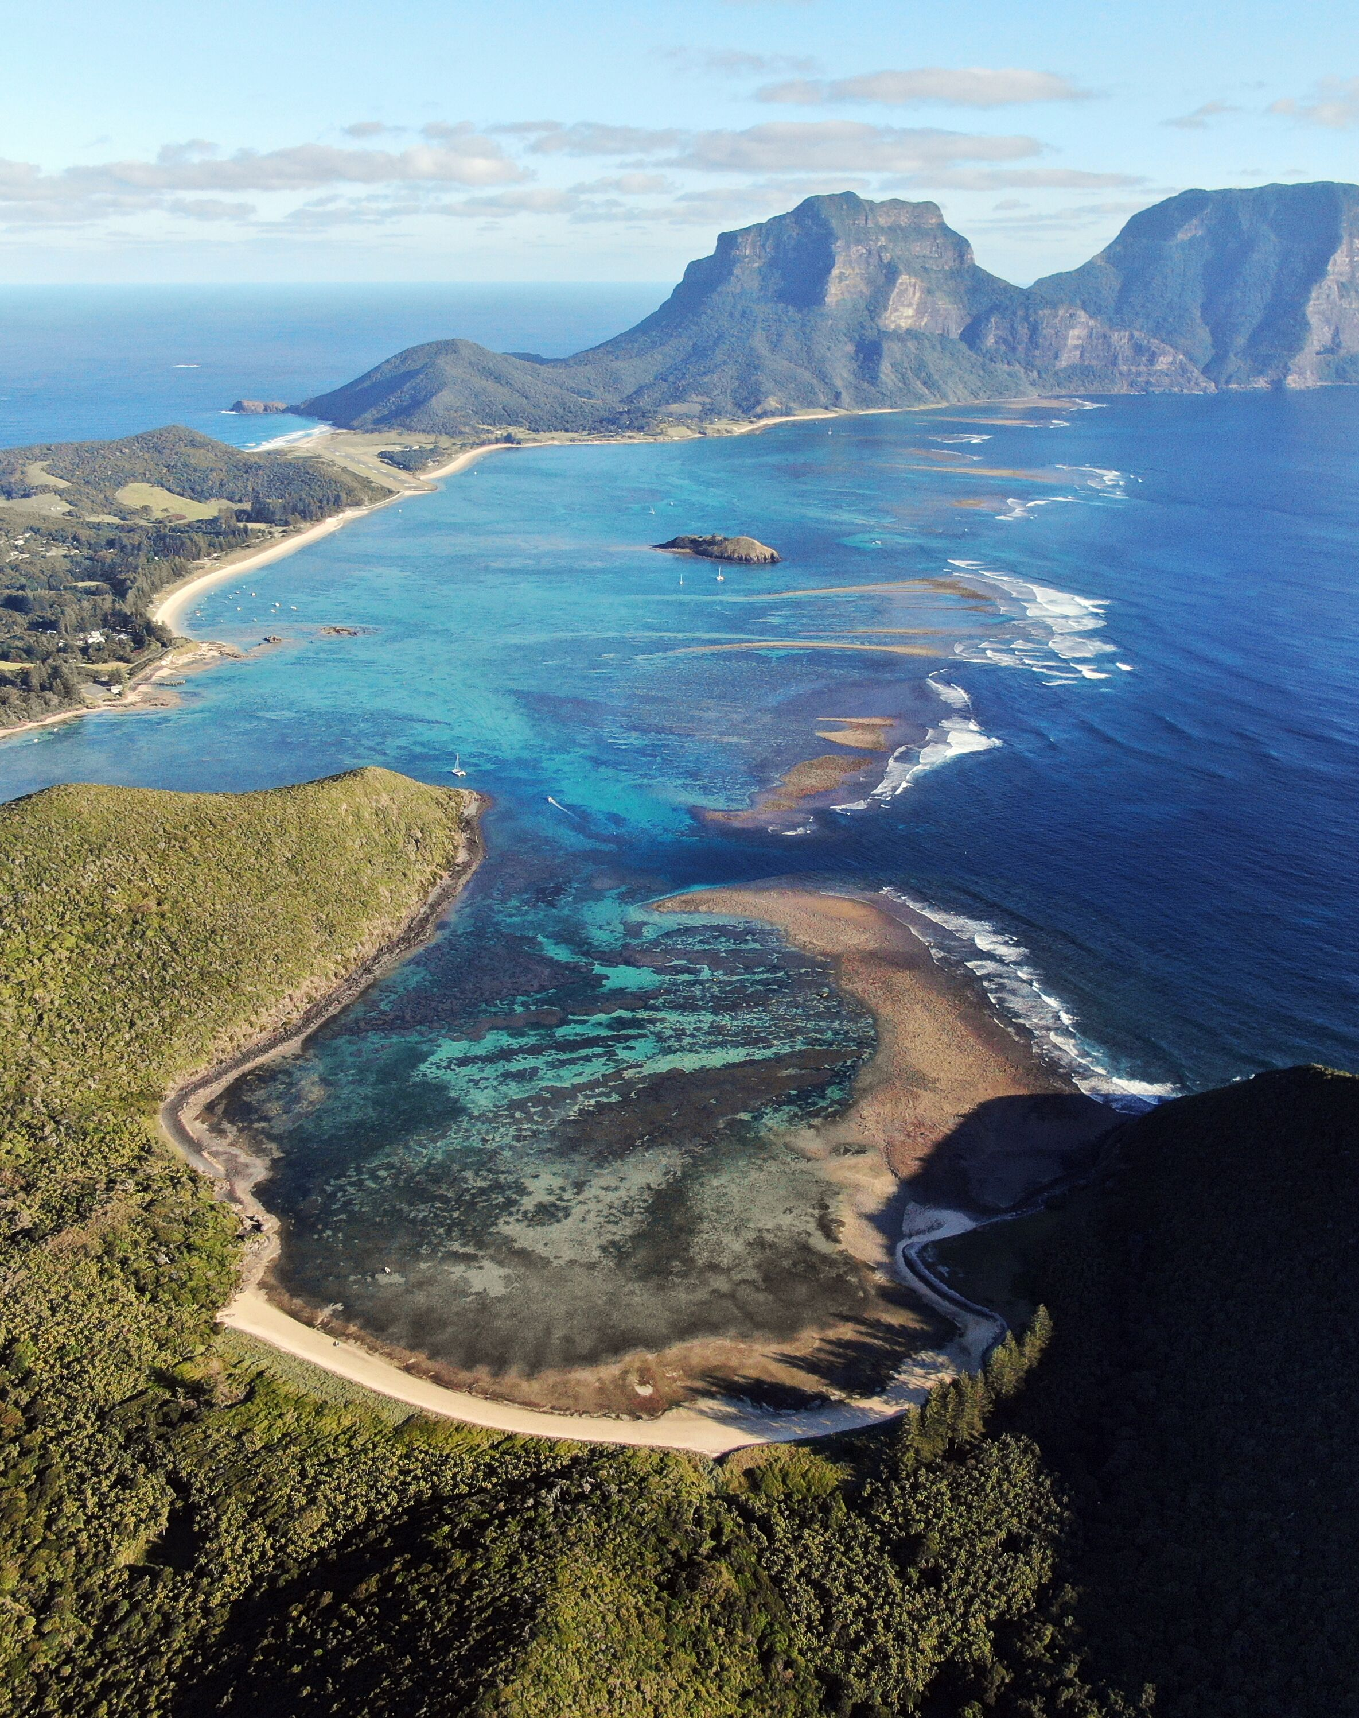
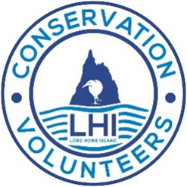

PROTECTING PARADISE
-Observational snorkel surveys with Marine Ecologists, to assess populations of McCulloch’s
Anemonefish and other unique fish species
-Guided snorkel and glass bottom boat tour to assess coral health within the
Lord Howe Island Marine Park
-Guided walks to learn about the island’s conservation history
See the LHI visitor centre for more information about the LHI Conservation Volunteers program for 2019
FOLLOW US! www.facebook.com/cvlhi instagram@cvlhi

JUNE 2019
Feature Week: 3rd- 9th June
JULY 2019
Feature Week: 21st – 28th July

LORD HOWE ISLAND MARINE PARK
-Marine pest monitoring with marine park staff
-Marine plastic & debris clean up activities
-Screenings of marine conservation documentaries at the museum
-Weekly lectures on Marine Life at the Lord Howe Island Museum
-Marine Activities with local operators

SEPTEMBER 2019
Feature Week: 1st-8th September

AMAZING INVERTEBRATES
-Guided night walks to learn about the island’s invertebrates
-Weekly viewing and presentation of the Lord Howe Island Phasmid
-Weekly lectures on invertebrates of Lord Howe Island at the museum
-Weekly screenings of documentaries on island conservation projects
AUGUST 2019
Feature Week: 11th-19th August

INVASIVE SPECIES
-Guided walks to learn about the weed eradication program
-Weekly lectures on plants of Lord Howe Island
-Weekly screenings of documentaries on plant and island conservation projects
-Guided walks to Mount Gower
-Local tour guides include commentaries on island plants

MAY 2019
Feature Week: 19th – 26th May

BIRDS OF LORD HOWE ISLAND
-Ocean bird watching boat trips
-Guided tours of Woodhen and Currawong quarters
-Weekly lectures at the Lord Howe Island Museum
-Weekly screenings of documentaries on Bird and Island Conservation projects
-Self guided land bird survey tours

BE INVOLVED IN PROTECTING PARADISE
JOIN THE LHI CONSERVATION VOLUNTEERS PROGRAM 2019

May – September 2019
LORD HOWE ISLAND
CONSERVATION VOLUNTEERS

