OSWANZ logo design brief
Oncology Social Work Australia New Zealand (OSWANZ) is a non-profit, incorporated organisation formed in 2004 by social workers working in oncology and palliative care across Australia, and formally joining with Aotearoa/New Zealand social workers in 2018. We strive for excellence in the delivery of psychosocial care for individuals and families affected by cancer through education, advocacy, research and resource and skill development of our members. Ultimately our aim is to strengthen the care and support available for cancer patients. Oncology Social Work Australia New Zealand requires a new logo to differentiate itself from its
previous name Oncology Social Work Australia (OSWA).

URL current website: oswa.net.au
OSWANZ Mission statement (taken from Strategic Plan 2010-15):
Vision
To create a sustainable professional organisation for a membership actively engaged in providing high quality psychosocial cancer care for patients, their families and friends and leadership in advocating for social justice on their behalf.
Values
The Australian Association of Social Workers Code of Ethics is the basis for social work practice standards in Australia. Central to social work, and of equal priority, are the values of human dignity and worth and social justice and human rights; these are achieved through service to humanity, integrity and competence.
Goal
To become a national leader in psychosocial cancer care, providing advice at federal and state levels to maximise the quality of life of patients diagnosed with cancer and their family and friends.
Short history of current brand and logo:
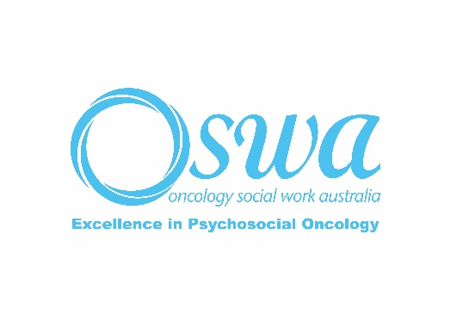
Designed 2003. A circle motif emphasising Oncology but also to reflect the wholistic focus of our role as health professionals; strength – of people with cancer and their support networks including the service system that the social work profession is embedded within; completing a loop.

Design concepts:
- Respect; Advocacy; Compassion; Warmth; Professional; Partnership
- As we are a professional organisation our target audience is social workers and other professional oncology organisations. As such we are seeking design differentiation from other associated professional oncology organisations within Australia and New Zealand:
  - Australia: Cancer Council, RedKite, CanTeen, Camp Quality, Leukaemia Foundation, Palliative Care Australia, National Breast Cancer Foundation, Prostate Cancer Foundation Australia etc.
  - New Zealand: Hospice New Zealand, Leukaemia & Blood Cancer New Zealand, CanTeen, Child Cancer Foundation, Cancer Society, Breast Cancer New Zealand, Camp Quality, Prostate Cancer Foundation New Zealand.
Current brand guidelines:
- We would like to include the text “OSWANZ” as well as text “Oncology Social Work Australia New Zealand”. “Excellence in Psychosocial Oncology” would be desirable but not essential.
- We do not want to appropriate any indigenous cultural motifs within Australia or New Zealand
- Image to be provided in a range of file types required for use on website, Microsoft Office applications, pdfs, and a range of printed promotional materials of varying dimensions.
Colour scheme:
- Current organisational scheme is white, blue and black.
- Calmness, sense of peace and tranquillity.
- We are not committed to keeping this scheme, but we are also happy to keep it. Other possible inclusions could relate to a warm or earthy palette (keeping in mind that earthy within new Zealand tends be green and blue and in Australia reds and browns). We are open to suggestions from the designer to provide a scheme that is congruent with a proposed symbols design and intent.
- Our website is currently being redesigned and any proposed colour schemes will be incorporated within the website design.

