These are photos of the truck with the correct rims. The top two is the side on views we are looking for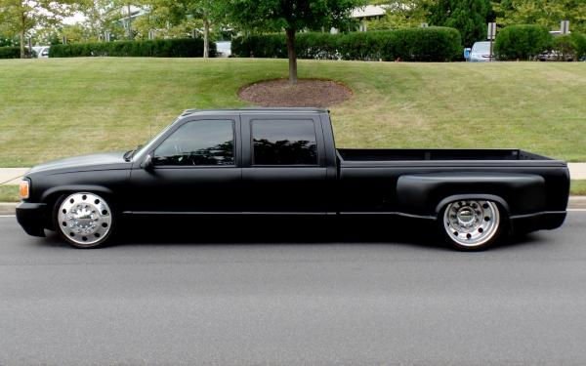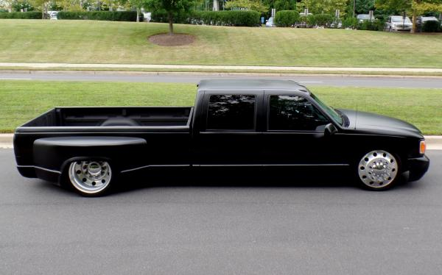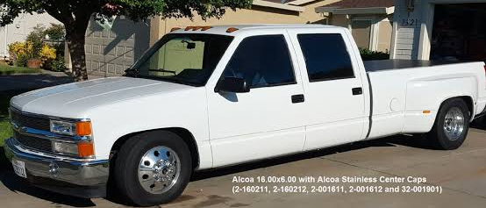
This is a close up of the rims. As this is what we will be selling they need to look quite close to this
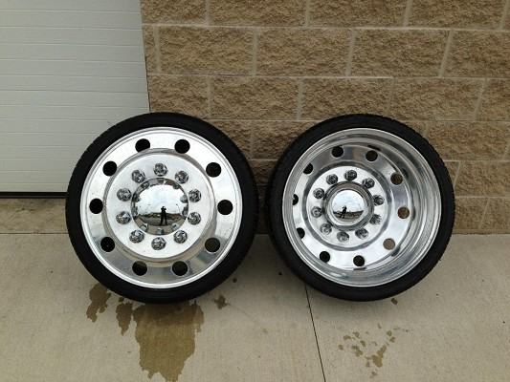

This is the stencil like design we are going for (none of these are the correct truck) however it will need to have a transparent (not white) background and the truck will need to be black and obviously the wheels will need to be drawn.
