WEB CONTENTS

Home/Landing Page

Meta Description (max 156 characters including spaces): Build a stronger workforce without wasting time & money on generic labour hire. Contact Front Age Consulting today on +61 3 8400 4133.

H1 Front Age Consulting – Australia’s Premier Recruitment Agency
[Bold] Modern Solutions to Sourcing Talent
- Are you spending exorbitant fees on the generic services of labour hire and direct recruiting companies without seeing results?
- Are your HR support costs increasing alongside growing employee numbers, whilst efficiency decreases?
- Have you wasted valuable time labouring through job advertising, resumes, screenings, interviews, and inductions, yet failing to source high calibre candidates?
- Is your attrition rate exceptionally high?
- Are your training and induction expenses continually increasing as a result?
- Do you want to take control of your staffing needs?
- Do you want to build a strong team, culture and brand name to boost performance and lower costs?
- Do you want access to a larger, more diverse pool of quality candidates on a national and global scale?
These are some of the most common issues facing companies across the world. After all, an organisation cannot hope to attain success if they cannot rely on their staff. Introducing new members into a workforce, regardless of the role, therefore requires greater care and attention than generic labour-hire companies can provide, especially in a contemporary marketplace with frequent innovation, fluctuating attrition rates, and aging staff.
Front Age Consulting understands this. In four short years, we have grown from a boutique recruitment agency to one of the world’s leading services, soon to be branching out from our Australian roots to assist companies in the Asia Pacific markets. We owe our success to constantly applying our insight into the recruitment process to not only alleviate the burden from HR departments, permitting them to continue focusing on key operational duties, but also to reduce the hefty costs that are frequently associated with sourcing new employees. Specialising in sourcing staff for industries that are labour intensive with low skill and high volume demands, our methodologies will help you refine the potential recruitment pool and integrate valuable prospects that will help your company flat line costs and flourish.
Speak with our professional staff today to get started by calling +61 3 8400 4133 or book online to arrange a 2 hour obligation free consultation.
H2 Modern Recruitment Solutions for Contemporary Companies
To help your business stay ahead in a modern market, Front Age Consulting has cultivated a comprehensive proprietary 7-Step Recruitment Process that actively works to remove unsuitable candidates and bring to the forefront the right applicants to benefit your operations. Our agile, determined and accessible team implement this alongside your management and HR departments to ensure our partnership remains fruitful.
By adopting Front Age’s methodology, we are proven to be the faster, more reliable, and more cost efficient avenue to sourcing new employees for your company – as opposed to conducting the interviews yourself or outsourcing to a labour-hire company – reducing comparative recruitment costs by up to 75%.
[Bold] ALWAYS AVAILABLE
We provide 24/7 ongoing support to all our employer clients nationally and 6 months support to your new staff hired through us
[Bold] REDUCE YOUR OPERATIONAL COST
Reduce your operating expenses using Front Age’s bespoke Pre-Employment Programs to flatline recruitment costs
[Bold] TECHNOLOGY
We embrace new technology and business automation in supporting various service delivery model to deliver amazing client experiences
[Bold] PROVEN TRACK RECORD
We focus on value-adding services, with a proven track record servicing labour intensive industries needing to recruit more than 100 employees per annum
H2 Contact our Recruitment Specialists Today
We operate throughout Sydney, Melbourne, Brisbane, Adelaide, Perth, Hobart and wider Australia. With our continued growth, however, we will continue to expand our services globally to accommodate companies across Asia Pacific countries. If you would like to learn more about our services, or request customer testimonials, our team would be happy to oblige. Call us today on +61 3 8400 4133, send an email to enquiries@front-age.com.au, or complete our simple online enquiry form on our contact page to book a 2 hour, obligation free consultation with our professional staff.

Modern Recruiters (Why Us)

Meta Description (max 156 characters including spaces): Allow your organisation to excel by recruiting the best employees for the job. Contact Front Age Consulting today by calling +61 3 8400 4133.

H1 Modern Recruitment Processes for Contemporary Businesses
In years gone by, companies across the world have solved their recruitment issues with one of two ways: either trying to handle the process themselves, spending vast amounts of time and resources on creating and implementing novice strategies; or turn to the brand name, faceless labour-hire corporations that apply an untailored, uniformed approach to each of their clients. For decades, these limited choices frequently left companies lumbered with candidates who may interview well, but were not suitable for the line of work they received or pay exorbitant labour-hire costs.
Front Age Consulting exists to overcome this problem. Established in 2015, we are a modern, boutique recruitment firm that addresses the process of screening, assessing and selecting new employees like the art form it is. We offer 360 degrees of recruitment services, specialising in companies operating in low skilled, high volume and labour-intensive industries, having completed recruitment for aircraft cabin cleaners, ramp/baggage/freight agents, airline passenger services, food process workers, warehouse/logistics workers, and much more.
H2 How Front Age Consultancy Can Help you Excel
At Front Age Consulting, we owe our success to employing tested and proven methods for our clients in an approach that is tailored to their needs and demands. We have refined our processes so they are both rigorous and thorough to adequately test applicants, but flexible enough for them to mould around not only specific industries, but the operations of a particular company. Front Age can help you access government incentives to reduce costs, structuring programs that enable employers access to wage subsidies and employment start-up costs. It is through this that we are confident of acquiring the right talent for any role and deliver quality value for money with our recruitment services.
[Bold] REDUCE RECRUITMENT COST
- lower recruitment costs by up to 75%
[Bold] Pre-Employment Program
- Front Age’s one and only bespoke Pre-Employment Programs (PEP) have proven track record in helping Employers reduce attrition by 50%
[Bold] One-stop Recruitment Solutions
- we offer a low cost, high value, one-stop recruitment solutions for labour intensive industries
[Bold] Global Scale
- we have the infrastructure to support your recruitment needs on a global scale
[Bold] PROVEN TRACK RECORD
- we are proud to be the recruitment partner for several Major National and Global Employers
[Bold] 24/7 PHONE AND EMAIL SUPPORT
- we offer prompt, 24/7 ongoing phone and/or email support to Employers and 6 months post placement support for new staff referred by us
H2 Speak with Our Consultants Today
Thanks to a broad network of recruitment partners throughout Australian and the wider world, as well as various government agencies and valuable community connections, our potential pool to which we can draw candidates from is extensive. Learn more about what we can offer you today by calling +61 3 8400 4133, send an email to enquiries@front-age.com.au, or fill out our short online enquiry form on our contact page.

Services
Sub menu : Recruitment Services
Meta Description (max 156 characters including spaces): Front Age Consulting has revolutionised the recruitment industries with contemporary services that accelerates hiring and reduces costs. Call +61 3 8400 4133 today.

H1 Premium Recruitment Services Tailored to Your Organisation
Assembling the right people into your workforce can be a tiring and costly undertaking. Not only locating valuable and talented employees, but also retaining them, is vital to achieve collaborative cohesion and operational success.
Front Age Consulting is a renowned boutique recruitment and consulting agency that can help. We move away from the conventional cookie-cutter approach of recruiting and cater a bespoke recruitment model using our proprietary 7-step process that will assist our clients to reduce costs and increase retention. Our unique approach to introducing new employees into contemporary companies has allowed us to enjoy exponential growth since our inception in 2015, elevating our services beyond Australian borders to soon service companies operating in the Asia Pacific markets. Outdated interviewing methods have long been notorious for being rife with inefficacies and selection bias. As a replacement, we offer proven alternatives, such as customised and practical assessments to simulate jobs tasks, and technology offering online tests/inductions as pre-screening measures, like our proprietary Pre-Employment Programs (PEP).
Discover more about how our recruitment services could benefit your company by calling Front Age Consulting today on +61 3 8400 4133.
H2 What We Offer in Our Services
Front Age Consulting’s success is built around our proprietary recruitment methodology – more precisely, our 7-Step Recruitment Process. Flowing through introductory & screening phases, testing, pre-employment programs, personalised assessments and more, our professional team create far more points of contact that ensure we are admitting appropriate candidates rather than a randomised applicant group. With proven results that our processes halve attrition rates and reduce recruitment costs by up to 75%, we deliver 360 degrees in tailored recruitment for your company. Our services even extend to offering government incentives to aid in your recruitment possibilities, should your organisation and candidates be eligible.
We offer:
[Bold] PRE-EMPLOYMENT PROGRAM
Bespoke industry-based assessment program tailor-made to each Employers’ business needs
[Bold] 360 DEGREES RECRUITMENT
Position analysis| sourcing| screening| shortlisting| schedule assessments| pre-employment program| on-boarding programs| wage incentives | negotiation & paperwork| pre-employment medicals| job offer| post placement support
[Bold] LABOUR INTENSIVE INDUSTRIES
We specialise in labour intensive industries that are needing to recruit more than 100 employees per annum
H2 Learn More About Our Services Today
Here at Front Age Consulting, we enjoy working with some of the largest corporations throughout Australia, the Asia Pacific region, and the wider world. If you would like to learn more about our services, or to receive testimonials from our satisfied clients, we would be happy to oblige. Contact us today by calling +61 3 8400 4133, sending an email to enquiries@front-age.com.au, or fill out our short online enquiry form on our contact page.

Sub menu : Pre-Employment Program

Meta Description (max 156 characters including spaces): Introduce Front Age Consulting’s personalised Pre-Employment Program to your recruitment process to select the best candidates for the job. Call +61 3 8400 4133 today.

H1 Pre-Employment Program
Front Age Consulting’s Pre-Employment Program (PEP) is an innovative approach designed to screen and test applicants in the actual job tasks you are recruiting for, to ensure they are the ideal entrants to your organisation.
H2 Why Choose the Pre-Employment Program?
[Bold] Replace Conventional Interview Process
Workplaces and the roles within them have greatly changed throughout generations. As a result, outdated recruitment strategies, such as the cookie-cutter approach to interviewing, no longer gauge a candidate’s ability, nor how they would interact within a specific team environment. How many times have you recruited jobseekers because they interview really well, but can’t really perform the tasks of the job? Or the workers the labour-hire companies have sent you simply end up costing you more? Hence the need for revolutionary replacement methods, such as Front Age’s 7-Step Recruitment Process and the PEP.
[Bold] Remove Selection Bias
Selection bias is a frequent issue in the interview stage of recruitment. Candidates displaying soft skills often climb in the subjective opinions of interviewers during the early periods, even if they are not an appropriate fit for the role. Front Age’s 7-Step Recruitment Process and FA PEP completely remove this bias from the equation.
[Bold] Personalised
Effective recruitment and pre-screening processes require a personalised approach. By assessing candidates in the actual tasks involved with the job, using customised tests and procedures reflecting the unique style of a company, employers can rest assured they are selecting the BEST applicants available.
[Bold] Cover Theory & Practical Job Tasks
Some applicants may be good on paper, but can they really handle the tasks of the role? By asking potential employees to place themselves in a situation they would likely find themselves in once with your company, and assess how they work covering both theoretical and aspects of the job provides a clearer representation of their ability.
[Bold] Specific Assessment Checklist
As we are external to your business, we work in close partnership with your management and HR teams to build an assessment checklist in which we can adequately gauge the abilities of the candidates in relation to the role they are applying for.
[Bold] Save Time & Money
By utilising proven, flexible methods, such as Front Age’s proprietary 7-Step Recruitment Process and FA PEP, businesses can forgo the lengthy list of expenses and time that are usually involved in the interviewing and training phases.
H2 Reach out to Learn More from Front Age Consulting Today
Get started and save today with personalised pre-employment programs from Front Age Consulting. Contact us today by calling +61 3 8400 4133, send an email to enquiries@front-age.com.au, or fill out our online enquiry form on our contact page.

Employer Page
Meta Description (max 156 characters including spaces): Make the faster, more effective, and more cost efficient choice with your recruitment process. Contact Front Age Consulting on +61 3 8400 4133 today.

H1 Front Age Consulting Aiding Employers Across the World
As an employer, it is only natural to want to take control of the recruitment process for your company. No one is as intimate with the ins and outs of your operations more than you are, after all, so who better to decide on who joins your team?
Front Age Consulting understands this, but we also appreciate that it isn’t the core speciality of most businesses to pre-screen, assess and recruit valuable new employees. Fortunately, it is ours.
Traditional methods of interviewing no longer prove effective in contemporary workplaces. We combine our refined knowledge and methodologies of the recruitment process with a close partnership with our Employer clients to develop an infallible system of acquiring viable candidates and analysing their potential. It is because of this approach that we have grown in four short years from a boutique recruitment agency, to one of the world’s leading services for companies operating in industries requiring a high volume of low skilled labour workers.
Discover more about what we have to offer by calling +61 3 8400 4133.
H2 Why Employers Benefit from Working with Front Age Consulting
A primary function of operating as an employer is to ensure that your business is running on-budget and on-time. Conducting your own interviewing process can be daunting, so many employers will rush to the services of labour-hire companies, only to find them extremely costly and time consuming, as they do not engage in best practise measures tailored to their business.
By engaging with Front Age Consulting, you will be opting for a partnership that will help you locate valuable employees in a way that is both cheaper and faster than traditional methods, whilst still maintaining control of your new entrants. You will save on costly job advertisements, as well as the time-consuming necessities surrounding introducing new applicants, such as interviews, training, and resume screening. By engaging with suitable new employees, you will by extension boost morale, lower attrition rates, and end the vicious cycle of constant hiring, fall offs and re-hiring.
Unlike with labour-hire companies, we allow you direct access to government incentives to make available greater candidate pools and wage subsidies, delivering savings in comparative recruitment costs of up to 75%.
Through the scope of our service, covering everything from sourcing, to screening, to assessment, to post placement support, we are confident that we can find the right team for your available positions.
H2 Begin a Recruiting Partnership Today
At Front Age Consulting, we have the pleasure of assisting some of the world’s largest organisations with their recruitment needs. If you would like testimonials of our various services, our professional staff are always happy to oblige. For more information, or to book a 2 hour obligation free consultation, call us today on +61 3 8400 4133, send an email to enquiries@front-age.com.au, or fill out our short online enquiry form on our contact page.

AI for Employer
Contents to be provided – it is about describing the bespoke solution we are developing and how it helps to automate business process and ease communications.
Contact Us

Head Quarter (Victoria)
Suite 883, Level 23
Collins Square Tower Five
727 Collins Street
Melbourne VIC 3008

New South Wales
Suite 13, Level 25, Aurora Place
88 Phillip Street
Sydney NSW 2000

Queensland
Suite 338, Level 54
111 Eagle Street
Brisbane QLD 4000

South Australia
Suite 8, Level 3, 97 Pirie Street
Adelaide SA 5000

Western Australia
Suite 3, Level 24 and 25
108 St Georges Terrace
Perth WA 6000

Tasmania
Level 3, 85 Macquarie Street
Hobart TAS 7000

P : 1800 FRONTAGE
E : enquiries@front-age.com.au
FRONT AGE LOGO



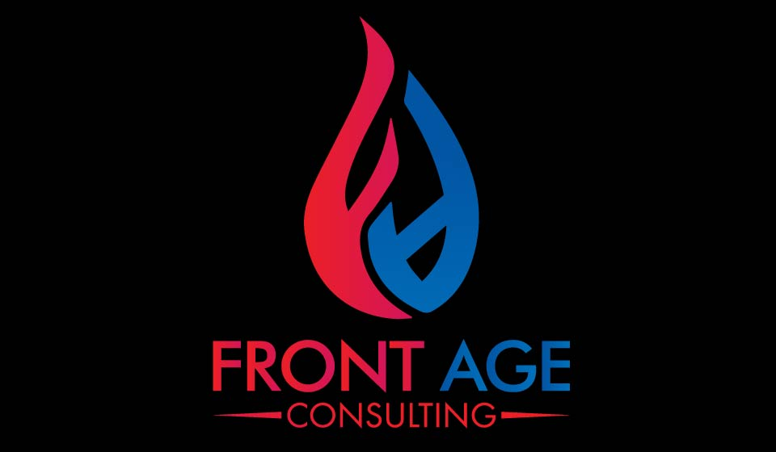
FRONT AGE BROCHURE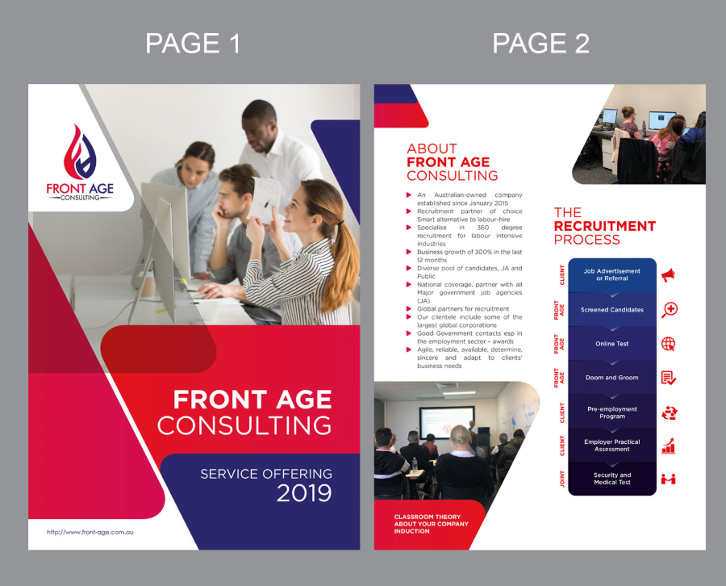
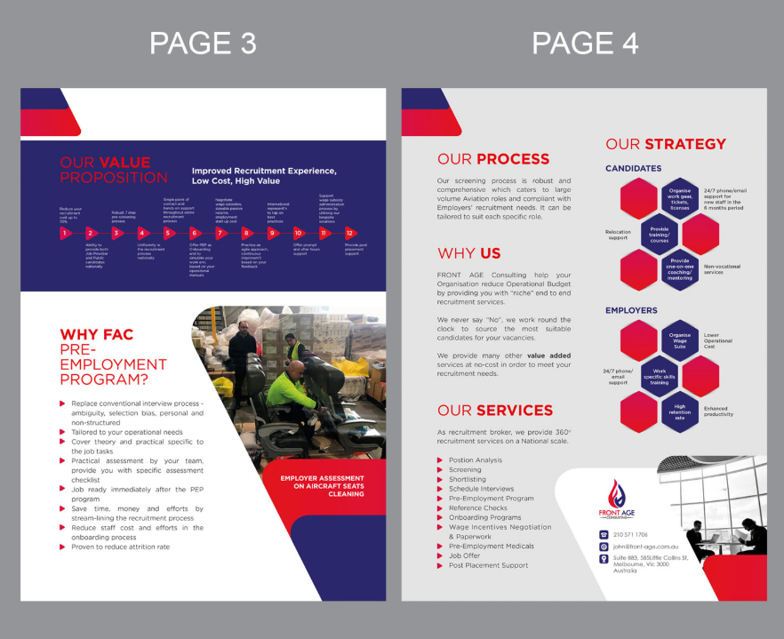

Name Card
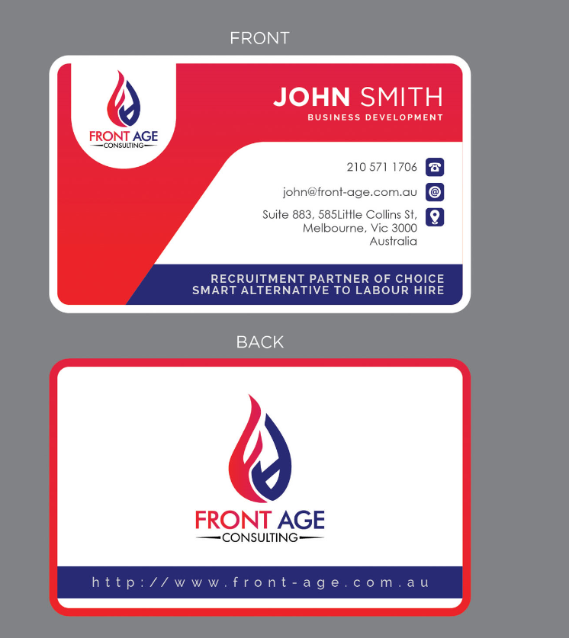
Colour Code
