

Welcome to Life Church en11!
We are so pleased you have decided to join us for the service today; we really appreciate you taking time out of your schedule to be with us.
You deciding to be with us is something we never take for granted and I hope you enjoy your visit to Life Church.
Life Church is part of the Elim denomination and has churches all around the UK and the World. If you would like find out more about Elim and the work it does please go to www.elim.org.uk to find out more.
This pack is designed to explain a little about who we are and what we do. If you have any further questions or queries please do not hesitate in making contact with us where one of the team will contact you.
If there is one thing we encourage everyone to be at Life Church it is to be yourself; we are all on a journey and today this could be the start of your journey with us. We hope to see you again at one of our services or events in the near future.
All the best,
Graeme

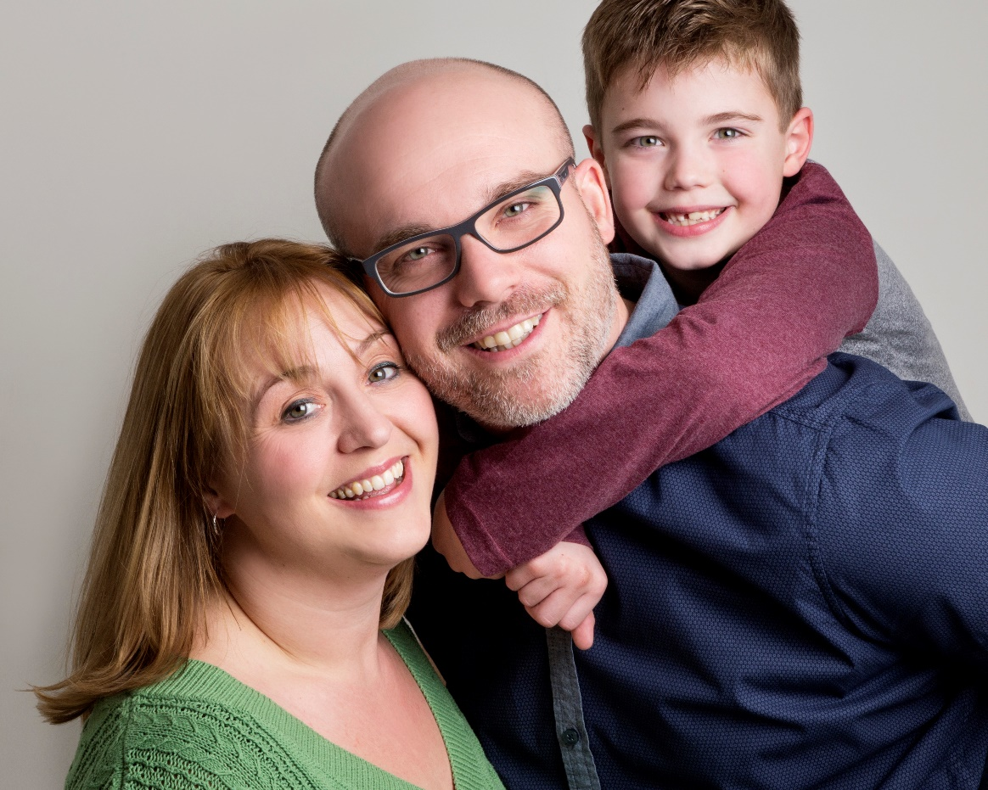
Senior Minister Graeme Stewart and his wife Jessie and son Isaac

The Life Church Aim & Vision
At Life Church we like to keep things as simple as possible! In light of that, what we are trying to be and achieve is pretty simple.
Our aim and vision is to be a church where people can connect, engage, grow & go.
We believe Jesus is still active and present in the world today, and we are trying to live our lives to be like Him in all we do.
As a church our aims are:
CONNECT - as a Church family meeting as much as possible, learning about living life for Jesus.
ENGAGE - getting involved in church life as much as possible as we love being part of an amazing team together for Jesus.
GROW - quite simply, we want our relationship with Jesus to grow and get stronger as we do life!
GO - We want to tell others about how amazing the God we follow is!
If this sounds like something you’d like to find out more about please let us know!

Vision
People Focused – Jesus Centred

Connect Groups
One of our first and main aims is ‘Connect’: Life Church is a family oriented church and we want to connect with each other as much as possible. When we keep connecting we can continually find out how others are doing. When we know this it allows us to support and care for each other as best as we can.
We connect on a Sunday when we gather to worship and we actively encourage everyone who counts Life Church as their home church to be in a Connect Group (CG) as much as possible.
Our CG’s meet on a regular basis and are a great way to make friends, be in a support group, go deeper into God’s Word and have fun!
Life Church is a gathered church which means although we meet as a church in Hoddesdon many people in the church travel from all around the area from places such as Ware, Hertford, Cheshunt to name a few. In light of this we have CG’s currently running various locations.
If you decide to be part of Life Church and would like to be part of a CG, please let us know.

Being Part of the Family
For anyone considering joining a church this can be quite a daunting challenge at times and we never want anyone to feel under pressure at Life Church. If and when someone decides they would like to be part of the Life Church family then, after a period of time of regularly being with us (around six months), we’d encourage anyone who is interested to consider becoming a partner with the church.
This would involve a discussion with the minister and attending a course (one or two evenings), but most of all, it’s about your desire to partner with us and become ‘part’ of the family.
Partnership is an amazing way of feeling you are really joining in the journey of where God is leading and taking Life Church.
If you decide that Life Church is the place for you, then after a few months if you are interested in finding out more about becoming a partner with us, please speak to Graeme or Jessie for further details.

Life Church Ministries
Quite simply Life Church could not do all it does and wants to achieve in the future without the amazing group of volunteers who make things happen.
For anyone wanting to get more involved in the life of the church there are many ways to do this and we ask everyone who counts Life Church as home to have a ministry in some way, shape and form.
Here is a list of just some of the ministries that take place on and outside of a Sunday at Life Church that people can consider getting involved with when the time is right:
- Welcome Team
- Tech Team
- Worship Team
- Refreshments Team
- Ignite Kids (4-10’s)
- G:Z (11-16’s)
- Set Up Team
- Ministry Team
- Pastoral Team
- Men’s & Women’s Ministry
- Church Building & Garden Maintenance
- Monday Night Football
- Quiz Nights
- Christianity Explored
- Movie Matinee’s and other community events
- Life Tots
For further details please see our website and Facebook page or speak to Graeme, Jessie or one of the leadership team to find out more.

Keeping in touch!
We hope this booklet has been useful and informative, and above all we hope you have enjoyed your time with us today.
Our hope and prayer is that you have met with Jesus and been able to discover more about his love for you and the calling he has for your life.
Also included in this pack is a self-addressed stamped envelope, if you would like us to keep in touch with you via our weekly email and keep you updated of any special services and events please complete the enclosed contact form, pop it in the envelope and send it back to us. Don’t worry, this information won’t be shared with anyone else but we’d love to keep in touch and let you know about all the exciting things happening and taking place at Life Church.
Finally thank you once again for being with us today; we hope you have enjoyed your time with us. If you came to Life Church today and you are not a Christian also included in this pack is a little booklet, we’d love it if you took some time to read it and see what it says about Jesus. If you would like to meet with one of the team at Life Church and talk about anything in this booklet please let us know or why not consider coming along to one of the Christianity Explored Courses we regularly run.
If this is something you might be interested in drop us an email or Facebook message and we’ll add you to the contact list for this event.
We hope to see again soon, until then all the very best.
Graeme

